Multiview Graph Restricted Boltzmann Machines

ABSTRACT
Recently, the restricted Boltzmann machine (RBM) has aroused considerable interest in the multiview learning field. Although effectiveness is observed, like many existing multiview learning models, multiview RBM ignores the local manifold structure of multiview data. In this article, we first propose a novel graph RBM model, which preserves the data manifold structure and is amenable to Gibbs sampling. Then, we develop a multiview graph RBM model on the basis of the graph RBM, which performs local structural learning and multiview representation learning simultaneously. The proposed multiview model has the following merits: 1) it preserves the data manifold structure for multiview classification and 2) it performs view-consistent representation learning and view-specific representation learning simultaneously. The experimental results show that the proposed multiview model outperforms other state-of-the-art multiview classification algorithms.

CHAPTER 2
2. SYSTEM ANALYSIS
  - EXISTING SYSTEM

- Graphs are built using multiple methods from multiple corpora and existing lexical databases such as WordNet.
- Comprehensive experiments of our proposed model in document modeling with a variety of evaluations: graph construction methods from in-domain, out-domain, and existing databases.
- To exploit prior structures, we use the CPAN-WordNet:Similarity package to query the similarity measures for every pair of words.
- As the analytical solution of the gradient cannot be computed, the existing training algorithms are mainly based on the sampling method.
- The entire RBM network is a bipartite graph, in which connections only exist between the visible and hidden units.
2.1.1 DRAWBACKS OF EXISTING SYSTEM :
- We aim to demonstrate that these structural constraints will improve the modeling qualities by preventing overfitting and enhancing factor coherence – the issues largely ignored in RBMs.
- However, the posterior computation is extremely hard due to the so-called “double intractability” problem in undirected graphical models – intractability of both the data likelihood and the posterior.
- To prevent this problem, we drop all edges associated with the nodes that have more than 20 outlinks.
- Our purpose is to automatically learn and understand the research topics, issues and the evolution of ASD research literature.
2.2. PROPOSED SYSTEM
- We demonstrate that the proposed technique improves the group coherence, facilitates visualization, provides means for estimation of intrinsic dimensionality, reduces overfitting, and possibly leads to better classification accuracy.
- Focusing on document modeling, we perform extensive experiments to evaluate the efficacy of the proposed framework.
- We propose a principled way to introduce domain structures into RBMs, focusing on an important class of constraints that arise from a network of features - pairwise correlation, pairwise smoothness, and groupwise smoothness.
- To assess factor coherence, we adopted the measure proposed, which has good agreement with human’s judgment.
2.2.1. ADVANTAGES OF PROPOSED SYSTEM
- In order to test the performance of the algorithms, the proposed algorithms are compared with state-of-the-art classification algorithms, the multi-view Gaussian process with posterior consistency (MvGP) and consensus and complementarity based maximum entropy discrimination (MED-2C).
- There are many efficient multi-view algorithms for classification, such as multi-view Gaussian process with posterior Consistency (MvGP) [10] and consensus and complementarity based maximum entropy discrimination (MED-2C).
- In the PCRBM, the negative of the distance between two conditional probabilities is used to measure the consistency between two conditional probabilities.
Literature Survey:
TITLE | AUTHORS | DESCRIPTION
An overview on restricted boltzmann machines | Zhang N., Ding S., Zhang J., Xue Y. | The restricted Boltzmann machine (RBM) is a two-layered network of stochastic units with undirected connections between pairs of units in the two layers.
The spike-and-slab RBM and extensions to discrete and sparse data distributions | Courville A., Desjardins G., Bergstra J., Bengio Y. | The spike-and-slab restricted Boltzmann machine (ssRBM) is defined to have both a real-valued "slab" variable and a binary "spike" variable associated with each unit in the hidden layer.
Structured recurrent temporal restricted boltzmann machines | Mittelman R., Kuipers B., Savarese S., Lee H. | In this work, we propose a new class of RTRBM, which we refer to as the structured RTRBM (SRTRBM), which explicitly uses a graph to model the dependency structure.
Research on Point-wise Gated Deep Networks | Zhang N., Ding S., Zhang J., Xue Y. | Stacking Restricted Boltzmann Machines (RBM) to create deep networks, such as Deep Belief Networks (DBN) and Deep Boltzmann Machines (DBM), has become one of the most important research fields in deep learning.

2.3 FEASIBILITY STUDY
The feasibility Analysis is an analytical program through project manager determines the project success ratio and through feasibility study project manager able to see either project. The key considerations involved in the feasibility analysis are:
- Economic Feasibility
- Technical Feasibility
- Operational Feasibility
- Environmental Feasibility
2.3.1 ECONOMICAL FEASIBILITY
Hence this project is economically feasible there is no need to involve any cost for this project.
2.3.2 TECHNICAL FEASIBILITY
Software Technologies used are PHP and MySql. In the educational institutions, it is possible to update the system in future. No special hardware is required for the purpose of using this system. Hence it is declared that this project is technically feasible.
2.3.3 OPERATIONAL FEASIBILITY
As the admin work mainly to maintain the Patient and Doctor .Doctor will predict patient cancer disease. Hence it is easy to operate with training. Therefore it is operationally feasible for implementation.
2.3.4 ENVIRONMENTAL FEASIBILITY
This project environment is correct as a admin has developed this system and no expenditure is involved under any head and this process is part of admin document management, this project environment is accessible.

2.4 SYSTEM REQUIREMENTS
- System : Pentium IV 2.4 GHz.
- Hard Disk : 40 GB.
- Monitor : 15 inch VGA Color.
- Mouse : Logitech Mouse.
- Ram : 512 MB
- Keyboard : Standard Keyboard

2.4.1 HARDWARE REQUIREMENTS
The Hardware of the computer consists of physical component such as Input Devices, Storage Devices, Processing & Control units and Output Devices. Computer includes external storage unit to store data in programs.
The Hardware Configuration involved in this project
- System : Pentium IV 2.4 GHz.
- Hard Disk : 40 GB.
- Monitor : 15 inch VGA Color.
- Mouse : Logitech Mouse.
- Ram : 512 MB
- Keyboard : Standard Keyboard

2.4.2 SOFTWARE REQUIREMENTS
Software is a group of programs that computers need to do a particular task. It is an essential requirement of Computer System. The Software used to develop the project is
- Operating System : Windows XP.
- Platform : DOT NET TECHNOLOGY
- Front End : ASP.Net 3.5
- Back End : SQL SERVER 2005

CHAPTER 3
SYSTEM DESIGN AND DEVELOPEMENT
SYSTEM ARCHICTURE

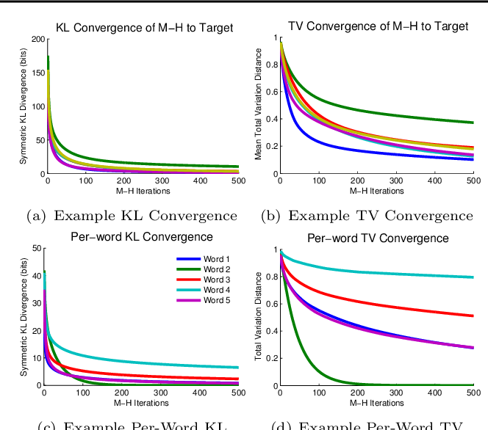

CHAPTER 4
TESTING AND IMPLEMENTATION

  - TESTING
Implementation is the stage of the project when the theoretical design is turned into a working system. This is the final and important phase in the system life cycle It is actually the process of converting the new system into a operational one.

4.1.1Unit Testing
Unit testing comprises the set of tests performed by an individual programmer prior to integration of the unit into a larger system. The module interface is tested to ensure that information properly flows into and out of the program unit. The local data structure is examined to ensure that data stored temporarily maintains its integrity during all steps in an algorithm’s execution. Boundary conditions are tested to ensure that the module operates properly at boundaries established to limit or restrict processing. All independent paths through the control structure are tested. All error-handling paths are tested.

4.1.2 Block Box Testing
Black-box testing is a method of software testing that examines the functionality of an application without peering into its internal structures or workings. This method of test can be applied virtually to every level of software testing: unit, integration, system and acceptance. It is sometimes referred to as specification-based testing.

4.2 SYSTEM IMPLEMENTATION
Implementation is the stage of the project when the theoretical design is turned into a working system. This is the final and important phase in the system life cycle It is actually the process of converting the new system into a operational one.

CHAPTER 5
CONCLUSION:
Restricted Boltzmann Machines (RBMs) are effectively probability graph models for representational learning. On this basis, this paper extends RBMs to deal with multi-view learning and names it as RBMs with posterior consistency (PCRBMs). PCRBMs utilize the negative of the distance between two conditional probabilities to measure the posterior consistency between two views and maximize this posterior consistency. Then, this paper proposes correlation RBMs with posterior consistency (Exp-PCRBMs), which are suitable for binary and real-valued data. In addition, activation functions of Exp-PCRBMs can be any smooth monotonic non-linearity function. Finally, experimental results show that Exp-PCRBM is effective multi-view classification method for two-class and multi-class data.

CHAPTER-6
REFERENCE
- 1. Hinton G.E., Salakhutdinov R.R.: Reducing the dimensionality of data with neural networks, Science. 313(5786), 504-507 (2006)
- 2. Zhang N., Ding S., Zhang J., Xue Y.: An overview on restricted boltzmann machines. Neurocomputing. 275, 1186-1199 (2018)
- 3. Courville A., Desjardins G., Bergstra J., Bengio Y.: The spike-and-slab RBM and extensions to discrete and sparse data distributions. IEEE transactions on pattern analysis and machine intelligence. 36(9), 1874-1887 (2014)
- 4. Mittelman R., Kuipers B., Savarese S., Lee H.: Structured recurrent temporal restricted boltzmann machines. Proceedings of International Conference on Machine Learning ICML’14, 21-26 June 2014, Beijing China, 1647-1655 (2014)
- 5. Zhang N., Ding S., Zhang J., Xue Y.: Research on Point-wise Gated Deep Networks. Applied Soft Computing. 52, 1210-1221 (2017)
- 6. Nguyen T.D., Tran T., Phung D., Venkatesh S.: Graph-induced restricted Boltzmann machines for document modelling. Information Sciences. 328, 60-75 (2016)
- 7. Amer M.R., Shields T., Siddiquie B. Tamrakar, A., Divakaran A., Chai S.: Deep multimodal fusion: A hybrid approach. International Journal of Computer Vision. 126(2-4), 440-456. (2018)
- 8. Salakhutdinov R.R., Hinton G.E.: Deep Boltzmann Machines. Proceedings of International Conference on Artificial Intelligence and Statistics AISTATS’09, 16-18 April 2009, Clearwater Beach, 448-455 (2009)
- 9. Zhao J., Xie X., Xu X., Sun S.: Multi-view learning overview: Recent progress and new challenges. Information Fusion. 38, 43-54 (2017)
- 10. Liu Q., Sun S.: Multi-view regularized Gaussian processes. Proceedings of Pacific-Asia Conference on Knowledge Discovery and Data Mining PAKDD’17, 23-26 May 2017, Jeju, 655-667 (2017)

