A Systematic Deep Learning Model Selection for P300-Based Brain-Computer Interfaces

ABSTRACT
Predicting attention-modulated brain responses is a major area of investigation in brain-computer interface (BCI) research that aims to translate neural activities into useful control and communication commands. Such studies involve collecting electroencephalographic (EEG) data from subjects to train classifiers for decoding users' mental states. However, various sources of inter or intrasubject variabilities in brain signals render training classifiers in BCI systems challenging. From a machine learning perspective, this model training generally follows a common methodology: 1) apply some type of feature extraction, which can be time-consuming and may require domain knowledge and 2) train a classifier using extracted features. The advent of deep learning technologies has offered unprecedented opportunities to not only construct remarkably accurate classifiers but also to integrate the feature extraction stage into the classifier construction. Although integrating feature extraction, which is generally domain-dependent, into the classifier construction is a considerable advantage of deep learning models, the process of architecture selection for BCIs generally depends on domain knowledge. In this study, we examine the feasibility of conducting a systematic model selection combined with mainstream deep learning architectures to construct accurate classifiers for decoding P300 event-related potentials. In particular, we present the results of 232 convolutional neural networks (CNNs) (4 datasets x 58 structures), 36 long short-term memory cells (LSTMs) (4 datasets x 9 structures), and 320 hybrid CNN-LSTM models (4 datasets x 80 structures) of varying complexity. Our empirical results show that in the classification of P300 waveforms, the constructed predictive models can outperform the current state-of-the-art deep learning architectures, which are partially or entirely inspired by domain knowledge. The source codes and constructed models are available at https://githu...

CHAPTER 2
2. SYSTEM ANALYSIS
  - EXISTING SYSTEM

- It can be seen that the application scenarios of TL in the existing literature have focused almost only on classification and regression tasks.
- The principle of TL is realizing the knowledge transfer from different but related tasks, i.e., using existing knowledge learned from accomplished tasks to help with new tasks.
- To decide if the current trial’s features and estimated label should be added to the existing knowledge base, a confidence ratio CR.
- The algorithms of electroencephalography (EEG) decoding are mainly based on machine learning in current research.
- One of the main assumptions of machine learning is that training and test data belong to the same feature space and are subject to the same probability distribution.
2.1.1 DRAWBACKS OF EXISTING SYSTEM :
- LIU improved the convolutional neural network on the basis of Cecotti’s algorithm which was named BN3 algorithm, taking the batch normalization (BN) layer and the dropout (DP) layer to deepen the network layers and overcome the problem of overfitting.
- The BN3 algorithm achieved good results in classification, but still need to improve the recognition accuracy when the number of experiments are reduced.
- Then, the number of positive samples should be increased before the next step, in order to prevent the classification problems caused by the imbalance of positive and negative samples.
- These may be caused by the overfitting problem when the convolutional neural network processes a large amount of data, which affects the experimental performance.
2.2. PROPOSED SYSTEM
- They proposed two different transfer methods: To finetune a pre-trained network and then extract image features by said pre-trained network, and to classify the status of brain using an SVM.
- Popular networks such as Alexnet, VGG16net, VGG19net, and Squeezenet, were used to verify the performance of the proposed framework.
- Some studies proposed that the Bayesian model is a promising approach to capture variability.
- This model is built based on multitask learning, and variation in some features is often extracted, such as spectral and spatial.
- The feature of EEG from these subjects exhibits inseparability in feature space. Therefore, the parameter optimization of the classifier does not significantly improve the classification results.
2.2.1. ADVANTAGES OF PROPOSED SYSTEM
- To measure the performance of the algorithms, we used two indices, the accuracy rate and the information translate rate (ITR) to compare the proposed PCA-CNN with other CNN algorithms in the literature.
- In this paper, we used the accuracy rate and ITR to evaluate the P300 signals detection performance on two datasets of different subjects.
- The ITR of PCA-CNN is higher than the traditional SVM classification algorithm, which proves the stability of the algorithm performance.
- It can implement a variety of different functions, and can even be used in the home of people with disability.
- PCA (Principal Component Analysis), a principal component analysis method, is widely used in feature extraction and data dimensionality reduction.
Literature Survey:
TITLE | AUTHORS | DESCRIPTION
Brain–computer interfaces for communication and control | Wolpaw, J.R.; Birbaumer, N.; McFarland, D.J.; Pfurtscheller, G.; Vaughan, T.M. | Prior work has highlighted the challenges faced by people with motor impairments when trying to acquire on-screen targets using a mouse or trackball.
BCI2000: A general-purpose Brain-Computer Interface (BCI) system | Schalk, G.; McFarland, D.J.; Hinterberger, T.; Birbaumer, N.; Wolpaw, J.R. | Many laboratories have begun to develop brain-computer interface (BCI) systems that provide communication and control capabilities to people with severe motor disabilities.
Principles of a brain–computer interface (BCI) based on real-time functional magnetic resonance imaging (fMRI) | Weiskopf, N.; Mathiak, K.; Bock, S.W.; Scharnowski, F.; Veit, R.; Grodd, W.; Goebel, R.; Birbaumer, N. | A brain-computer interface (BCI) based on functional magnetic resonance imaging (fMRI) records noninvasively activity of the entire brain with a high spatial resolution.
Frequency Recognition Based on Canonical Correlation Analysis for SSVEP-Based BCIs | Lin, Z.; Zhang, C.; Wu, W.; Gao, X. | Canonical correlation analysis (CCA) is applied to analyze the frequency components of steady-state visual evoked potentials (SSVEP) in electroencephalogram (EEG).

2.3 FEASIBILITY STUDY
The feasibility Analysis is an analytical program through project manager determines the project success ratio and through feasibility study project manager able to see either project. The key considerations involved in the feasibility analysis are:
- Economic Feasibility
- Technical Feasibility
- Operational Feasibility
- Environmental Feasibility
2.3.1 ECONOMICAL FEASIBILITY
Hence this project is economically feasible there is no need to involve any cost for this project.
2.3.2 TECHNICAL FEASIBILITY
Software Technologies used are PHP and MySql. In the educational institutions, it is possible to update the system in future. No special hardware is required for the purpose of using this system. Hence it is declared that this project is technically feasible.
2.3.3 OPERATIONAL FEASIBILITY
As the admin work mainly to maintain the Patient and Doctor .Doctor will predict patient cancer disease. Hence it is easy to operate with training. Therefore it is operationally feasible for implementation.
2.3.4 ENVIRONMENTAL FEASIBILITY
This project environment is correct as a admin has developed this system and no expenditure is involved under any head and this process is part of admin document management, this project environment is accessible.

2.4 SYSTEM REQUIREMENTS
- System : Pentium IV 2.4 GHz.
- Hard Disk : 40 GB.
- Monitor : 15 inch VGA Color.
- Mouse : Logitech Mouse.
- Ram : 512 MB
- Keyboard : Standard Keyboard

2.4.1 HARDWARE REQUIREMENTS
The Hardware of the computer consists of physical component such as Input Devices, Storage Devices, Processing & Control units and Output Devices. Computer includes external storage unit to store data in programs.
The Hardware Configuration involved in this project
- System : Pentium IV 2.4 GHz.
- Hard Disk : 40 GB.
- Monitor : 15 inch VGA Color.
- Mouse : Logitech Mouse.
- Ram : 512 MB
- Keyboard : Standard Keyboard

2.4.2 SOFTWARE REQUIREMENTS
Software is a group of programs that computers need to do a particular task. It is an essential requirement of Computer System. The Software used to develop the project is
- Operating System : Windows XP.
- Platform : DOT NET TECHNOLOGY
- Front End : ASP.Net 3.5
- Back End : SQL SERVER 2005

CHAPTER 3
SYSTEM DESIGN AND DEVELOPEMENT
SYSTEM ARCHICTURE

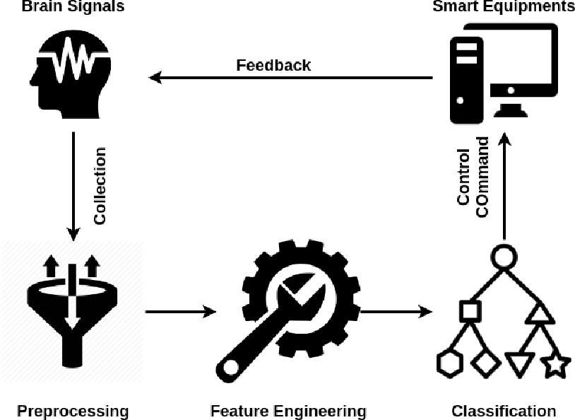

CHAPTER 4
TESTING AND IMPLEMENTATION

  - TESTING
Implementation is the stage of the project when the theoretical design is turned into a working system. This is the final and important phase in the system life cycle It is actually the process of converting the new system into a operational one.

4.1.1Unit Testing
Unit testing comprises the set of tests performed by an individual programmer prior to integration of the unit into a larger system. The module interface is tested to ensure that information properly flows into and out of the program unit. The local data structure is examined to ensure that data stored temporarily maintains its integrity during all steps in an algorithm’s execution. Boundary conditions are tested to ensure that the module operates properly at boundaries established to limit or restrict processing. All independent paths through the control structure are tested. All error-handling paths are tested.

4.1.2 Block Box Testing
Black-box testing is a method of software testing that examines the functionality of an application without peering into its internal structures or workings. This method of test can be applied virtually to every level of software testing: unit, integration, system and acceptance. It is sometimes referred to as specification-based testing.

4.2 SYSTEM IMPLEMENTATION
Implementation is the stage of the project when the theoretical design is turned into a working system. This is the final and important phase in the system life cycle It is actually the process of converting the new system into a operational one.

CHAPTER 5
CONCLUSION:
Our work focuses on P300 EEG signals preprocessing and the convolution neural network structure designing. In the P300 EEG signals preprocessing part, the PCA is used to retain the data features of the original P300 EEG signals, which reduced the dimension of the original signals and reduced the computational cost of subsequent algorithms. In the convolution neural network structure designing part, this paper used a deep convolutional neural network to implement the classification and recognition of P300 EEG signals. The convolution neural network uses its own powerful feature extraction capabilities to construct a better classifier. The new algorithm changed the single-kernel convolutional layer in the convolution neural network to a multi-kernel convolutional layer, that is, using a multi-kernel convolution filter to extract P300 EEG signals, which improved the classification ability of the network. Compared with some traditional classification algorithms, the PCA-CNN algorithm has a higher character recognition accuracy rate. In the future, our research will consider how to improve the recognition speed of BCI system and implement an online P300 brain–computer interface system based on the deep convolution neural networks.

CHAPTER-6
REFERENCE
- 1. Wolpaw, J.R.; Birbaumer, N.; McFarland, D.J.; Pfurtscheller, G.; Vaughan, T.M. Brain–computer interfaces for communication and control. Clin. Neurophysiol. 2002, 113, 767–791. [CrossRef]
- 2. Schalk, G.; McFarland, D.J.; Hinterberger, T.; Birbaumer, N.; Wolpaw, J.R. BCI2000: A general-purpose Brain-Computer Interface (BCI) system. IEEE Trans. Biomed. Eng. 2004, 51, 1034–1043. [CrossRef]
- 3. Weiskopf, N.; Mathiak, K.; Bock, S.W.; Scharnowski, F.; Veit, R.; Grodd, W.; Goebel, R.; Birbaumer, N. Principles of a brain–computer interface (BCI) based on real-time functional magnetic resonance imaging (fMRI). IEEE Trans. Biomed. Eng. 2004, 51,966–970. [CrossRef] [PubMed]
- 4. Donchin, E.; Coles, M.G.H. Is the P300 component a manifestation of context updating? Behav. Brain Sci. 1988, 11, 357–374. [CrossRef]
- 5. Lin, Z.; Zhang, C.; Wu, W.; Gao, X. Frequency Recognition Based on Canonical Correlation Analysis for SSVEP-Based BCIs. IEEE Trans. Biomed. Eng. 2006, 77, 2610–2614. [CrossRef] [PubMed]
- 6. Decety, J. The neurophysiological basis of motor imagery. Behav. Brain Res. 1996, 77, 45–52. [CrossRef]
- 7. Fazel-Rezai, R.; Allison, B.Z.; Guger, C.; Sellers, E.W.; Kleih, S.C.; Kübler, A. P300 brain computer interface: Current challenges and emerging trends. Front. Neuroeng. 2004, 5, 73–77. [CrossRef]
- 8. Iturrate, I.; Antelis, J.M.; Kubler, A.; Minguez, J. A Noninvasive Brain-Actuated Wheelchair Based on a P300 Neurophysiological Protocol and Automated Navigation. IEEE Trans. Robot. 2009, 25, 614–627. [CrossRef]
- 9. Salvaris, M.; Sepulveda, F. Visual modifications on the P300 speller BCI paradigm. J. Neural Eng. 2009, 6, 046011. [CrossRef]
- 10. Krusienski, D.J.; Sellers, E.W.; Cabestaing, F.; Bayoudh, S.; McFarland, D.J.; Vaughan, T.M.; Wolpaw, J.R. A comparison of classification techniques for the P300 Speller. J. Neural Eng. 2006, 3, 299–305. [CrossRef]

