Deep-Green A Dispersed Energy-Efficiency Computing Paradigm for Green Industrial IoT

ABSTRACT
The rapid development of the Industrial Internet of Things (IIoT) has led to the explosive growth of industrial control data. Cloud computing-based industrial control models cause vast energy consumption. Most existing solutions try to reduce the overall energy consumption by optimizing task scheduling and disregard how to reduce the load of computing and data transmission. On the other hand, due to the rigid architecture and limited capability of the edge computing platform, solutions based on edge computing urgently need to be deeply optimized in terms of data processing and energy efficiency. This paper proposes Deep-Green, which is a dispersed energy-efficient computing paradigm for the Industrial Internet of Things. The core idea of Deep-Green is to realize the joint optimization of computing and network resources by merging data transmission and data processing. Deep-Green provides a novel method of constructing an IIoT edge layer based on a dispersed computing platform. By using an energy-efficiency task scheduling algorithm, container service technology, and programmable protocol stack, the data processing service is dispatched from the cloud side to the on-site controller. Therefore, the data from manufacturing equipment can be processed while they are forwarded by the on-site industrial controller. The results of experiments show that Deep-Green can not only effectively reduce the computing load and communication overhead of the cloud-side server, but also simplify the network topology and the number of devices at the edge layer of the IIoT.
CHAPTER 2
2. SYSTEM ANALYSIS
  - EXISTING SYSTEM

- As there are variety of sensor and actuator devices, communication technologies, and data computing approached, in this section, we explain the existing technologies which enable IoT.
- The recent developments in digital technologies have provided a driving force to apply smart, IoT based solutions for the existing problems in a smart city context .
- This paper reviews the existing literature on the application of IoT in in energy systems, in general, and in the context of smart grids particularly.
- The main contribution of this paper is to extend the existing body of literature by providing energy policy-makers, economists, energy experts, and managers with a general overview of the opportunities and challenges of applying IoT in different parts of the entire energy sector.
2.1.1 DRAWBACKS OF EXISTING SYSTEM :
- IoT is going to have a huge impact on how we deal with certain problems in our daily life and it is certainly going to make our lives easier and better but with ease come the challenges.
- We have to deal with the large scale consumption of energy resources by IoT and the earlier we tackle this problem, the more efficient will be the IoT.
- This is called the overhearing problem which is responsible for a huge wastage of energy resources.
- In a smart phones charger can be the cause of the environmental damage because its main component is print wiring boards, the main problem was the electronic components.
2.2. PROPOSED SYSTEM
- The work proposes a platform by integrating multiple systems, such as air-conditioning, lighting, and energy monitoring to perform building energy optimization.
- Other solutions propose designing co-simulation models for energy systems to integrate the system and minimize synchronization delay error between the subsystems.
- The research in proposes a wireless sensor and actuator network to provide an IoT-based automatic intelligent system.
- Whereas, by optimizing the operation of devices and machines in the IoT, the proposed system achieves reduction in their overall energy consumption at a given time.

2.2.1. ADVANTAGES OF PROPOSED SYSTEM
- Many methods were introduced in for the improvement of the power consumption and performance of the smart phones.
- We evaluate if an approach is realistic or not on the basis of its performance in real life scenarios or whether that model can be implemented or not in a large scale IoT network and all the proposed models are found to be realistic.
- However, using another medium for energy storage instead of batteries could lead to more energy efficiency.
- Data Centers can be pivotal to an energy efficient IoT network but energy efficiency needs to be introduced in data centers to make them viable for IoT.
- A CS framework to achieve energy efficiency using priori data sparsity information proposed in can minimize the redundant data collection.
Literature Survey:
TITLE | AUTHORS | DESCRIPTION
Application of RFID technology for logistics on Internet of Things | C. Sun, | Radio Frequency Identification RFID is a non-contact automatic identification technology, which signals through radio frequency automatic identification and access to relevant target data, no need for manual intervention to identify job can work in a variety of harsh environment.
Internet of Things: Vision, applications and research challenges | D. Miorandi, S. Sicari, F. De Pellegrini, and I. Chlamtac, | This survey paper is an effort to describe IoT along with its vision, possible application domains and key challenges faced in making IoT a reality.
The evolution of the Internet of Things | J. Chase, | The study confirms the claim that a consensus on the IoT definition has not yet been reached, as enabling technology keeps evolving and new application domains are being proposed.
Realtime locating systems using active RFID for Internet of Things | D. Zhang, L. T. Yang, M. Chen, S. Zhao, M. Guo, and Y. Zhang, | To achieve fine-grained localization accuracy, iLocate presents the concept of virtual reference tags.

2.3 FEASIBILITY STUDY
The feasibility Analysis is an analytical program through project manager determines the project success ratio and through feasibility study project manager able to see either project. The key considerations involved in the feasibility analysis are:
- Economic Feasibility
- Technical Feasibility
- Operational Feasibility
- Environmental Feasibility
2.3.1 ECONOMICAL FEASIBILITY
Hence this project is economically feasible there is no need to involve any cost for this project.
2.3.2 TECHNICAL FEASIBILITY
Software Technologies used are PHP and MySql. In the educational institutions, it is possible to update the system in future. No special hardware is required for the purpose of using this system. Hence it is declared that this project is technically feasible.
2.3.3 OPERATIONAL FEASIBILITY
As the admin work mainly to maintain the Patient and Doctor .Doctor will predict patient cancer disease. Hence it is easy to operate with training. Therefore it is operationally feasible for implementation.
2.3.4 ENVIRONMENTAL FEASIBILITY
This project environment is correct as a admin has developed this system and no expenditure is involved under any head and this process is part of admin document management, this project environment is accessible.

2.4 SYSTEM REQUIREMENTS
- System : Pentium IV 2.4 GHz.
- Hard Disk : 40 GB.
- Monitor : 15 inch VGA Color.
- Mouse : Logitech Mouse.
- Ram : 512 MB
- Keyboard : Standard Keyboard

2.4.1 HARDWARE REQUIREMENTS
The Hardware of the computer consists of physical component such as Input Devices, Storage Devices, Processing & Control units and Output Devices. Computer includes external storage unit to store data in programs.
The Hardware Configuration involved in this project
- System : Pentium IV 2.4 GHz.
- Hard Disk : 40 GB.
- Monitor : 15 inch VGA Color.
- Mouse : Logitech Mouse.
- Ram : 512 MB
- Keyboard : Standard Keyboard

2.4.2 SOFTWARE REQUIREMENTS
Software is a group of programs that computers need to do a particular task. It is an essential requirement of Computer System. The Software used to develop the project is
- Operating System : Windows XP.
- Platform : DOT NET TECHNOLOGY
- Front End : ASP.Net 3.5
- Back End : SQL SERVER 2005

CHAPTER 3
SYSTEM DESIGN AND DEVELOPEMENT
SYSTEM ARCHICTURE

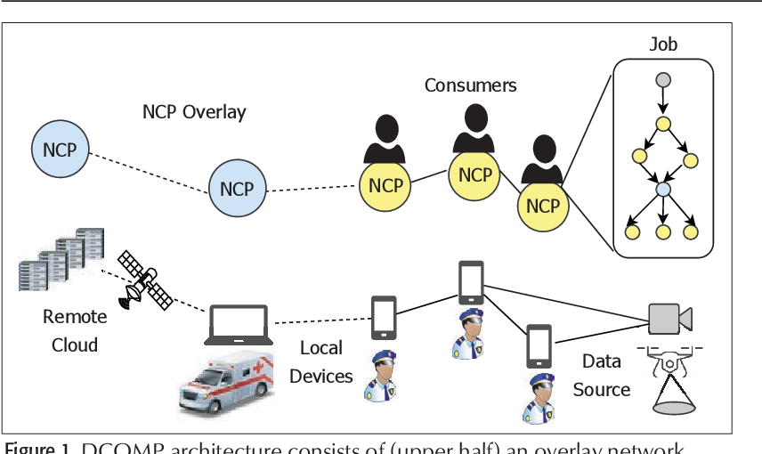

CHAPTER 4
TESTING AND IMPLEMENTATION

  - TESTING
Implementation is the stage of the project when the theoretical design is turned into a working system. This is the final and important phase in the system life cycle It is actually the process of converting the new system into a operational one.

4.1.1Unit Testing
Unit testing comprises the set of tests performed by an individual programmer prior to integration of the unit into a larger system. The module interface is tested to ensure that information properly flows into and out of the program unit. The local data structure is examined to ensure that data stored temporarily maintains its integrity during all steps in an algorithm’s execution. Boundary conditions are tested to ensure that the module operates properly at boundaries established to limit or restrict processing. All independent paths through the control structure are tested. All error-handling paths are tested.

4.1.2 Block Box Testing
Black-box testing is a method of software testing that examines the functionality of an application without peering into its internal structures or workings. This method of test can be applied virtually to every level of software testing: unit, integration, system and acceptance. It is sometimes referred to as specification-based testing.

4.2 SYSTEM IMPLEMENTATION
Implementation is the stage of the project when the theoretical design is turned into a working system. This is the final and important phase in the system life cycle It is actually the process of converting the new system into a operational one.

CHAPTER 5
CONCLUSION:
In this paper, the major challenges of energy efficiency and carbon footprints in the IoT network have been discussed and different solutions to solve these problems have been critically evaluated. Furthermore, a detailed taxonomy of methods to achieve Green IoT has been provided in this paper. Five principles have been proposed to realize the concept of Green IoT. The impact of IoT on economy is going to be paramount and it is predicted to revolutionize the entire ICT industry. The need of research for a generic architecture, recyclable material and policy making to achieve Green IoT has been highlighted. IoT can undoubtedly change the course of technological advancements in the world if focused and dedicated work is put in the right direction. The world awaits the wonders it can unfold.

CHAPTER-6
REFERENCE
- [1] C. Sun, ‘‘Application of RFID technology for logistics on Internet of Things,’’ AASRI Procedia, vol. 1, pp. 106–111, Aug. 2012.
- [2] D. Miorandi, S. Sicari, F. De Pellegrini, and I. Chlamtac, ‘‘Internet of Things: Vision, applications and research challenges,’’ Ad Hoc Netw., vol. 10, no. 7, pp. 1497–1516, Sep. 2012.
- [3] J. Chase, ‘‘The evolution of the Internet of Things,’’ Texas Instrum., Dallas, TX, USA, White Paper, Feb. 2013, p. 7.
- [4] D. Zhang, L. T. Yang, M. Chen, S. Zhao, M. Guo, and Y. Zhang, ‘‘Realtime locating systems using active RFID for Internet of Things,’’ IEEE Syst. J., vol. 10, no. 3, pp. 1226–1235, Sep. 2014.
- [5] C. Zhu, V. C. M. Leung, L. Shu, and E. C.-H. Ngai, ‘‘Green Internet of Things for smart world,’’ IEEE Access, vol. 3, pp. 2151–2162, 2015.
- [6] S. Li, L. Da Xu, and S. Zhao, ‘‘The Internet of Things: A survey,’’ Inf. Syst. Frontiers, vol. 17, no. 2, pp. 243–259, 2015.
- [7] Z. Pang, Q. Chen, W. Han, and L. Zheng, ‘‘Value-centric design of the Internet-of-Things solution for food supply chain: Value creation, sensor portfolio and information fusion,’’ Inf. Syst. Frontiers, vol. 17, no. 2, pp. 289–319, 2015.
- [8] L. Da Xu, W. He, and S. Li, ‘‘Internet of Things in industries: A survey,’’ IEEE Trans. Ind. Informat., vol. 10, no. 4, pp. 2233–2243, Nov. 2014.
- [9] A. Kiourti, C. Lee, and J. L. Volakis, ‘‘Fabrication of textile antennas and circuits with 0.1 mm precision,’’ IEEE Antennas Wireless Propag. Lett., vol. 15, pp. 151–153, 2015.
- [10] A. Caragliu, C. Del Bo, and P. Nijkamp, ‘‘Smart cities in Europe,’’ J. Urban Technol., vol. 18, no. 2, pp. 65–82, 2011.

