Blockchain-based Privacy-Preserving Driver Monitoring for MaaS in the Vehicular IoT

ABSTRACT
Driving behaviors are highly relevant to automotive statuses and on-board safety, which offer compelling shreds of evidence for mobility as a service (MaaS) providers to develop personalized rental prices and insurance products. However, the direct dissemination of driving behaviors may lead to violations of identity and location privacy. In this paper, our proposed mechanism first achieves the verifiable aggregation and immutable dissemination of performance records by exploiting a blockchain with the proof-of-stake (PoS) consensus. Moreover, to acquire a driver's aggregated performance record from the blockchain, the proposed scheme first realizes quick identification with a Bloom filter and further approaches the target performance record through an oblivious transfer (OT) protocol. A performance evaluation shows that during the acquisition of the records, the computational complexity of our scheme is only related to the scale of the records contained in one transaction. However, the computational complexity of one traditional scheme without a Bloom filter depends on the scale of the records generated during each time slot. Furthermore, the computational complexity of another traditional scheme without aggregation relies on the scale of the records contained in one transaction, as well as the length of a driver's performance history. We also investigate the trade-off between the privacy level and computational complexity, and we determine the optimal number of data records in each transaction.

CHAPTER 2
2. SYSTEM ANALYSIS
  - EXISTING SYSTEM

- The existing technologies, blockchain is the most promising one to meet these new security requirements and reshape the 5G communication landscape.
- Despite growing interest in blockchain and 5G, the focus of existing survey works is on each of the specific technologies.
- With the help of innovative blockchain designs, 5G is expected to overcome the existing challenges and open up new opportunities to empower blockchain 5G-based services and applications.
- The existing 5G technology infrastructure has remained unsolved challenges in terms of security, networking and computing performance degradation due to its centralized architecture.
2.1.1 DRAWBACKS OF EXISTING SYSTEM :
- The IoV has the potential to solve various traffic and road safety problems effectively in order to prevent fatal crashes.
- In order to overcome these challenges, this work is adapting Blockchain technology for real time application (RTA) to solve Vehicle-to-Everything (V2X) communications problems.
- These allow an AI system to learn how to solve problems that cannot be specified, or whose solution method cannot be described by symbolic reasoning rules.
- On the other hand, for the public sector MaaS services may be seen as an option to battle some of their mobility, sustainability and urban space problems.
2.2. PROPOSED SYSTEM
- To achieve these objectives, several underlying wireless technologies have been proposed to enable future 5G networks, including cloud computing, edge computing, Software Defined Networking (SDN), Network Function Virtualization (NFV), Network Slicing, and D2D communication.
- The study proposed a cloud-centric IoT framework enabled by smart contracts and blockchain for secure data provenance.
- The proposed scheme contains three tiers with an IoT sensor network, a federation of multiple clouds, and a service platform.
- Multiple SDN controllers in this proposed approach can communicate each other and interact with blockchain which enables secure information exchanges between them.
2.2.1. ADVANTAGES OF PROPOSED SYSTEM
- Algorithms can also replace human actions and decisions for individual agents in the logistics chain. It is expected that self-learning algorithms (AI) can improve decisions and therewith the performance of the logistics chain based on big data from sensors a lot.
- The main objectives of C-ITS applications are to improve traffic safety and/or transport efficiency (including reduction of congestion) and/or environmental performance.
- With a decrease of movements needed because of efficiency increase and occupancy rates, less energy is needed to reach the same performance.
- Smart agents are optimising their performance based on local information and local intelligence.
Literature Survey:
TITLE | AUTHORS | DESCRIPTION
The internet of things: A survey | Atzori, L.; Iera, A.; Morabito, G. | Main enabling factor of this promising paradigm is the integration of several technologies and communications solutions.
BlockChain: A Distributed Solution to Automotive Security and Privacy | Dorri, A.; Steger, M.; Kanhere, S.S.; Jurdak, R. | We propose a BC-based architecture to protect the privacy of the users and to increase the security of the vehicular ecosystem.
Survey on Security Attacks in Vehicular Ad hoc Networks (VANETs) | Al-kahtani, M. | Vehicular Ad hoc Networks (VANETs) are emerging mobile ad hoc network technologies incorporating mobile routing protocols for inter-vehicle data communications to support intelligent transportation systems.
An Intrusion Detection System for Connected Vehicles in Smart Cities | Aloqaily, M.; Otoum, S.; Al Ridhawi, I.; Jararweh, Y. | The framework is validated through simulations to demonstrate the effectiveness of the solution in terms of intrusion attack detection.

2.3 FEASIBILITY STUDY
The feasibility Analysis is an analytical program through project manager determines the project success ratio and through feasibility study project manager able to see either project. The key considerations involved in the feasibility analysis are:
- Economic Feasibility
- Technical Feasibility
- Operational Feasibility
- Environmental Feasibility

2.3.1 ECONOMICAL FEASIBILITY
Hence this project is economically feasible there is no need to involve any cost for this project.
2.3.2 TECHNICAL FEASIBILITY
Software Technologies used are PHP and MySql. In the educational institutions, it is possible to update the system in future. No special hardware is required for the purpose of using this system. Hence it is declared that this project is technically feasible.
2.3.3 OPERATIONAL FEASIBILITY
As the admin work mainly to maintain the Patient and Doctor .Doctor will predict patient cancer disease. Hence it is easy to operate with training. Therefore it is operationally feasible for implementation.
2.3.4 ENVIRONMENTAL FEASIBILITY
This project environment is correct as a admin has developed this system and no expenditure is involved under any head and this process is part of admin document management, this project environment is accessible.
2.4 SYSTEM REQUIREMENTS
- System : Pentium IV 2.4 GHz.
- Hard Disk : 40 GB.
- Monitor : 15 inch VGA Color.
- Mouse : Logitech Mouse.
- Ram : 512 MB
- Keyboard : Standard Keyboard
2.4.1 HARDWARE REQUIREMENTS
The Hardware of the computer consists of physical component such as Input Devices, Storage Devices, Processing & Control units and Output Devices. Computer includes external storage unit to store data in programs.
The Hardware Configuration involved in this project
- System : Pentium IV 2.4 GHz.
- Hard Disk : 40 GB.
- Monitor : 15 inch VGA Color.
- Mouse : Logitech Mouse.
- Ram : 512 MB
- Keyboard : Standard Keyboard
2.4.2 SOFTWARE REQUIREMENTS
Software is a group of programs that computers need to do a particular task. It is an essential requirement of Computer System. The Software used to develop the project is
- Operating System : Windows XP.
- Platform : DOT NET TECHNOLOGY
- Front End : ASP.Net 3.5
- Back End : SQL SERVER 2005

CHAPTER 3
SYSTEM DESIGN AND DEVELOPEMENT
SYSTEM ARCHICTURE

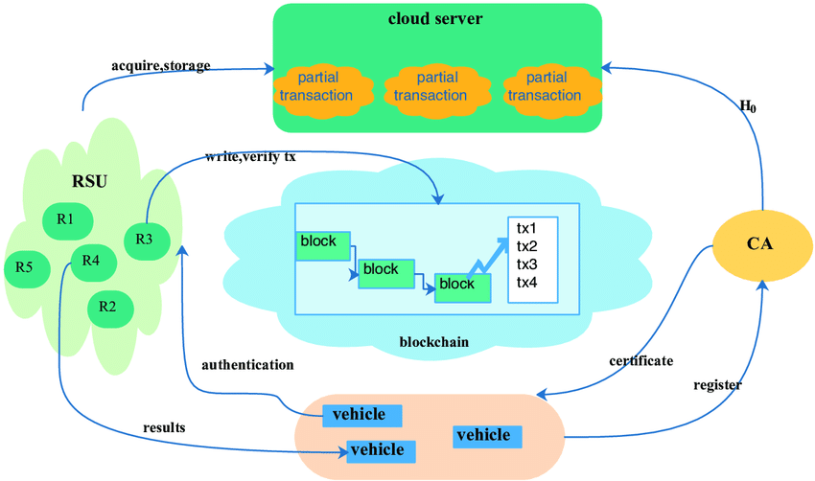

CHAPTER 4
TESTING AND IMPLEMENTATION

  - TESTING
Implementation is the stage of the project when the theoretical design is turned into a working system. This is the final and important phase in the system life cycle It is actually the process of converting the new system into a operational one.

4.1.1Unit Testing
Unit testing comprises the set of tests performed by an individual programmer prior to integration of the unit into a larger system. The module interface is tested to ensure that information properly flows into and out of the program unit. The local data structure is examined to ensure that data stored temporarily maintains its integrity during all steps in an algorithm’s execution. Boundary conditions are tested to ensure that the module operates properly at boundaries established to limit or restrict processing. All independent paths through the control structure are tested. All error-handling paths are tested.

4.1.2 Block Box Testing
Black-box testing is a method of software testing that examines the functionality of an application without peering into its internal structures or workings. This method of test can be applied virtually to every level of software testing: unit, integration, system and acceptance. It is sometimes referred to as specification-based testing.

4.2 SYSTEM IMPLEMENTATION
Implementation is the stage of the project when the theoretical design is turned into a working system. This is the final and important phase in the system life cycle It is actually the process of converting the new system into a operational one.

CHAPTER 5
CONCLUSION:
This paper introduced a new Decentralized IoT solution for Vehicles communication (DISV). It incorporates three primary layers to explore the possibility of using Blockchain for communication in the IoV. A prototype of the smart contract on the Testnet of Ethereum have been deployed. This study considered several properties of the solution, including availability, integrity, and security to test whether the Blockchain is an efficient and secure mechanism for IoV communications. The results showed that DISV can be considered as a real time application as well as a solution for the main challenges of Vehicle-to-X (V2X) communications such as security, centralization, and lack of privacy. In addition, it can facilitate the data exchange and cooperation between cars, infrastructure, and other actors of intelligent transportation systems. Moreover, DISV could be seen as an important element of the Advanced Driver Assistance Systems (ADAS) that might enhance the transportation safety and mobility. As a direction for future research, an enhanced version of DISV will be developed that includes reputation assessment system for unreliable data sources as in [58] Furthermore, a network for vehicle-based on Blockchain to allow users paying for electrical charging, parking spaces, and tolls through machine-to-machine transactions will be proposed.

CHAPTER-6
REFERENCE
- 1. Atzori, L.; Iera, A.; Morabito, G. The internet of things: A survey. Comput. Netw. 2010, 54, 2787–2805. [CrossRef]
- 2. Yang, F.; Wang, S.; Li, J.; Liu, Z.; Sun, Q. The internet of things: A survey. China Commun. 2014, 11, 1–15. [CrossRef]
- 3. Delhi: 18,000 Autos Install GPS in One Month, Deadline Extended to February 28. Available online: https://www.hindustantimes.com/delhi-news/delhi-18-000-autos-install-gps-in-one-monthdeadline-extended-to-february-28/story-xlIsXOhh94aKOxaO5wwErJ.html (accessed on 18 November 2019).
- 4. Dorri, A.; Steger, M.; Kanhere, S.S.; Jurdak, R. BlockChain: A Distributed Solution to Automotive Security and Privacy. IEEE Commun. Mag. 2017, 55, 119–125. [CrossRef]
- 5. Al-kahtani, M.. Survey on Security Attacks in Vehicular Ad hoc Networks (VANETs). In Proceedings of the the 6th International Conference on Signal Processing and Communication Systems (ICSPCS), Gold Coast, Australia, 12–14 December 2012; Volume 12–14, pp. 1–9.
- 6. Tesla Fixes Security Bugs After Claims of Model S Hack. Available online: https://www.reuters. com/article/us-tesla-cyber/tesla-fixes-security-bugs-after-claims-of-model-s-hack-idUSKCN11Q2SD (accessed on 15 January 2020).
- 7. Aloqaily, M.; Otoum, S.; Al Ridhawi, I.; Jararweh, Y. An Intrusion Detection System for Connected Vehicles in Smart Cities. Ad Hoc Networks 2019, 90, 101842. [CrossRef]
- 8. Glass, S.M.; Muthukkumarasamy, V.; Portmann, M. Detecting Man-in-the-Middle and Wormhole Attacks in Wireless Mesh Networks. In Proceedings of the the International Conference on Advanced Information Networking and Applications, Bradford, UK, 26–29 May 2009; Volume 26–29, pp. 530–538.
- 9. Controlling Vehicle Features of Nissan LEAFs across the Globe via Vulnerable APIs. Available online: https://www.troyhunt.com/controlling-vehicle-features-of-nissan/ (accessed on 15 January 2020).
- 10. Hackers Discovered It is Possible to Remotely Control Features of Mitsubishi Outlander PHEV by Hacking the Mobile Applications Designed by the Car Vendor. Available online: https://securityaffairs.co/ wordpress/48114/hacking/mitsubishi-outlander-phev-hacking.html (accessed on 15 January 2020).

