Endogenous Trusted DRL-Based Service Function Chain Orchestration for IoT

ABSTRACT
With the development of the Internet of Things, trust has become a limited factor in the integration of heterogeneous IoT networks. In this regard, we use the combination of blockchain technology and SDN/NFV to build a heterogeneous IoT network resource management model based on the consortium chain. In order to solve the efficiency problem caused by the full amount of data on the chain, we deploy light nodes and full nodes for the consortium chain. At the same time, we use the idea of identification to realize the separation of identification and resource information, build the application mode of on-chain identification and off-chain information, and realize resources endogenous trust management. We also propose a practical Byzantine fault-tolerant consensus mechanism based on reputation value to save consensus costs and improve efficiency. Combined with artificial intelligence technology, we introduce deep reinforcement learning for service function chain orchestration, and design a service function chain orchestration algorithm based on Asynchronous Advantage Actor-Critic to optimize orchestration costs. The final simulation results show that the consensus algorithm and service function chain orchestration algorithm we designed have good performance in terms of cost saving and efficiency improvement.

CHAPTER 2
2. SYSTEM ANALYSIS
  - EXISTING SYSTEM

- THz based communications require rethinking of existing solutions and investigate novel approaches that offer a seamless operation over the entire THz band.
- Various shortcomings in existing wireless communications has led to the foundation for the next generations. This paper provides a detailed survey on 6g wireless network.
- Upcoming technologies such as artificial intelligence (AI), virtual reality, and the Internet of Everything (IOE) require low latency, ultrahigh data rates and reliability, for the uplink and downlink which cannot be satisfied by existing 5G‟s ubiquitous mobile ultra-broadband, ultrahigh-speedwith-low latency communications, and ultrahigh data density.
2.1.1 DRAWBACKS OF EXISTING SYSTEM :
- In order to overcome the interference problem, inter-cell cooperation has been studied in LTE under the name of coordinated multi-point (CoMP) transmissions or network MIMO.
- The main problem is that while globally optimal policies are known and can be computed in principle (see, e.g.,for the max-min fairness policy), these policies do not scale neither in performance nor computationally.
- In symbiotic radio networks, the user association problem can be solved with limited environmental information using DRL.
- UAV communications involve some security and privacy problems such as eavesdropping and jamming. These problems may pose threats to personal information, so it needs to be comprehensively investigated.
2.2. PROPOSED SYSTEM
- In the framework of PoX, enormous alternative mechanisms have been proposed in terms of cost, eco-friendliness, fairness and performance.
- Fast smart contract deployment (FSCD) is an advanced mechanism proposed for accelerating and securing the service in B-RAN .
- By implementing the concept of template in smart contracts, the root contract in FSCD defines the service terms in detail, which is later automatically applied to all services.
- In order to implement the proposed design and better test its performance, we assess the basic capability needs in B-RAN and construct a corresponding prototype.

2.2.1. ADVANTAGES OF PROPOSED SYSTEM
- The key contribution of their study is to demonstrate how the presence of foveated rendering can improve the rendering performance by reducing the field of view.
- It is necessary to optimize the performance of the cloud rendering pipeline.
- The future C-V2X architecture should support the deterministic transmission, in additional to the enhanced performance of latency, reliability, and throughput. Synchronization is the premise.
- These new technologies not only provide enhanced transmission performance, but also provide positioning, sensing, and 3D imaging capabilities.
- Iterative processing is used in the SCC decoder, and a performance similar to that of a classic PCC may be achieved.
Literature Survey:
TITLE | AUTHORS | DESCRIPTION
Cellular architecture and key technologies for 5G wireless communication networks | Wang C X, Haider F, Gao X Q, et al. | The fourth generation wireless communication systems have been deployed or are soon to be deployed in many countries.
The tactile Internet: applications and challenges | Fettweis G P. | Wireless communications today enables us to connect devices and people for an unprecedented exchange of multimedia and data content.
A vision of 6G wireless systems: applications, trends, technologies, and open research problems | Saad W, Bennis M, Chen M. | We then identify the enabling technologies for the introduced 6G services and outline a comprehensive research agenda that leverages those technologies.
6G technologies: key drivers, core requirements, system architectures, and enabling technologies | Zong B Q, Fan C, Wang X Y, et al. | The key drivers of 6G result not only from the challenges and performance limits that 5G presents but also from the technology-driven paradigm shift and the continuous evolution of wireless networks.

2.3 FEASIBILITY STUDY
The feasibility Analysis is an analytical program through project manager determines the project success ratio and through feasibility study project manager able to see either project. The key considerations involved in the feasibility analysis are:
- Economic Feasibility
- Technical Feasibility
- Operational Feasibility
- Environmental Feasibility
2.3.1 ECONOMICAL FEASIBILITY
Hence this project is economically feasible there is no need to involve any cost for this project.
2.3.2 TECHNICAL FEASIBILITY
Software Technologies used are PHP and MySql. In the educational institutions, it is possible to update the system in future. No special hardware is required for the purpose of using this system. Hence it is declared that this project is technically feasible.
2.3.3 OPERATIONAL FEASIBILITY
As the admin work mainly to maintain the Patient and Doctor .Doctor will predict patient cancer disease. Hence it is easy to operate with training. Therefore it is operationally feasible for implementation.
2.3.4 ENVIRONMENTAL FEASIBILITY
This project environment is correct as a admin has developed this system and no expenditure is involved under any head and this process is part of admin document management, this project environment is accessible.

2.4 SYSTEM REQUIREMENTS
- System : Pentium IV 2.4 GHz.
- Hard Disk : 40 GB.
- Monitor : 15 inch VGA Color.
- Mouse : Logitech Mouse.
- Ram : 512 MB
- Keyboard : Standard Keyboard

2.4.1 HARDWARE REQUIREMENTS
The Hardware of the computer consists of physical component such as Input Devices, Storage Devices, Processing & Control units and Output Devices. Computer includes external storage unit to store data in programs.
The Hardware Configuration involved in this project
- System : Pentium IV 2.4 GHz.
- Hard Disk : 40 GB.
- Monitor : 15 inch VGA Color.
- Mouse : Logitech Mouse.
- Ram : 512 MB
- Keyboard : Standard Keyboard

2.4.2 SOFTWARE REQUIREMENTS
Software is a group of programs that computers need to do a particular task. It is an essential requirement of Computer System. The Software used to develop the project is
- Operating System : Windows XP.
- Platform : DOT NET TECHNOLOGY
- Front End : ASP.Net 3.5
- Back End : SQL SERVER 2005

CHAPTER 3
SYSTEM DESIGN AND DEVELOPEMENT
SYSTEM ARCHICTURE

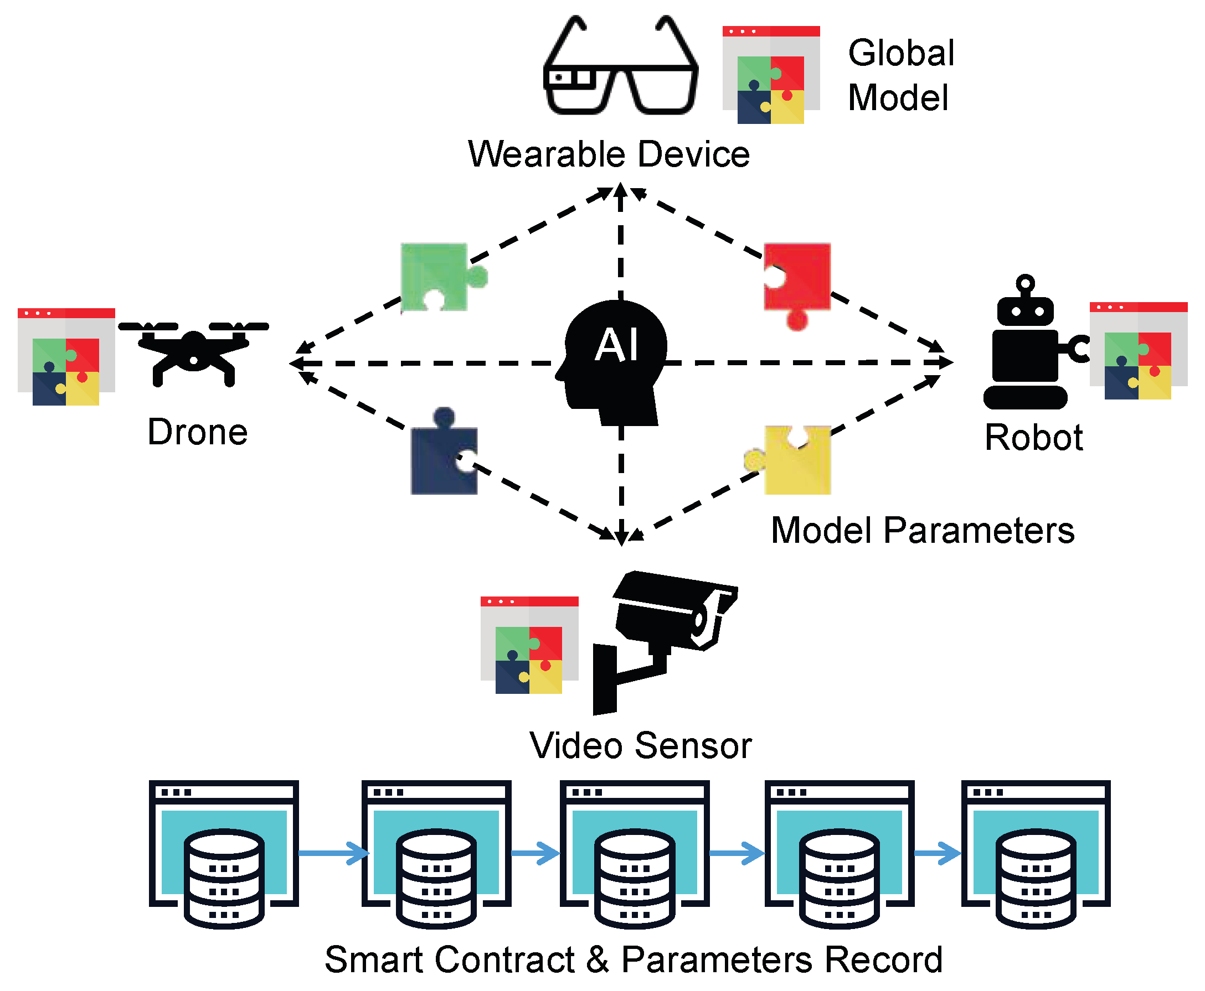

CHAPTER 4
TESTING AND IMPLEMENTATION

  - TESTING
Implementation is the stage of the project when the theoretical design is turned into a working system. This is the final and important phase in the system life cycle It is actually the process of converting the new system into a operational one.

4.1.1Unit Testing
Unit testing comprises the set of tests performed by an individual programmer prior to integration of the unit into a larger system. The module interface is tested to ensure that information properly flows into and out of the program unit. The local data structure is examined to ensure that data stored temporarily maintains its integrity during all steps in an algorithm’s execution. Boundary conditions are tested to ensure that the module operates properly at boundaries established to limit or restrict processing. All independent paths through the control structure are tested. All error-handling paths are tested.

4.1.2 Block Box Testing
Black-box testing is a method of software testing that examines the functionality of an application without peering into its internal structures or workings. This method of test can be applied virtually to every level of software testing: unit, integration, system and acceptance. It is sometimes referred to as specification-based testing.

4.2 SYSTEM IMPLEMENTATION
Implementation is the stage of the project when the theoretical design is turned into a working system. This is the final and important phase in the system life cycle It is actually the process of converting the new system into a operational one.

CHAPTER 5
CONCLUSION:
In this comprehensive survey review, a vision, enabling technologies, four new paradigm shifts, and future research directions of 6G wireless communication networks have been proposed, after having pointed out the limitations of current 5G wireless communication networks. New performance metrics and application scenarios of 6G have been introduced, e.g., to provide global coverage, enhanced spectral/energy/cost efficiency, better intelligence level, security and resilience, etc. In addition, example industry verticals of 6G wireless communication networks have been given, with cloud VR, IoT industry automation, CV2X, digital twin body area network, and energy efficient wireless network control and federated learning systems as illustrations. The enabling technologies to meet the 6G requirements have been provided. Novel air interface and transmission technologies have been investigated, such as new waveforms, multiple access, channel coding, CF massive MIMO, dynamic and intelligent spectrum sharing and accessing, blockchain-based wireless accessing and networking, photonics defined radio, and MCo for uRLLC. Also, novel network architectures have been studied, including SDN/NFV, network slicing, SBA, CSA, DEN2 , CF, and cloud/fog/edge computing. The four new paradigm shifts, i.e., global coverage (satellite, UAV, terrestrial, maritime communications), all spectra (sub-6 GHz, mmWave, THz, optical frequency bands), full applications (AI-enabled wireless communications), and strong network security, have been proposed to achieve a fully integrated 6G network. Future research directions have also been pointed out in each part. We believe that this survey review can provide academic researchers and industry experts with sufficient insightful thoughts on the developments of future 6G wireless communication networks.

CHAPTER-6
REFERENCE
- 1 Wang C X, Haider F, Gao X Q, et al. Cellular architecture and key technologies for 5G wireless communication networks. IEEE Commun Mag, 2014, 52: 122–130
- 2 Fettweis G P. The tactile Internet: applications and challenges. IEEE Veh Technol Mag, 2014, 9: 64–70
- 3 Saad W, Bennis M, Chen M. A vision of 6G wireless systems: applications, trends, technologies, and open research problems. IEEE Netw, 2020, 34: 134–142
- 4 Zong B Q, Fan C, Wang X Y, et al. 6G technologies: key drivers, core requirements, system architectures, and enabling technologies. IEEE Veh Technol Mag, 2019, 14: 18–27
- 5 Dang S, Amin O, Shihada B, et al. From a human-centric perspective: what might 6G be. https://arxiv.org/pdf/1906. 00741.pdf
- 6 ITU-R M.2083 report. IMT vision–framework and overall objectives of the future development of IMT for 2020 and beyond. https://www.itu.int/rec/R-REC-M.2083-0-201509-I/en
- 7 Chen S Z, Liang Y C, Sun S H, et al. Vision, requirements, and technology trend of 6G: how to tackle the challenges of system coverage, capacity, user data-rate and movement speed. IEEE Wirel Commun, 2020, 27: 218–228
- 8 Zhang Z Q, Xiao Y, Ma Z, et al. 6G wireless networks: vision, requirements, architecture, and key technologies. IEEE Veh Technol Mag, 2019, 14: 28–41
- 9 Yang P, Xiao Y, Xiao M, et al. 6G wireless communications: vision and potential techniques. IEEE Netw, 2019, 33: 70–75
- 10 Zhang L, Liang Y C, Niyato D. 6G visions: mobile ultra-broadband, super internet-of-things, and artificial intelligence. China Commun, 2019, 16: 1–14

