EIHDP Edge-Intelligent Hierarchical Dynamic Pricing Based on Cloud-Edge-Client Collaboration for IoT Systems

ABSTRACT
Nowadays, IoT systems can better satisfy the service requirements of users with effectively utilizing edge computing resources. Designing an appropriate pricing scheme is critical for users to obtain the optimal computing resources at a reasonable price and for service providers to maximize profits. This problem is complicated with incomplete information. The state-of-the-art solutions focus on the pricing game between a single service provider and users, which ignores the competition among multiple edge service providers. For this challenge, we design an edge-intelligent hierarchical dynamic pricing mechanism based on cloud-edge-client collaboration. We describe an improved double-layer Stackelberg game model. Technically, we propose a novel pricing prediction algorithm based on double-label Radius K-nearest Neighbors, which reduces the number of invalid games to accelerate the game convergence. The experimental results show that our proposed mechanism effectively improves the quality of service for users and realizes the maximum benefit equilibrium for service providers, compared with the traditional pricing scheme. Our proposed mechanism is highly suitable for the IoT applications (e.g., intelligent agriculture or Internet of Vehicles), where there are multiple competing edge service providers for resource allocation.

CHAPTER 2
2. SYSTEM ANALYSIS
  - EXISTING SYSTEM

- The Internet of Things (IoT) has pervaded our daily life by making things interconnected through the Internet smarter, distributed and more autonomous.
- In, the authors proposed a simple, robust, efficient, scalable, and heterogeneous multi-tenant database architecture for the ad-hoc cloud to allow various organizations to collaborate and create a common cloud platform without harming their existence or profitability.
- As one can see, the existing works focus only on the combination of fog and cloud platforms in term of the communication network (e.g., low latency) and management of F2C resources.
- As with any emerging technology, the promising advancements are also accompanied with numerous challenges that are not yet well summarized in the existing literature.
2.1.1 DRAWBACKS OF EXISTING SYSTEM :
- In the followup research, because of the above problems, there can be a clearer research plan: combining the existing knowledge graph research results, in the process of knowledge extraction, the existing sample data information is transformed into a semantic model and a knowledge graph.
- Although the above literature has made certain research on edge computing and knowledge sharing, there are still some problems: (1) In the traditional cloud edge structure, the cloud carries more computing and control tasks.
- Once recorded, the order is issued directly to the manufacturing resource edge, generating the control flow related to the processing task.
- Once a similar action sample set Cl is found, the knowledge reuse impact is evaluated on qualified samples.
2.2. PROPOSED SYSTEM
- Due to the utilization of a massive number of mobile devices in our daily life, the researchers have proposed building cloud infrastructure by integrating many mobile devices that could act simultaneously as customers and providers of services.
- In, an IoT-Based computational framework for healthcare has been proposed to monitor human activities involving physical effort.
- In this work, the quality of the service and the mobility of IoT devices or the fog nodes are, however, not discussed, since the proposed solution operates inside a single fog domain.
- In, the authors have proposed a cloud-aware framework based on mobile edge features for designing elastic mobile applications.
2.2.1. ADVANTAGES OF PROPOSED SYSTEM
- The manufacturing production line’s efficiency is reflected in the multi-task collaborative production and dynamic production line reconfiguration.
- Intelligent manufacturing’s physical resources include equipment used in a series of intermediate processes such as product processing, packaging, and transportation.
- The attributes used include the equipment’s name, number, physical size, capabilities, and the processing operations that can be performed.
- The actions are defined for each manufacturing station, and the action primitives are used for processing.
- Each new processing task is decomposed and refined, and the original action primitive combination is used to reuse the original manufacturing resource knowledge.
Literature Survey:
TITLE | AUTHORS | DESCRIPTION
Internet of Things: A Survey on Enabling Technologies, Protocols, and Applications | Al-Fuqaha, A.I.; Guizani, M.; Mohammadi, M.; Aledhari, M.; Ayyash, M. | This paper provides an overview of the Internet of Things (IoT) with emphasis on enabling technologies, protocols, and application issues.
The internet of things: A survey | Atzori, L.; Iera, A.; Morabito, G. | Main enabling factor of this promising paradigm is the integration of several technologies and communications solutions.
Artificial Intelligence for Cloud-Assisted Smart Factory | Wan, J.; Yang, J.; Wang, Z.; Hua, Q. | The application of the AI in smart factories has accelerated the implementation of the Industry 4.0 to the certain extent.
Cloud computing: Issues and challenges | Dillon, T.; Wu, C.; Chang, E. | It reduces the overheads of up-front investments and financial risks for the end-user.

2.3 FEASIBILITY STUDY
The feasibility Analysis is an analytical program through project manager determines the project success ratio and through feasibility study project manager able to see either project. The key considerations involved in the feasibility analysis are:
- Economic Feasibility
- Technical Feasibility
- Operational Feasibility
- Environmental Feasibility
2.3.1 ECONOMICAL FEASIBILITY
Hence this project is economically feasible there is no need to involve any cost for this project.
2.3.2 TECHNICAL FEASIBILITY
Software Technologies used are PHP and MySql. In the educational institutions, it is possible to update the system in future. No special hardware is required for the purpose of using this system. Hence it is declared that this project is technically feasible.
2.3.3 OPERATIONAL FEASIBILITY
As the admin work mainly to maintain the Patient and Doctor .Doctor will predict patient cancer disease. Hence it is easy to operate with training. Therefore it is operationally feasible for implementation.
2.3.4 ENVIRONMENTAL FEASIBILITY
This project environment is correct as a admin has developed this system and no expenditure is involved under any head and this process is part of admin document management, this project environment is accessible.
2.4 SYSTEM REQUIREMENTS
- System : Pentium IV 2.4 GHz.
- Hard Disk : 40 GB.
- Monitor : 15 inch VGA Color.
- Mouse : Logitech Mouse.
- Ram : 512 MB
- Keyboard : Standard Keyboard
2.4.1 HARDWARE REQUIREMENTS
The Hardware of the computer consists of physical component such as Input Devices, Storage Devices, Processing & Control units and Output Devices. Computer includes external storage unit to store data in programs.
The Hardware Configuration involved in this project
- System : Pentium IV 2.4 GHz.
- Hard Disk : 40 GB.
- Monitor : 15 inch VGA Color.
- Mouse : Logitech Mouse.
- Ram : 512 MB
- Keyboard : Standard Keyboard
2.4.2 SOFTWARE REQUIREMENTS
Software is a group of programs that computers need to do a particular task. It is an essential requirement of Computer System. The Software used to develop the project is
- Operating System : Windows XP.
- Platform : DOT NET TECHNOLOGY
- Front End : ASP.Net 3.5
- Back End : SQL SERVER 2005

CHAPTER 3
SYSTEM DESIGN AND DEVELOPEMENT
SYSTEM ARCHICTURE

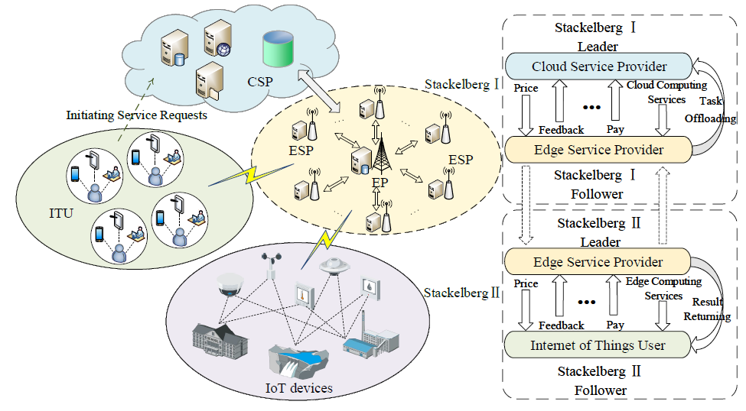

CHAPTER 4
TESTING AND IMPLEMENTATION

  - TESTING
Implementation is the stage of the project when the theoretical design is turned into a working system. This is the final and important phase in the system life cycle It is actually the process of converting the new system into a operational one.

4.1.1Unit Testing
Unit testing comprises the set of tests performed by an individual programmer prior to integration of the unit into a larger system. The module interface is tested to ensure that information properly flows into and out of the program unit. The local data structure is examined to ensure that data stored temporarily maintains its integrity during all steps in an algorithm’s execution. Boundary conditions are tested to ensure that the module operates properly at boundaries established to limit or restrict processing. All independent paths through the control structure are tested. All error-handling paths are tested.

4.1.2 Block Box Testing
Black-box testing is a method of software testing that examines the functionality of an application without peering into its internal structures or workings. This method of test can be applied virtually to every level of software testing: unit, integration, system and acceptance. It is sometimes referred to as specification-based testing.

4.2 SYSTEM IMPLEMENTATION
Implementation is the stage of the project when the theoretical design is turned into a working system. This is the final and important phase in the system life cycle It is actually the process of converting the new system into a operational one.

CHAPTER 5
CONCLUSION:
In the face of the current growing demand for personalized customization in the manufacturing field, the importance of dynamic reconfiguration of production lines is becoming more and more important. To solve the problem of knowledge reuse of manufacturing re-source processing experience in the production process, this paper builds on the existing cloud-edge collaboration architecture and deploys services for manufacturing process tasks on the edge side, reducing the system’s dependence on the cloud; the task decomposition scheme makes knowledge reuse granular and enhances the versatility of knowledge; the knowledge matching algorithm has high accuracy and can well meet the needs of the existing manufacturing environment. In the case study, we manually configure part of the equipment on the production line to achieve the effect of learning sample input. After the knowledge extraction is completed on the edge side, the knowledge is learned and reused according to the requirements of each equipment processing task. The experimental results selected two groups of control groups for comparison. The experimental results well prove the effectiveness of our proposed scheme and reflect the accuracy of the learning process through the action reduction degree, and through the learning between different tasks, it reflects the improvement of the generality of knowledge by task decomposition.

CHAPTER-6
REFERENCE
- 1. Al-Fuqaha, A.I.; Guizani, M.; Mohammadi, M.; Aledhari, M.; Ayyash, M. Internet of Things: A Survey on Enabling Technologies, Protocols, and Applications. IEEE Commun. Surv. Tutor. 2015, 17, 2347–2376. [CrossRef]
- 2. Atzori, L.; Iera, A.; Morabito, G. The internet of things: A survey. Comput. Netw. 2010, 54, 2787–2805. [CrossRef]
- 3. Wan, J.; Yang, J.; Wang, Z.; Hua, Q. Artificial Intelligence for Cloud-Assisted Smart Factory. IEEE Access 2018, 6, 55419–55430. [CrossRef]
- 4. Dillon, T.; Wu, C.; Chang, E. Cloud computing: Issues and challenges. In Proceedings of the 2010 24th IEEE International Conference on Advanced Information Networking and Applications, Perth, WA, Australia, 20–23 April 2010; pp. 27–33.
- 5. Shi, W.; Cao, J.; Zhang, Q.; Li, Y.; Xu, L. Edge Computing: Vision and Challenges. IEEE Internet Things J. 2016, 3, 637–646. [CrossRef]
- 6. Salman, O.; Elhajj, I.; Kayssi, A.I.; Chehab, A. Edge computing enabling the Internet of Things. In Proceedings of the 2015 IEEE 2nd World Forum on Internet of Things (WF-IoT), Milan, Italy, 14–16 December 2015; Institute of Electrical and Electronics Engineers (IEEE): Greenvile, SC, USA, 2015; pp. 603–608.
- 7. Wan, J.; Li, X.; Dai, H.-N.; Kusiak, A.; Martinez-Garcia, M.; Li, D. Artificial-Intelligence-Driven Customized Manufacturing Factory: Key Technologies, Applications, and Challenges. Proc. IEEE 2021, 109, 377–398. [CrossRef]
- 8. Suganuma, T.; Oide, T.; Kitagami, S.; Sugawara, K.; Shiratori, N. Multiagent-Based Flexible Edge Computing Architecture for IoT. IEEE Netw. 2018, 32, 16–23. [CrossRef]
- 9. Jiang, C.; Wan, J. A Thing-Edge-Cloud Collaborative Computing Decision-Making Method for Personalized Customization Production. IEEE Access 2021, 9, 10962–10973. [CrossRef]
- 10. Surbier, L.N.; Alpan, G.l.N.; Blanco, E. A comparative study on production ramp-up: State-of-the-art and new challenges. Prod. Plan. Control 2014, 25, 1264–1286. [CrossRef]

