An Efficient Data Security in Medical Report using Block Chain Technology
Abstract:
- The health care services industry is always showing signs of change and supporting new advancements and advances. One of the predominant requirements in today's health care systems is to protect the patient's medical report against potential attackers. Hence, it is basic to have secure information that can just approve people can get to the patient's medical report. So, We have proposed Block chain technology as a disbursed approach to grant security in accessing the medical report of a patient. It's composed of three 1. Authentication, 2. Encryption and 3. Data Retrieval using Block Chain technology. For authentication - Quantum Cryptography, for Encryption - AES and for Data Retrieval - SHA algorithms are used to resist the frequent attacks. This proposed framework may likewise ensure the protection of the patients and moreover keeps up the security and trustworthiness of the health care system.

Existing System:
- The existing systems are poor in processing large volumes of multi-structured healthcare data with less security using AES Algorithum and not providing accurate health recommendation data.

Disadvantage of Existing System :
- Problem transformation method ﬁrst transforms one multilabel dataset into multiple single-label datasets, and then exploits existing single-label learning algorithm to process each single-label dataset.

PROPOSED SYSTEM :
- The main aim of this research is to provide secure management in accessing the medical records using block chain technology by unique identification of the data security.
- Using Block Chain Crypto System Algorithm the laboratory test data and basic information of patients are Encrypted.
- The clinical dataset is an information system that offers knowledge and personalized information to users in enhancing health and healthcare outcomes .

ADVANTAGE:
- Using Crypto System the data of each patient are secured with crypto currency encryption process.
- A novel framework is proposed for retrieving the most relevant information of patients from multiple data sources,.
- such as laboratory test data, basic information of patients, symptoms of patients and electrocardiogram data, and for combining them to generate integrated features.
SYSTEM ARCHITECTURE :
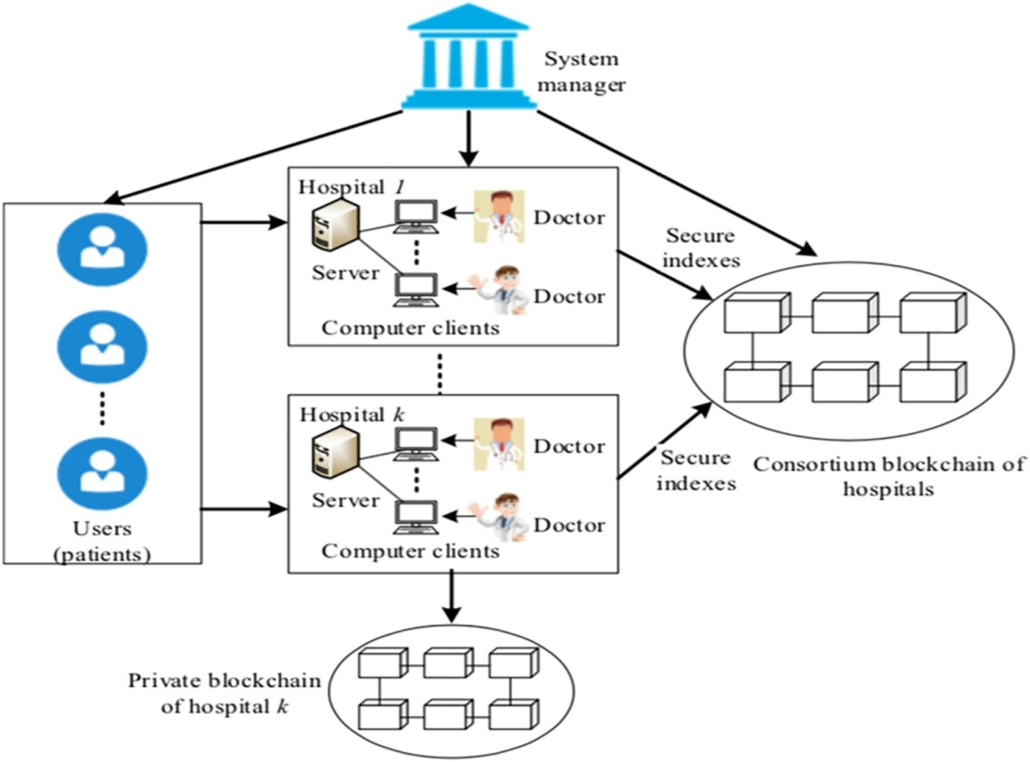

MODULES
- Register and Login
- Health Care Data
- Block Chain Crypto System Algorithm
- Recommend Diagnosis Analyze

Register and Login
- Register as user by providing first name, last name, user name and password, etc..
- Login Using User Name and Pasword .

Health Care Data
- Patient health care data like height, weight, blood pressure, temperature, heart beat rate , Diseases Symptoms will be given as input.
- Considering the likely complications due to multiple medical diseases (conditions), Crypto system algorithm is proposed for multi-label learning, by using correlations among labels dataset and for anticipating more potential diseases of a patient, so that a list of diseases can be recommended to the physician simultaneously.

Block Chain Crypto System Algorithm
- Using Block chain Algorithm data of each patient will be Encrypted Based on Cryptographic technique.
- Encrypted data from database is shown to appropriate doctor and patient with decrypted format.
Recommend Diagnosis Analyze
- Using Pattern matching we have do string matching with disease dataset then the finalized analyzing disease status will be updated .
- Comparing the results of testing items with the reference ranges of those items to identify the abnormal items and quantify the levels of their abnormality.

INTRODUCTION :
IN THE era of fourth revolution of industry (Industry 4.0), the associated services (smart services) develop rapidly [1]. In this context, Health 4.0 has been growing as a vital strategic concept for health domain, which is aimed at providing realtime and personalized health services (called smart healthcare services) for patients and professionals [2]. Health data from numerous medical sources (Cyber-Physical Systems, the Internet of Things) is collected continuously, facilitating the growth of healthcare industry [3]. It is widely accepted that health information tools and ma- chine learning techniques can be exploited successfully to help doctors in diagnosing and treating their patients more efﬁciently [4]. Using their experience and knowledge, the physicians classify patients and diagnose their diseases, but in doing so, it is probable that they commit some mistakes, particularly when they lack adequate experience or when their faculty of judgment is poor. In such situations, Block Chain Cryptography Technique systems, including systems that provide diagnosis, personalized medical measurement, treatment and relevant knowledge, would be helpful to the physicians by way of providing them with speciﬁc knowledge, patients’ information and intelligent applications, which can improve the efﬁciency of their decision-making processes [5]. Block Chain focus on extracting characteristics of patients, based on which they classify patients and provide corresponding clinical suggestions to the physicians. Patients’ medical information is extracted from their personal medical data, such as the physiological data, electronic health records (EHRs), 3D images, radiology images, genomic sequencing, and clinical and billing data. Through CDS applications, the physicians can avoid the mistakes that are likely to arise from medical negligence and thus improve the quality of their medical service. In the medical ﬁeld, the demand for high-quality clinical support systems has been steadily on the increase [6]. In medical scenes, the speciﬁes of scoring standards and the context complexity of medical ﬁeld are the challenges of Block Chain Cryptography Technique system.
The remainder of the paper is organized as follows. Section II presents some related works about Block Chain Cryptography Technique systems and multi-label learning algorithms. We describe methods in Section III, and the analysis of the correlations in the health data is given in Section IV. In Section V, the paper introduces the model validation. Finally, Section VI concludes the paper and gives an outlook on future works.
Implementation :
Big data has ﬁve attributes: Volume, Velocity, Variety, Value and Veracity [14]. The number of visiting patients in a general hospital is generally large. For example, Haikou peoples’ hospital had received 46,000 inpatients and 95,000 outpatients approximately last year. The health medical data of such a large number of patients would obviously be of peta or zeta bytes, and this refers to the Volume of Big data. The patient’s information will be updated as soon as he/she visits the hospital again, and this represents the Velocity of health medical data. The health medical data consists of structured, semi-structured and unstructured data. Moreover, the health medical data is of different categories: electronic health medical records written by physicians; data from real-time monitors; images collected by computed tomography (CT); nuclear magnetic resonance images (MRI); cardiac angiographs etc. Each patient’s medical records from professional physicians and medical instruments reﬂect his/her real physical condition, which represent the Veracity of health medical data. Furthermore, the amenabil- ity of the collected health data for transformation into useful and meaningful knowledge, which represents the Value of the data. Therefore, health medical data is a kind of “Big data” to some extent.
Literature Review :
The search of the three databases provided a total of 117 rec- ords after removing duplicates. Also 11 studies from other sources were considered for review. After screening by title and abstract 75 were discarded for not accomplishing criteria, 53 were selected as relevant for full text review. Of the 53 selected for full-text examination 41 remained to be included in the synthesis and 12 were discarded as they did not comply with the eligibility criteria. features to enable syntactic interoperability while others en- hanced those features to share information at a semantic level. Of the 41 papers reviewed 22% (n=9) described the applica- tion of medical logic and guidelines representation standards (e.g. GLIF, Arden Syntax etc.); 63% (n=26) described the use of clinical information standards such as HL7 CDA, HL7 RIM, OpenEHR or HL7 VMR; 32% (n=13) employed seman- tic web technologies such as ontologies; 46% (n=19) outlined the use of standard terminologies; and 32% (n=13) reported the use of web services to offer CDS functionalities. Table 1 presents the mechanisms used to enable interoperability in the studies reviewed. It is important to notice that those categories are not disjoint but complementary.
Thus a particular study may pertain to several of them. Currently, several information architecture standards exist for the documentation and exchange of EHR extracts. Several works propose their use to specify the interface to interact with the CDS system. Thus, the logic references a standard infor- mation model rather than a proprietary data schema. This alle- viates the ‘curly braces’ problem Preparing the data specified in standards such as CDA or RIM to be used by the decision logic is challenging as a conse- quence of the impedance mismatch between the information model and the inference model. Works to map the RIM VMR to the guideline specification can be found in Peleg et al. [4]. Specifically, they use a mapping ontology (KDOM) to create the abstract concepts required by the logic from the fine grained information contained in the RIM-based VMR. To solve this problem in CDA-based VMRs, Saez et al. [22] pro- posed to use a wrapper in order to link CDA documents to the CDS rules. Although both RIM and CDA can be used as in- formation models to build a VMR, they are complex and too detailed for the requirements of a CDS data schema. Kawamo- to et al. studied the requirements to create a CDS specific in- formation standard to build VMRs based on a simplification.
ANALYSIS OF HEALTH DATA :
Health Medical Data :
The authors analyzed laboratory test data and some health medical records of a randomly selected patient, which were collected by a local hospital from 18th May to 18th October. Laboratory test data was stored in the databases in a structured format, while basic information, medical history and symptoms of the patient were recorded in an unstructured format. The Natural Language processing technology was exploited to extract

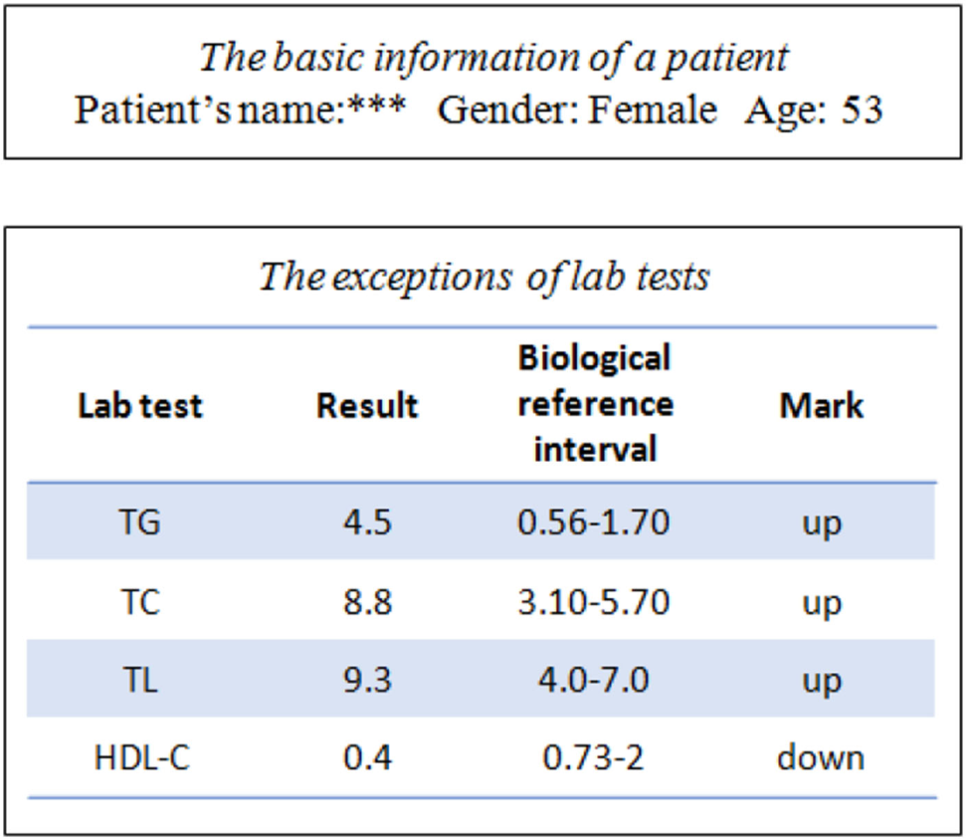
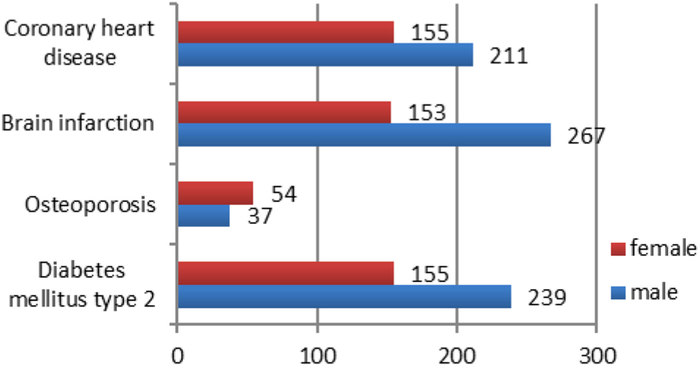
basic information of each patient from medical health records and to diagnose his or her disease [46]. After processing the medical health records, 9 common diseases were selected to analyze.
Correlation Between Information and Diseases :
1) Laboratory Test Data: Apatient, who was diagnosed with hyperlipidemia, was selected from the health medical database. This patient’s exceptions of laboratory test results and basic information are listed in Fig. 4. This patient is a female and 53 years old, and her condition reﬂects the fact that the inci-dence of hyperlipidemia is higher in menopausal women [47]. Triglyceride (TG), Total Cholesterol (TC), Total Lipids (TL) and High Density Lipoprotein Cholesterol (HDL-C) are shown as the exceptions of her lab tests. In the patients with hyperlipidemia, the results of TG, TC and TL are usually higher than their biological reference intervals, whereas the result of HDL-C is lower [48]. Hence, physicians require laboratory test results to diagnose some diseases.

2) Gender: Fig. 5 shows the number of patients, in terms of gender, suffering from coronary heart disease, brain infarction, fatty liver and diabetes mellitus type 2. For coronary heart disease, diabetes mellitus type 2 and brain infraction, the numbers of males are higher than those of females. The number of men who drink and/or smoke is much higher than that of women who drink and/or smoke. Therefore, men are more prone to be affected by these illnesses. However, the number of males with osteoporosis is smaller than that of females, because osteoporo- sis is more common in women than in men [49]. These statistics illustrate that some diseases are correlative with gender.
ASP .NET

ASP.NET is an open-source server-side web application framework designed for web development to produce dynamic web pages. It was developed by Microsoft to allow programmers to build dynamic web sites, web applications and web services.

It was first released in January 2002 with version 1.0 of the .NET Framework, and is the successor to Microsoft's Active Server Pages(ASP) technology. ASP.NET is built on the Common Language Runtime (CLR), allowing programmers to write ASP.NET code using any supported .NET language. The ASP.NET SOAP extension framework allows ASP.NET components to process SOAP messages.

ASP.NET's successor is ASP.NET Core. It is a re-implementation of ASP.NET as a modular web framework, together with other frameworks like Entity Framework. The new framework uses the new open-source .NET Compiler Platform (codename "Roslyn") and is cross platform. ASP.NET MVC, ASP.NET Web API, and ASP.NET Web Pages (a platform using only Razor pages) have merged into a unified MVC 6.

CHARACTERISTICS

ASP.NET Web pages, known officially as Web Forms, are the main building blocks for application development in ASP.NET. There are two basic methodologies for Web Forms, a web application format and a web site format. Web applications need to be compiled before deployment, while web sites structures allows the user to copy the files directly to the server without prior compilation. Web forms are contained in files with a ".aspx" extension; these files typically contain static (X)HTML markup or component markup. The component markup can include server-side Web Controls and User Controls that have been defined in the framework or the web page. For example, a textbox component can be defined on a page as <asp:textbox id='myid' runat='server'>, which is rendered into a html input box. Additionally, dynamic code, which runs on the server, can be placed in a page within a block <% -- dynamic code -- %>, which is similar to other Web development technologies such as PHP, JSP, and ASP. With ASP.NET Framework 2.0, Microsoft introduced a new code-behind model that lets static text remain on the .aspx page, while dynamic code remains in an .aspx.vb or .aspx.cs or .aspx.fs file (depending on the programming language used).

Developers need to be wary of storing sensitive or private information in the View state of a page or control, as the base64 string containing the view state data can easily be de-serialized. By default, View state does not encrypt the __VIEWSTATE value. Encryption can be enabled on a server-wide (and server-specific) basis, allowing for a certain level of security to be maintained.

CLOUD COMPUTING
Simply put, cloud computing is the delivery of computing services—servers, storage, databases, networking, software, analytics and more—over the Internet (“the cloud”). Companies offering these computing services are called cloud providers and typically charge for cloud computing services based on usage, similar to how you are billed for water or electricity at home.

Types of cloud services:
Most cloud computing services fall into three broad categories: infrastructure as a service (IaaS), platform as a service (PaaS) and software as a service (Saas). These are sometimes called the cloud computing stack, because they build on top of one another. Knowing what they are and how they are different makes it easier to accomplish your business goals.

Conclusions :

The block chain technology is gaining signiﬁcant attention from individuals, as well as organizations of nearly all kinds and dimensions. It is capable of transforming the traditional industry with its features, which include decentralization, anonymity, persistency, and auditability. The block chain technology is expected to reshape the healthcare ecosystem. Not only the process will be transparent and secure, but also the quality of healthcare will be increased at a lower cost. In this paper, we discussed various block chain applications in the healthcare industry and identified the major research initiatives as well as future research opportunities. Specifically, we presented current research on health data management and how block chain will empower patients and stream line the sharing process of health data. We found that there is a consensus among researchers that, with block chain technology, patient data will be truly owned and controlled by the rightful owner of the data, i.e., the patient. The blockchain allows for health records to be time-stamped so that no one can tamper with them after becoming part of the distributor ledger. The patients will have the right to decide who can and cannot access their data and for what purpose. However, there are still several open challenges that require further investigation.

SOFTWARE REQUIREMENTS:
- Operating system : Windows XP/7.
- Coding Language : Asp.Net
- IDE : .Net Framwork3.5
- Database : Mssql2008

HARDWARE REQUIREMENTS:
- System : I3 Processer
- Hard Disk : 500 GB.
- Monitor : 15 VGA Colour.
- Mouse :
- Ram : 2 Gb

