Multi-Perspective Trust Management Framework for Crowdsourced IoT Services

ABSTRACT
We propose a novel generic trust management framework for crowdsourced IoT services. The framework exploits a multi-perspective trust model that captures the inherent characteristics of crowdsourced IoT services. Each perspective is defined by a set of attributes that contribute to the perspective’s influence on trust. The attributes are fed into a machine-learning-based algorithm to generate a trust model for crowdsourced services in IoT environments. We demonstrate the effectiveness of our approach by conducting experiments on real-world datasets.

CHAPTER 2
2. SYSTEM ANALYSIS
  - EXISTING SYSTEM

- Existing trust models suffer from this attack since they rely on a unique trust value that globally characterizes a node including all assisted services.
- It is more complex to quantify the former term, namely context similarity in terms of type of service, since multiple collaborative services exist that share little in common.
- There exists a local trust management system within this infrastructure that manages collaboration between nodes for multiple networking services.
- Of course, truly malicious nodes do exist too and have to be dealt with, even though these would likely try to fail the trust metric by camouflaging their misbehaviours.
2.1.1 DRAWBACKS OF EXISTING SYSTEM :
- We address the issue of establishing trust between IoT service providers and consumers. Service providers and consumers are assumed to own IoT devices.
- Therefore, the problem is defined as assessing the context-dependent trust of highly dynamic IoT services.
- However, if such data is missing, the problem becomes a bootstrapping problem.
- Some of the main issues in service provisioning are highlighted as follows: trustworthiness, reliability, and availability.
- The framework tries to overcome these issues by giving users the control over who can use their services and which services they can use (i.e., setting their preferences).
2.2. PROPOSED SYSTEM
- The proposed system claims to be safe from bad mouthing and ballot-stuffing attacks, assuming that the deployed agents are trusted-third parties and would not engender these types of attacks.
- Eventually, only the best partners with respect to a sought cooperative service are proposed to a requesting node.
- The proposed model takes into account both first-hand information (direct observations and own experiences) and second-hand information (indirect experiences and observations reported by neighbouring nodes) to update trust values.
- The proposed TMS defines a weighting factor to evaluate the confidence put in recommendations received from other nodes.
2.2.1. ADVANTAGES OF PROPOSED SYSTEM
- Attributes that have no influence on the trust should be filtered out and not be used for trust evaluation as it could degrade the performance of the network and the framework as a result.
- Device perspective attributes can have more impact on the trust in services where the device and its performance is crucial (e.g., sensing and energy sharing services).
- The node’s reputation is computed based on its performance characteristics: packet delivery, forwarding ratio, and energy consumption.
- While IoT crowdsourcing platforms provide distinct opportunities in terms of convenience and efficiency, they also present fundamental challenges.
Literature Survey:
TITLE | AUTHORS | DESCRIPTION
Internet of things (iot): A vision, architectural elements, and future directions | J. Gubbi, R. Buyya, S. Marusic, and M. Palaniswami, | This offers the ability to measure, infer and understand environmental indicators, from delicate ecologies and natural resources to urban environments.
Crowdsourcing to smartphones: Incentive mechanism design for mobile phone sensing | D. Yang, G. Xue, X. Fang, and J. Tang, | In a mobile phone sensing system, the platform recruits smartphone users to provide sensing service.
A survey of crowdsourcing systems | M.-C. Yuen, I. King, and K.-S. Leung, | In crowd sourcing paradigm, tasks are distributed to networked people to complete such that a company's production cost can be greatly reduced.
Femto clouds: Leveraging mobile devices to provide cloud service at the edge | K. Habak, M. Ammar, K. A. Harras, and E. Zegura, | Mobile devices are becoming increasingly capable computing platforms with significant processor power and memory.

2.3 FEASIBILITY STUDY
The feasibility Analysis is an analytical program through project manager determines the project success ratio and through feasibility study project manager able to see either project. The key considerations involved in the feasibility analysis are:
- Economic Feasibility
- Technical Feasibility
- Operational Feasibility
- Environmental Feasibility
2.3.1 ECONOMICAL FEASIBILITY
Hence this project is economically feasible there is no need to involve any cost for this project.
2.3.2 TECHNICAL FEASIBILITY
Software Technologies used are PHP and MySql. In the educational institutions, it is possible to update the system in future. No special hardware is required for the purpose of using this system. Hence it is declared that this project is technically feasible.
2.3.3 OPERATIONAL FEASIBILITY
As the admin work mainly to maintain the Patient and Doctor .Doctor will predict patient cancer disease. Hence it is easy to operate with training. Therefore it is operationally feasible for implementation.
2.3.4 ENVIRONMENTAL FEASIBILITY
This project environment is correct as a admin has developed this system and no expenditure is involved under any head and this process is part of admin document management, this project environment is accessible.
2.4 SYSTEM REQUIREMENTS
- System : Pentium IV 2.4 GHz.
- Hard Disk : 40 GB.
- Monitor : 15 inch VGA Color.
- Mouse : Logitech Mouse.
- Ram : 512 MB
- Keyboard : Standard Keyboard
2.4.1 HARDWARE REQUIREMENTS
The Hardware of the computer consists of physical component such as Input Devices, Storage Devices, Processing & Control units and Output Devices. Computer includes external storage unit to store data in programs.
The Hardware Configuration involved in this project
- System : Pentium IV 2.4 GHz.
- Hard Disk : 40 GB.
- Monitor : 15 inch VGA Color.
- Mouse : Logitech Mouse.
- Ram : 512 MB
- Keyboard : Standard Keyboard
2.4.2 SOFTWARE REQUIREMENTS
Software is a group of programs that computers need to do a particular task. It is an essential requirement of Computer System. The Software used to develop the project is
- Operating System : Windows XP.
- Platform : DOT NET TECHNOLOGY
- Front End : ASP.Net 3.5
- Back End : SQL SERVER 2005

CHAPTER 3
SYSTEM DESIGN AND DEVELOPEMENT
SYSTEM ARCHICTURE

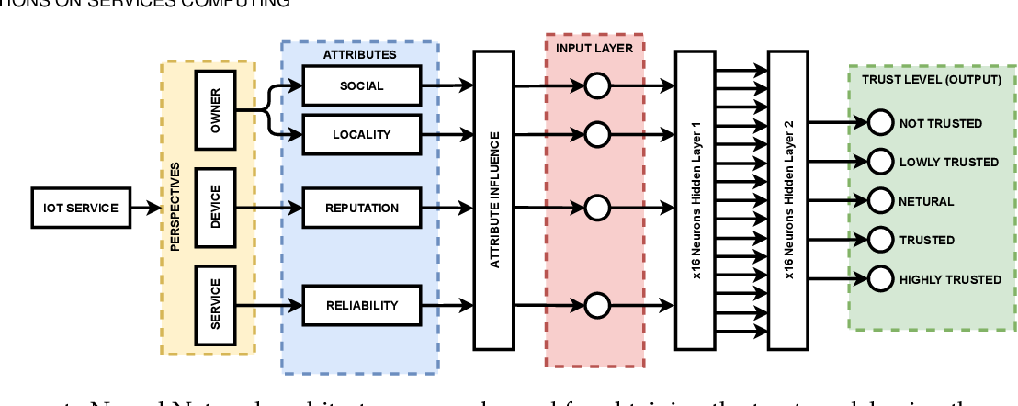

CHAPTER 4
TESTING AND IMPLEMENTATION

  - TESTING
Implementation is the stage of the project when the theoretical design is turned into a working system. This is the final and important phase in the system life cycle It is actually the process of converting the new system into a operational one.

4.1.1Unit Testing
Unit testing comprises the set of tests performed by an individual programmer prior to integration of the unit into a larger system. The module interface is tested to ensure that information properly flows into and out of the program unit. The local data structure is examined to ensure that data stored temporarily maintains its integrity during all steps in an algorithm’s execution. Boundary conditions are tested to ensure that the module operates properly at boundaries established to limit or restrict processing. All independent paths through the control structure are tested. All error-handling paths are tested.

4.1.2 Block Box Testing
Black-box testing is a method of software testing that examines the functionality of an application without peering into its internal structures or workings. This method of test can be applied virtually to every level of software testing: unit, integration, system and acceptance. It is sometimes referred to as specification-based testing.

4.2 SYSTEM IMPLEMENTATION
Implementation is the stage of the project when the theoretical design is turned into a working system. This is the final and important phase in the system life cycle It is actually the process of converting the new system into a operational one.

CHAPTER 5
CONCLUSION:
We proposed an IoT trust management framework that tries to ascertain a level of trust between potential providers and consumers. Specifically, our approach measures the trustworthiness of IoT service providers. The framework is based on a multi-perspective trust model. Each perspective in the model contributes to the overall trust. The perspectives are defined by a set of attributes that are extracted from the inherent characteristics of IoT services. We evaluated our approach in terms of the accuracy of detecting trustful and distrustful IoT services. It is worth noting that our proposed approach evaluates the service trustworthiness only (i.e., consumer perspective). Future directions can be investigating the trust level of IoT service consumers. Additionally, our work focused on leveraging trust-related data to evaluate IoT services’ trust, while assuming that the privacy and integrity of the data is protected. Our future work focuses on designing a privacy and integrity-preserving framework for storing and exchanging such data between IoT devices.

CHAPTER-6
REFERENCE
- [1] J. Gubbi, R. Buyya, S. Marusic, and M. Palaniswami, “Internet of things (iot): A vision, architectural elements, and future directions,” Future generation computer systems, vol. 29, no. 7, pp. 1645– 1660, 2013.
- [2] D. Yang, G. Xue, X. Fang, and J. Tang, “Crowdsourcing to smartphones: Incentive mechanism design for mobile phone sensing,” in Proceedings of the 18th annual international conference on Mobile computing and networking, ACM. New York, NY, USA: ACM, 2012, pp. 173–184.
- [3] M.-C. Yuen, I. King, and K.-S. Leung, “A survey of crowdsourcing systems,” in 2011 IEEE Third International Conference on Privacy, Security, Risk and Trust and 2011 IEEE Third International Conference on Social Computing. IEEE, 2011, pp. 766–773.
- [4] K. Habak, M. Ammar, K. A. Harras, and E. Zegura, “Femto clouds: Leveraging mobile devices to provide cloud service at the edge,” in 2015 IEEE 8th international conference on cloud computing. IEEE, 2015, pp. 9–16.
- [5] E. Bulut, S. Hernandez, A. Dhungana, and B. K. Szymanski, “Is crowdcharging possible?” in 2018 27th International Conference on Computer Communication and Networks (ICCCN). IEEE, 2018, pp. 1–9.
- [6] S. D. T. Kelly, N. K. Suryadevara, and S. C. Mukhopadhyay, “Towards the implementation of iot for environmental condition monitoring in homes,” IEEE sensors journal, vol. 13, no. 10, pp. 3846–3853, 2013.
- [7] D. Kyriazis and T. Varvarigou, “Smart, autonomous and reliable internet of things,” Procedia Computer Science, vol. 21, pp. 442–448, 2013.
- [8] Y. B. Saied, A. Olivereau, D. Zeghlache, and M. Laurent, “Trust management system design for the internet of things: A contextaware and multi-service approach,” Computers & Security, vol. 39, pp. 351–365, 2013.
- [9] D. Chen, G. Chang, D. Sun, J. Li, J. Jia, and X. Wang, “Trm-iot: A trust management model based on fuzzy reputation for internet of things,” Computer Science and Information Systems, vol. 8, no. 4, pp. 1207–1228, 2011.
- [10] Z. Yan, P. Zhang, and A. V. Vasilakos, “A survey on trust management for internet of things,” Journal of network and computer applications, vol. 42, pp. 120–134, 2014.

