SSUR An Approach to Optimizing Virtual Machine Allocation Strategy Based on User Requirements for Cloud Data Center

ABSTRACT
Cloud data centers provide services for an increasing number of applications. The virtual machines (VMs) that perform the corresponding application tasks need to be allocated to physical machines (PMs). For VM allocation, cloud service centers consider both energy consumption and quality of service (QoS), while cloud users are primarily concerned with their own needs, such as throughput and reliability. This paper proposes an allocation scheme for optimization based on user requirements in a cloud data center. First, various application requests from mobile phones and devices, which are regarded as a group of VM lists in the data center, are submitted to the cloud platform. Our method first allocates these arriving VMs to appropriate PMs based on their usage of hardware resources and the current throughput of the PMs in the data center. Second, due to dynamic workloads, the loads of the PMs that host these VMs may become very high. CPU utilization thresholds are set to determine whether migration is required, and the energy consumption before and after allocation is used to choose which VMs are reallocated. A suitable strategy for VM migration and PM shutdown can improve reliability and reduce energy consumption. Finally, it is shown through experimental simulations that compared with two existing algorithms, on the premise that the user requirements are met, the proposed method offers good performance in terms of total energy consumption, CPU utilization, number of PMs used and number of service-level agreement (SLA) violation.

CHAPTER 2
2. SYSTEM ANALYSIS
  - EXISTING SYSTEM

- We focus on resource allocation strategies and the related existing solutions.
- Several works in the existing literature have addressed virtual machine placement issue.
- In existing literature, this approach has been well explored but it stills not clear what formula to use to generate this metric so that one-dimensional FFD can be performed.
- Another set of heuristics was proposed in the existing literature to achieve a better host utilization.
- Several blocking estimation models from the existing literature are subject to the same limitation; notably the singleresource case.
2.1.1 DRAWBACKS OF EXISTING SYSTEM :
- The concept of VM placement algorithms originates from the consolidation of Operating Systems (OSs) within the same PM to avoid application compatibility issues.
- Despite these efforts, there are some remaining problems that need to be addressed. Amongst these are threats introduced by the cloud’s architectural vulnerabilities.
- The problem with their solution (Biran et al., 2012) is that it works only with small to medium sized cloud architectures.
- It is modelled using modified bin packing problem, where PMs are bins and VMs are items.
- This will ensure the availability of the critical VMs which if compromised, can cause massive harm to the users.
2.2. PROPOSED SYSTEM
- To achieve optimal resource placement, an exact formulation that aims at finding the best placement of resources by maximizing the revenue and minimizing the corresponding costs is proposed in.
- Optimization approaches can be very time consuming, several works addressing resource allocation in cloud systems proposed alternative approaches providing solutions in more reasonable time.
- A general analytical model for evaluating task blocking probability in cloud computing system is proposed in .
- The proposed model considers the concept of virtualization as well as heterogeneous server pools but this study is also limited to single-resource dimension.
2.2.1. ADVANTAGES OF PROPOSED SYSTEM
- This strives to avoid performance degradation which results from migrating data-intensive VMs away from the PMs that contain their images.
- The data-intensive VMs lose their performance up to 40 percent if they are migrated away from those PMs that contain their images.
- The VM placement algorithm discussed does not only save the costs but also strives to maintain the performance of the cloud environment even after any migrations.
- The idea is to evaluate the currently implemented VM placement algorithms to identify the algorithm that qualifies to be used in implementation of O-Sec VM Placement algorithm.
- Again the VM placement needs to ensure that the least number of PMs is used in order to minimize energy consumption.
Literature Survey:
TITLE | AUTHORS | DESCRIPTION
A security-aware scheduler for virtual machines on IaaS clouds | Afoulki, Z., Bousquet, A., and Rouzaud-Cornabas, J. (2011). | The problem is even worse in the case of adversary users hosted on the same hardware and therefore the isolation facility within clouds needs to be strong.
Security-aware resource allocation in clouds | Al-Haj, S., Al-Shaer, E., and Ramasamy, H. V. (2013). | Elasticity and economic considerations make Infrastructure-as-a-Service (IaaS) clouds attractive propositions for hosting enterprise IT applications.
Securing the cloud: Threats, attacks and mitigation techniques | Alani, M. M. (2014). | This paper is aimed to present information about the most current threats and attacks on cloud computing, as well as security measures.
Dynamic load management of virtual machines in cloud architectures | Andreolini, M., Casolari, S., Colajanni, M., and Messori, M. (2009). | Cloud infrastructures must accommodate changing demands for different types of processing with heterogeneous workloads and time constraints.

2.3 FEASIBILITY STUDY
The feasibility Analysis is an analytical program through project manager determines the project success ratio and through feasibility study project manager able to see either project. The key considerations involved in the feasibility analysis are:
- Economic Feasibility
- Technical Feasibility
- Operational Feasibility
- Environmental Feasibility
2.3.1 ECONOMICAL FEASIBILITY
Hence this project is economically feasible there is no need to involve any cost for this project.
2.3.2 TECHNICAL FEASIBILITY
Software Technologies used are PHP and MySql. In the educational institutions, it is possible to update the system in future. No special hardware is required for the purpose of using this system. Hence it is declared that this project is technically feasible.
2.3.3 OPERATIONAL FEASIBILITY
As the admin work mainly to maintain the Patient and Doctor .Doctor will predict patient cancer disease. Hence it is easy to operate with training. Therefore it is operationally feasible for implementation.
2.3.4 ENVIRONMENTAL FEASIBILITY
This project environment is correct as a admin has developed this system and no expenditure is involved under any head and this process is part of admin document management, this project environment is accessible.
2.4 SYSTEM REQUIREMENTS
- System : Pentium IV 2.4 GHz.
- Hard Disk : 40 GB.
- Monitor : 15 inch VGA Color.
- Mouse : Logitech Mouse.
- Ram : 512 MB
- Keyboard : Standard Keyboard
2.4.1 HARDWARE REQUIREMENTS
The Hardware of the computer consists of physical component such as Input Devices, Storage Devices, Processing & Control units and Output Devices. Computer includes external storage unit to store data in programs.
The Hardware Configuration involved in this project
- System : Pentium IV 2.4 GHz.
- Hard Disk : 40 GB.
- Monitor : 15 inch VGA Color.
- Mouse : Logitech Mouse.
- Ram : 512 MB
- Keyboard : Standard Keyboard
2.4.2 SOFTWARE REQUIREMENTS
Software is a group of programs that computers need to do a particular task. It is an essential requirement of Computer System. The Software used to develop the project is
- Operating System : Windows XP.
- Platform : DOT NET TECHNOLOGY
- Front End : ASP.Net 3.5
- Back End : SQL SERVER 2005

CHAPTER 3
SYSTEM DESIGN AND DEVELOPEMENT
SYSTEM ARCHICTURE

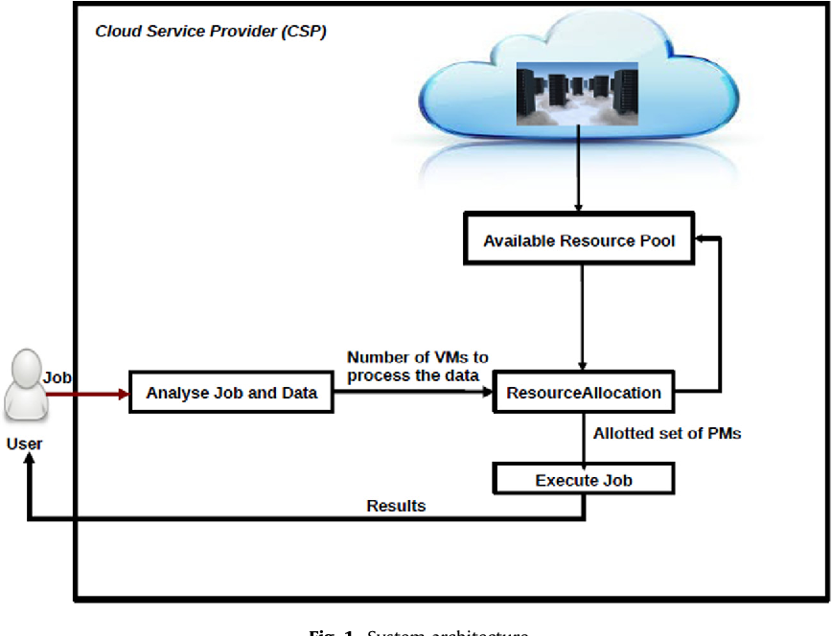

CHAPTER 4
TESTING AND IMPLEMENTATION

  - TESTING
Implementation is the stage of the project when the theoretical design is turned into a working system. This is the final and important phase in the system life cycle It is actually the process of converting the new system into a operational one.

4.1.1Unit Testing
Unit testing comprises the set of tests performed by an individual programmer prior to integration of the unit into a larger system. The module interface is tested to ensure that information properly flows into and out of the program unit. The local data structure is examined to ensure that data stored temporarily maintains its integrity during all steps in an algorithm’s execution. Boundary conditions are tested to ensure that the module operates properly at boundaries established to limit or restrict processing. All independent paths through the control structure are tested. All error-handling paths are tested.

4.1.2 Block Box Testing
Black-box testing is a method of software testing that examines the functionality of an application without peering into its internal structures or workings. This method of test can be applied virtually to every level of software testing: unit, integration, system and acceptance. It is sometimes referred to as specification-based testing.

4.2 SYSTEM IMPLEMENTATION
Implementation is the stage of the project when the theoretical design is turned into a working system. This is the final and important phase in the system life cycle It is actually the process of converting the new system into a operational one.

CHAPTER 5
CONCLUSION:
In this paper, authors have developed an evaluation method to compare the optimization objectives reflected in the different VM placement algorithms. This evaluation method uses an equation which scores the different optimization objectives based on their importance rating. According to the evaluation method, the VM placement algorithm which scores the highest is assumed to have the most important optimization objectives. The idea is to further expand such an algorithm to include security-aware objectives in order to achieve an Optimized Security-aware (O-Sec) VM placement algorithm. To achieve their goal, the authors of this paper have categorized VM placement algorithms into three. These categories are based on what the algorithms aim to accomplish; cost reduction, good QoS and security. The authors further discuss how the VM placement algorithms for each category can further be adapted or modified to accomplish the notion of OSec VM placement algorithm. The optimization objectives reflected in these VM placement algorithms help to identify and rate the objectives suitable for the evaluation criteria. After the evaluation process, the Traffic and Power-aware VM Placement algorithm (TPVMP) is found as a potential candidate to further be augmented with security features.

CHAPTER-6
REFERENCE
- Afoulki, Z., Bousquet, A., and Rouzaud-Cornabas, J. (2011). A security-aware scheduler for virtual machines on IaaS clouds. Report 2011.
- Al-Haj, S., Al-Shaer, E., and Ramasamy, H. V. (2013). Security-aware resource allocation in clouds. In Services Computing (SCC), 2013 IEEE International Conference on, pages 400–407. IEEE.
- Alani, M. M. (2014). Securing the cloud: Threats, attacks and mitigation techniques. Journal of Advanced Computer Science & Technology, 3(2):202.
- Andreolini, M., Casolari, S., Colajanni, M., and Messori, M. (2009). Dynamic load management of virtual machines in cloud architectures. In International Conference on Cloud Computing, pages 201–214. Springer.
- Biran, O., Corradi, A., Fanelli, M., Foschini, L., Nus, A., Raz, D., and Silvera, E. (2012). A stable networkaware VM placement for cloud systems. In Proceedings of the 2012 12th IEEE/ACM International Symposium on Cluster, Cloud and Grid Computing (ccgrid 2012), pages 498–506. IEEE Computer Society
- Bobroff, N., Kochut, A., and Beaty, K. (2007). Dynamic placement of virtual machines for managing SLA violations. In 2007 10th IFIP/IEEE International Symposium on Integrated Network Management, pages 119– 128. IEEE.
- Caron, E., Le, A. D., Lefray, A., and Toinard, C. (2013). Definition of security metrics for the cloud computing and security-aware virtual machine placement algorithms. In Cyber-Enabled Distributed Computing and Knowledge Discovery (CyberC), 2013 International Conference on, pages 125–131. IEEE.
- Chowdhury, M. R., Mahmud, M. R., and Rahman, R. M. (2015). Implementation and performance analysis of various vm placement strategies in cloudsim. Journal of Cloud Computing, 4(1):1.
- Dong, Z., Liu, N., and Rojas-Cessa, R. (2015). Greedy scheduling of tasks with time constraints for energyefficient cloud-computing data centers. Journal of Cloud Computing, 4(1):1.
- Eloff, J. H. (1983). Selection process for security packages. Computers & Security, 2(3):256–260.

