Sanitizable Access Control System for Secure Cloud Storage Against Malicious Data Publishers

ABSTRACT
Cloud computing is considered as one of the most prominent paradigms in the information technology industry, since it can significantly reduce the costs of hardware and software resources in computing infrastructure. At the first sight, by merely storing the shared data as plaintext in the cloud storage and protect them using an appropriate access control would be a nice solution. Therefore, encryption is mandatory, and the shared data will need to be stored as a ciphertext using an appropriate access control. However, in practice, some of these employees may be malicious and may want to deviate from the required sharing policy. The existing protection in the literature has been explored to allow only legitimate recipients to decrypt the contents stored in the cloud storage, but unfortunately, no existing work deals with issues raised due to the presence of malicious data publishers. In this work, we present a new direction of research that can cope with the presence of malicious data publishers. We resolve the aforementioned problem by proposing the notion of Sanitizable Access Control System (SACS) to solve the aforementioned problem.

CHAPTER 2
2. SYSTEM ANALYSIS
  - EXISTING SYSTEM

- In Existing the document or file which is being stored by client in the cloud computing means that was stored entirely due to this someone can able to hack that so, hacker can able to see all the information’s of the uploaded file.
- The system model involves five kinds of different entities: the cloud, the user, the sanitizer, the Private Key Generator (PKG) and the Third Party Auditor The cloud provides enormous data storage space to the user.
- Through the cloud storage service, users can upload their data to the cloud and share their data with others.
- The user is a member of an organization, which has a large number of files to be stored in the cloud.
2.1.1 DRAWBACKS OF EXISTING SYSTEM :
- We leave the construction of a CD-ABACE scheme based on a Boolean circuit instead of AND-gate circuits with the same performance as an interesting open problem.
- To avoid this security problem, the signature used in requires strongly unforgeable chameleon hashes, which will inevitable incur huge computation overhead.
- To reduce the damage of users’ key exposure, Yu et al. proposed key-exposure resilient remote data integrity auditing schemes based on key update technique.
- First identify the difficulties and potential security problems has been direct extensions with fully dynamic data updates from prior works and then show how to construct an elegant verification scheme for the seamless integration of these two salient features in our design.
2.2. PROPOSED SYSTEM
- The proposed construction guarantees that no PPT adversary can obtain the receiver’s identity, deterministically.
- We examine how the performance of our proposed CD-ABACE scheme compares to the selectively-secure Wang and Chow scheme [WC21], which is the only implemented ACE construction to date.
- In contrast, the proposed variant of Abe et al.’s SPS requires no new generator for the second cyclic group, and the intended NIZK proof cuts out the need for target group operations.
- In this work, we proposed a generic and accordingly an efficient Cross-Domain AttributeBased Access Control Encryption schemes that are based on the set of attributes that the users possess.
2.2.1. ADVANTAGES OF PROPOSED SYSTEM
- To efficiently support data sharing with sensitive information hiding in identity-based integrity auditing for secure cloud storage.
- While the proposal of the ACE-concept and of efficient ACE-schemes were important first steps toward outsourcing access control, the existing security definition turns out to be insufficient for several realistic attack scenarios.
- We consider a scheme secure if an adversary can efficiently produce a ciphertext such that there is a receiver role that can decrypt it even though the policy does not allow it, as long as this receiver role is hard to find.
- To settle these questions, the authors are currently working on a theoretical model to capture the use case of ACE in a simulation-based framework. Another interesting research direction is to find more efficient schemes for useful policies.
Literature Survey:
TITLE | AUTHORS | DESCRIPTION
Controlling Data in the Cloud: Outsourcing Computation without Outsourcing Control | R. Chow, P. Golle, M. Jakobsson, E. Shi, J. Staddon, R. Masuoka, and J. Molina, | Cloud computing is clearly one of today's most enticing technology areas due, at least in part, to its cost-efficiency and flexibility.
The Notorious Nine Cloud Computing Top Threats in 2013 | Cloud Security Alliance (CSA), | Unlimited storage, virtual hardware, a vast amount of computing power, low cost, location-independent data access.
Provable Data Possession at Untrusted Stores | G. Ateniese, R.C. Burns, R. Curtmola, J. Herring, L. Kissner, Z.N.J Peterson, and D.X. Song, | The challenge/response protocol transmits a small, constant amount of data, which minimizes network communication.
Compact Proofs of Retrievability | H. Shacham and B. Waters, | In a proof-of-retrievability system, a data storage center convinces a verifier that he is actually storing all of a client’s data.

2.3 FEASIBILITY STUDY
The feasibility Analysis is an analytical program through project manager determines the project success ratio and through feasibility study project manager able to see either project. The key considerations involved in the feasibility analysis are:
- Economic Feasibility
- Technical Feasibility
- Operational Feasibility
- Environmental Feasibility
2.3.1 ECONOMICAL FEASIBILITY
Hence this project is economically feasible there is no need to involve any cost for this project.
2.3.2 TECHNICAL FEASIBILITY
Software Technologies used are PHP and MySql. In the educational institutions, it is possible to update the system in future. No special hardware is required for the purpose of using this system. Hence it is declared that this project is technically feasible.
2.3.3 OPERATIONAL FEASIBILITY
As the admin work mainly to maintain the Patient and Doctor .Doctor will predict patient cancer disease. Hence it is easy to operate with training. Therefore it is operationally feasible for implementation.
2.3.4 ENVIRONMENTAL FEASIBILITY
This project environment is correct as a admin has developed this system and no expenditure is involved under any head and this process is part of admin document management, this project environment is accessible.
2.4 SYSTEM REQUIREMENTS
- System : Pentium IV 2.4 GHz.
- Hard Disk : 40 GB.
- Monitor : 15 inch VGA Color.
- Mouse : Logitech Mouse.
- Ram : 512 MB
- Keyboard : Standard Keyboard
2.4.1 HARDWARE REQUIREMENTS
The Hardware of the computer consists of physical component such as Input Devices, Storage Devices, Processing & Control units and Output Devices. Computer includes external storage unit to store data in programs.
The Hardware Configuration involved in this project
- System : Pentium IV 2.4 GHz.
- Hard Disk : 40 GB.
- Monitor : 15 inch VGA Color.
- Mouse : Logitech Mouse.
- Ram : 512 MB
- Keyboard : Standard Keyboard
2.4.2 SOFTWARE REQUIREMENTS
Software is a group of programs that computers need to do a particular task. It is an essential requirement of Computer System. The Software used to develop the project is
- Operating System : Windows XP.
- Platform : DOT NET TECHNOLOGY
- Front End : ASP.Net 3.5
- Back End : SQL SERVER 2005

CHAPTER 3
SYSTEM DESIGN AND DEVELOPEMENT
SYSTEM ARCHICTURE

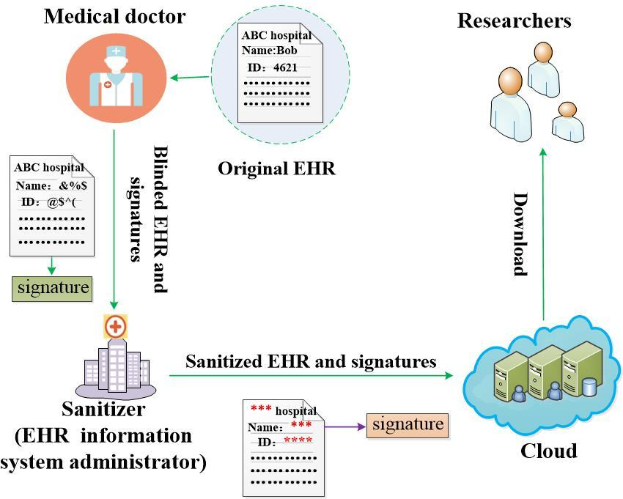

CHAPTER 4
TESTING AND IMPLEMENTATION

  - TESTING
Implementation is the stage of the project when the theoretical design is turned into a working system. This is the final and important phase in the system life cycle It is actually the process of converting the new system into a operational one.

4.1.1Unit Testing
Unit testing comprises the set of tests performed by an individual programmer prior to integration of the unit into a larger system. The module interface is tested to ensure that information properly flows into and out of the program unit. The local data structure is examined to ensure that data stored temporarily maintains its integrity during all steps in an algorithm’s execution. Boundary conditions are tested to ensure that the module operates properly at boundaries established to limit or restrict processing. All independent paths through the control structure are tested. All error-handling paths are tested.

4.1.2 Block Box Testing
Black-box testing is a method of software testing that examines the functionality of an application without peering into its internal structures or workings. This method of test can be applied virtually to every level of software testing: unit, integration, system and acceptance. It is sometimes referred to as specification-based testing.

4.2 SYSTEM IMPLEMENTATION
Implementation is the stage of the project when the theoretical design is turned into a working system. This is the final and important phase in the system life cycle It is actually the process of converting the new system into a operational one.

CHAPTER 5
CONCLUSION:
This project helps to secure cloud data through third party auditor. To free user from the burden incurred by frequent integrity verifications, Third Party Auditor (TPA) is introduced to perform verifications on behalf of user for data integrity assurance. However, existing public auditing schemes rely on the assumption that TPA is trusted, thus these schemes cannot be directly extended to support the outsourced auditing model, where TPA might be dishonest and any two of the three involved entities (i.e. user, TPA, and cloud service provider) might be in collusion. In this paper, we propose a dynamic outsourced auditing scheme which cannot only protect against any dishonest entity and collision, but also support verifiable dynamic updates to outsourced data.

CHAPTER-6
REFERENCE
- [1] R. Chow, P. Golle, M. Jakobsson, E. Shi, J. Staddon, R. Masuoka, and J. Molina, “Controlling Data in the Cloud: Outsourcing Computation without Outsourcing Control,” Proc. 2009 ACM Workshop on Cloud Computing Security (CCSW '09), pp. 85-90, 2009.
- [2] Cloud Security Alliance (CSA), “The Notorious Nine Cloud Computing Top Threats in 2013,” https://cloudsecurityalliance. org/download/thenotorious-nine-cloud-computing-top -threats-in-2013, Feb. 2013.
- [3] G. Ateniese, R.C. Burns, R. Curtmola, J. Herring, L. Kissner, Z.N.J Peterson, and D.X. Song, “Provable Data Possession at Untrusted Stores,” Proc. 14th ACM Conf. Computer and Comm. Security (CCS ’07), pp. 598-609, 2007.
- [4] Juels and B.S. KaliskiJr, “PORs: Proofs of Retrievability for Large Files,” Proc. 14th ACM Conf. Computer and Comm. Security (CCS ’07), pp. 584- 597, 2007.
- [5] H. Shacham and B. Waters, “Compact Proofs of Retrievability,” Proc. 14th Int’l Conf. Theory and Application of Cryptology and Information Security: Advances in Cryptology (ASIACRYPT ’08), pp. 90- 107, 2008.
- [6] Q. Wang, C. Wang, K. Ren, W. Lou, and J. Li, “Enabling Public Auditability and Data Dynamics for Storage Security in Cloud Computing,” IEEE Trans. Parallel and Distributed Systems, vol. 22, no. 5, pp. 847-859, May 2011.
- [7] C.C. Erway, A. Küpçü, C. Papamanthou, and R. Tamassia, “Dynamic Provable Data Possession,” Proc. 16th ACM Conf. Computer and Comm. Security (CCS ’09), pp. 213-222, 2009.
- [8] D. Cash, A. Küpçü, and D. Wichs, “Dynamic Proofs of Retrievability via Oblivious Ram,” Proc. 32nd Int’l Conf. Theory and Applications of Cryptographic Techniques: Advances in Cryptology (EUROCRYPT ’13), pp. 279-295, 2013.
- [9] C. Wang, S.S.M. Chow, Q. Wang, K. Ren, and W. Lou, “Privacy- Preserving Public Auditing for Secure Cloud Storage,” IEEE Trans. Computers, vol. 62, no. 2, pp. 362-375, Feb. 2013.
- [10]Y. Zhu, G.J. Ahn, H. Hu, S.S. Yau, H.G. An, and C.J. Hu, “Dynamic Audit Services for Outsourced Storages in Clouds,” IEEE Trans. Services Computing, vol. 6, no. 2, pp. 227-238, April-June 2013

