A Compressive Integrity Auditing Protocol for Secure Cloud Storage

ABSTRACT
With the widespread application of cloud storage, ensuring the integrity of user outsourced data catches more and more attention. To remotely check the integrity of cloud storage, plenty of protocols have been proposed, implemented by checking the equation constructed by the aggregated blocks, tags, and indices. However, the verifier only has the knowledge of the indices of the audited blocks and tags, which thus requires the cloud to store both data blocks and tags for integrity verification. In this article, we present a compressive secure cloud storage protocol inspired by Goldreich-Goldwasser-Halevi (GGH) cryptosystem. Since the aggregated blocks can be reconstructed from the aggregated tags without the help of data indices, the cloud can only store data tags for providing the verifiable integrity proof. In this way, communication and storage costs can be hugely reduced and user private information can be hidden from the cloud. Furthermore, the proposed protocol only contains a few basic algebraic operations, making it highly efficient. We also provide formal security proof of the proposed protocol regarding forge, replay and replace attacks. In addition, we explore a new technique to support data dynamics. Furthermore, we establish a generic framework of compressive secure cloud storage protocols. Finally, we provide the theoretical analysis and experimental results, which further validate the effectiveness of the proposed protocol.

CHAPTER 2
2. SYSTEM ANALYSIS
  - EXISTING SYSTEM

- Existing system has vast storage for storing information and also allows exchange of data between the cloud and user.
- To overcome these existing problems this project proposes a system which handles both Integrity auditing and Data Deduplication.
- The design of the HMAC specification was motivated by the existence of attacks on more trivial mechanisms for combining a key with a hash function.
- To insert a new block or delete an existing block, it must move forward or backward the remaining (n/k − i) blocks of the DCT, which contains (n/k) blocks.
- Although cloud storage provides convenient data outsourcing services, an untrusted cloud server frequently threatens the integrity and security of the outsourced data.
2.1.1 DRAWBACKS OF EXISTING SYSTEM :
- The obvious problem of this simple strategy is the huge overheads of computation and communication.
- Although it is a strong protocol for data integrity, there is one inevitable problem.
- One problem of random sampling schemes is that they cannot assure in 100 % confidence.
- However, the major problem of this scheme is the limited number of challenge once the sentinel embedded file is upload to the prover.
- This scheme efficiently solves the dynamic operation problem but has the drawback that the messages exchanged between the Client and the Server is proportional to the number of file blocks.
2.2. PROPOSED SYSTEM
- The proposed system will achieve both file de-duplication and integrity auditing.
- Our proposed system successfully achieved Integrity auditing and secure de-duplication in cloud, which are main factors in achieving security in cloud.
- We propose a system for plainly examining integument looking under encoded share of the information.
- The proposed architecture of Cloud storage is a layered, cooperative architecture where the key technologies involved are data storage, data migration, data retrieval, data security etc.
- Compared with the relevant schemes in the literature, security analysis and performance evaluations show that the proposed scheme gains some advantages in integrity verification and dynamic updating.

2.2.1. ADVANTAGES OF PROPOSED SYSTEM
- The Efficient Provable Data Possession (E-PDP) scheme achieved a higher performance at the cost of a weaker guarantee by eliminating all coefficients aj in the GenProof and CheckProof algorithms.
- The overhead of POR mainly includes the storage for error-correcting code and sentinels, as well as computation of error-correcting code and permutation operations. Several optimization can be done to improve POR’s performance.
- The extended scheme achieved higher efficiency because it only relied on symmetry-key cryptography.
- PDP provides a high probability guarantee that a system possesses a file with high efficiency in computation and communication.
- However, there is not sufficient study on efficiency and performance.
Literature Survey:
TITLE | AUTHORS | DESCRIPTION
Provable data possession at untrusted stores | Ateniese, G., Burns, R., Curtmola, R., Herring, J., Kissner, L., Peterson, Z., Song, D. | We introduce a model for provable data possession (PDP) that allows a client that has stored data at an untrusted server to verify that the server possesses the original data without retrieving it.
Scalable and efficient provable data possession | Ateniese, G., Di Pietro, R., Mancini, L.V., Tsudik, G. | Storage outsourcing is a rising trend which prompts a number of interesting security issues, many of which have been extensively investigated in the past.
Proofs of Storage from Homomorphic Identification Protocols | Ateniese, G., Kamara, S., Katz, J. | We provide a framework for building public-key HLAs from any identification protocol satisfying certain homomorphic properties.
Aggregate and verifiably encrypted signatures from bilinear maps | Boneh, D., Gentry, C., Lynn, B., Shacham, H. | In this paper we introduce the concept of an aggregate signature, present security models for such signatures, and give several applications for aggregate signatures.

2.3 FEASIBILITY STUDY
The feasibility Analysis is an analytical program through project manager determines the project success ratio and through feasibility study project manager able to see either project. The key considerations involved in the feasibility analysis are:
- Economic Feasibility
- Technical Feasibility
- Operational Feasibility
- Environmental Feasibility
2.3.1 ECONOMICAL FEASIBILITY
Hence this project is economically feasible there is no need to involve any cost for this project.
2.3.2 TECHNICAL FEASIBILITY
Software Technologies used are PHP and MySql. In the educational institutions, it is possible to update the system in future. No special hardware is required for the purpose of using this system. Hence it is declared that this project is technically feasible.
2.3.3 OPERATIONAL FEASIBILITY
As the admin work mainly to maintain the Patient and Doctor .Doctor will predict patient cancer disease. Hence it is easy to operate with training. Therefore it is operationally feasible for implementation.
2.3.4 ENVIRONMENTAL FEASIBILITY
This project environment is correct as a admin has developed this system and no expenditure is involved under any head and this process is part of admin document management, this project environment is accessible.
2.4 SYSTEM REQUIREMENTS
- System : Pentium IV 2.4 GHz.
- Hard Disk : 40 GB.
- Monitor : 15 inch VGA Color.
- Mouse : Logitech Mouse.
- Ram : 512 MB
- Keyboard : Standard Keyboard
2.4.1 HARDWARE REQUIREMENTS
The Hardware of the computer consists of physical component such as Input Devices, Storage Devices, Processing & Control units and Output Devices. Computer includes external storage unit to store data in programs.
The Hardware Configuration involved in this project
- System : Pentium IV 2.4 GHz.
- Hard Disk : 40 GB.
- Monitor : 15 inch VGA Color.
- Mouse : Logitech Mouse.
- Ram : 512 MB
- Keyboard : Standard Keyboard
2.4.2 SOFTWARE REQUIREMENTS
Software is a group of programs that computers need to do a particular task. It is an essential requirement of Computer System. The Software used to develop the project is
- Operating System : Windows XP.
- Platform : DOT NET TECHNOLOGY
- Front End : ASP.Net 3.5
- Back End : SQL SERVER 2005

CHAPTER 3
SYSTEM DESIGN AND DEVELOPEMENT
SYSTEM ARCHICTURE

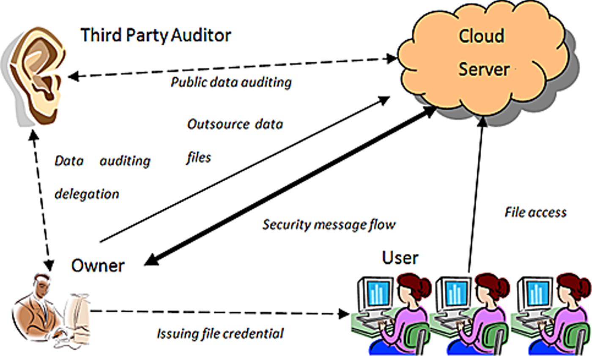

CHAPTER 4
TESTING AND IMPLEMENTATION

  - TESTING
Implementation is the stage of the project when the theoretical design is turned into a working system. This is the final and important phase in the system life cycle It is actually the process of converting the new system into a operational one.

4.1.1Unit Testing
Unit testing comprises the set of tests performed by an individual programmer prior to integration of the unit into a larger system. The module interface is tested to ensure that information properly flows into and out of the program unit. The local data structure is examined to ensure that data stored temporarily maintains its integrity during all steps in an algorithm’s execution. Boundary conditions are tested to ensure that the module operates properly at boundaries established to limit or restrict processing. All independent paths through the control structure are tested. All error-handling paths are tested.

4.1.2 Block Box Testing
Black-box testing is a method of software testing that examines the functionality of an application without peering into its internal structures or workings. This method of test can be applied virtually to every level of software testing: unit, integration, system and acceptance. It is sometimes referred to as specification-based testing.

4.2 SYSTEM IMPLEMENTATION
Implementation is the stage of the project when the theoretical design is turned into a working system. This is the final and important phase in the system life cycle It is actually the process of converting the new system into a operational one.

CHAPTER 5
CONCLUSION:
An efficient auditing system is critical to establish accountability for cloud users who do not have physical possession of their data. Existance of a trustworthy third party audits enable users to check the data integrity, track suspicious activities, obtain evidence for forensics, and evaluate service providers’ behaviors when needed. This chapter provides our readers fundamental understanding of cloud auditing technologies. We expect to witness development of standard framework for cloud auditing and efforts at cloud service providers to make their policies and mechanisms more auditable and accountable.

CHAPTER-6
REFERENCE
- 1. Ateniese, G., Burns, R., Curtmola, R., Herring, J., Kissner, L., Peterson, Z., Song, D.: Provable data possession at untrusted stores. In: Proceedings of the 14th ACM conference on Computer and communications security, CCS ’07, pp. 598–609. ACM, NewYork, NY, USA (2007). DOI 10.1145/1315245.1315318. URL http://doi.acm.org/10.1145/1315245.1315318
- 2. Ateniese, G., Di Pietro, R., Mancini, L.V., Tsudik, G.: Scalable and efficient provable data possession. In: Proceedings of the 4th international conference on Security and privacy in communication networks, SecureComm ’08, pp. 9:1–9:10. ACM, NewYork, NY, USA (2008). DOI 10.1145/1460877.1460889. URL http://doi.acm.org/10.1145/1460877.1460889
- 3. Ateniese, G., Kamara, S., Katz, J.: Proofs of Storage from Homomorphic Identification Protocols. In: M. Matsui (ed.) Advances in Cryptology - ASIACRYPT 2009, Lecture Notes in Computer Science, vol. 5912, chap. 19, pp. 319–333. Springer Berlin / Heidelberg, Berlin, Heidelberg (2009). DOI 10.1007/978-3-642-10366-7_19. URL http://dx.doi.org/10.1007/978-3-642-10366-7_19
- 4. Boneh, D., Gentry, C., Lynn, B., Shacham, H.: Aggregate and verifiably encrypted signatures from bilinear maps. Advances in Cryptology-EUROCRYPT 2003 pp. 641–641 (2003)
- 5. Boneh, D., Lynn, B., Shacham, H.: Short signatures from the weil pairing. Journal of Cryptology 17, 297–319 (2004). URL http://dx.doi.org/10.1007/s00145-004-0314-9. 10.1007/s00145-004-0314–9
- 6. Buchanan, S., Gibb, F.: The information audit: Role and scope. International journal of information management 27(3), 159–172 (2007)
- 7. Erway, C., Küpçü, A., Papamanthou, C., Tamassia, R.: Dynamic provable data possession. In: Proceedings of the 16th ACM conference on Computer and communications security, CCS ’09, pp. 213–222. ACM, New York, NY, USA (2009). DOI 10.1145/1653662.1653688. URL http://doi.acm.org/10.1145/1653662.1653688
- 8. Feng, J., Chen,Y.: A fair non–repudiation framework for data integrity in cloud storage services. International Journal of Cloud Computing 2(1), 20–47 (2013)
- 9. Feng, J., Chen, Y., Liu, P.: Bridging the missing link of cloud data storage security in aws. In: Consumer Communications and Networking Conference (CCNC), 2010 7th IEEE, pp. 1–2. IEEE (2010)
- 10. Feng, J., Chen, Y., Summerville, D., Ku, W.S., Su, Z.: Enhancing cloud storage security against roll-back attacks with a new fair multi-party non-repudiation protocol. In: Consumer Communications and Networking Conference (CCNC), 2011 IEEE, pp. 521–522. IEEE (2011)

