Comments on “Attribute-Based Data Sharing Scheme Revisited in Cloud Computing”

ABSTRACT
In this letter, we discuss the security weakness of Wang et al.'s attribute-based data sharing scheme, in IEEE TRANSACTIONS ON INFORMATION FORENSICS AND SECURITY (TIFS) (DOI: 10.1109/TIFS.2016.2549004). Through designing two concrete attacks, we identify two serious security flaws in their scheme. 1) First, we show that their scheme is insecure because in their scheme any authenticated user can freely tamper with the weight of his own attribute to gain higher level decryption privilege to arbitrarily decrypt the ciphertext belonging to another user with higher weight of attribute. 2) Second, we further demonstrate that their scheme is trivial insecure because in their scheme even any malicious authenticated user's attribute does not match the access policy of a ciphertext, he/she still has the power to decrypt the ciphertext, i.e., the decryption power is independent of attributes, thus, their scheme is not a rigorous attribute-based scheme. The two weaknesses discovered may hinder their scheme infeasible for practical deployment. Accordingly, we present a remedy solution to the issues while preserving all the security features of the original scheme. We hope that our cryptoanalysis and remedy scheme may contribute to avoiding similar design flaws in future designs.

CHAPTER 2
2. SYSTEM ANALYSIS
  - EXISTING SYSTEM

- Existing system uses the cipher text policies. In which confidentiality of the data are made by using three factors data, encryption algorithm & the size of key.
- As well existing concepts third parties are used such as key as well as digital certificate providers & verifiers.
- To ensure information protection against untrusted CSPs, existing arrangements apply cryptographic techniques (e.g., encryption mechanisms).challenging issue, particularly when managing dynamic client group.
- Besides, most of the existing CP-ABE schemes cannot support attribute with arbitrary 3 state.
2.1.1 DRAWBACKS OF EXISTING SYSTEM :
- Employing a CP-ABE system directly into a cloud application that may yield some open problems.
- However, CP-ABE is limited to a potential security risk that is known as key escrow problem, whereby the secret keys of users have to be issued by a trusted key authority.
- We propose an improved key issuing protocol to resolve the key escrow problem of CP-ABE in cloud computing.
- To solve the key escrow problem, it generates both parts of system parameter and secret key for each user.
- In addition, an improved key issuing protocol is proposed to resolve the key escrow problem of CP-ABE in cloud computing.
2.2. PROPOSED SYSTEM
- In this paper we proposed a mechanism which deals with revocation and data privacy & make Access Control Policy (ACP) in dynamic user group problem.
- In this paper, authors proposed a policy preserving EHR system on the basis of CP-ABE.
- The subsequent evaluation of element insert, lookup and recovery shows that their proposed scheme only introduces light-weighted overhead cost.
- This proposed scheme not only offer fine-grained authorization of cipher-texts but also protects the identities of users.
- In addition, a new computational problem called the twin-decision BDH problem (tDBDH) is proposed in this paper.
2.2.1. ADVANTAGES OF PROPOSED SYSTEM
- The performance analysis and the security proof show that the proposed scheme is able to achieve efficient and secure data sharing in cloud computing.
- We presented the performance and security analyses for the proposed scheme, in which the results demonstrate high efficiency and security of our scheme.
- The cost is reduced by nearly half in theory which is consistent with the above efficiency analysis.
- Accordingly, how to securely and efficiently share user data is one of the toughest challenges in the scenario of cloud computing.
- The simulation shows that CP-WABE-RE scheme is efficient both in terms of computation complexity and storage cost.
Literature Survey:
TITLE | AUTHORS | DESCRIPTION
A secure cloud computing based framework for big data information management of smart grid | J. Baek, Q. H. Vu, J. K. Liu, X. Huang, and Y. Xiang, | Smart grid is a technological innovation that improves efficiency, reliability, economics, and sustainability of electricity services.
An expressive and provably secure ciphertext-policy attribute-based encryption | A. Balu and K. Kuppusamy, | Ciphertext-Policy Attribute-Based Encryption (CP-ABE) allows to encrypt data under an access policy, specified as a logical combination of attributes.
Randomizable proofs and delegatable anonymous credentials | M. Belenkiy, J. Camenisch, M. Chase, M. Kohlweiss, A. Lysyanskaya, and H. Shacham, | We revise the entire approach to constructing anonymous credentials and identify randomizable zero-knowledge proof of knowledge systems as the key building block.
Ciphertext-policy attributebased encryption | J. Bethencourt, A. Sahai, and B. Waters, | In several distributed systems a user should only be able to access data if a user posses a certain set of credentials or attributes.

2.3 FEASIBILITY STUDY
The feasibility Analysis is an analytical program through project manager determines the project success ratio and through feasibility study project manager able to see either project. The key considerations involved in the feasibility analysis are:
- Economic Feasibility
- Technical Feasibility
- Operational Feasibility
- Environmental Feasibility
2.3.1 ECONOMICAL FEASIBILITY
Hence this project is economically feasible there is no need to involve any cost for this project.
2.3.2 TECHNICAL FEASIBILITY
Software Technologies used are PHP and MySql. In the educational institutions, it is possible to update the system in future. No special hardware is required for the purpose of using this system. Hence it is declared that this project is technically feasible.
2.3.3 OPERATIONAL FEASIBILITY
As the admin work mainly to maintain the Patient and Doctor .Doctor will predict patient cancer disease. Hence it is easy to operate with training. Therefore it is operationally feasible for implementation.
2.3.4 ENVIRONMENTAL FEASIBILITY
This project environment is correct as a admin has developed this system and no expenditure is involved under any head and this process is part of admin document management, this project environment is accessible.
2.4 SYSTEM REQUIREMENTS
- System : Pentium IV 2.4 GHz.
- Hard Disk : 40 GB.
- Monitor : 15 inch VGA Color.
- Mouse : Logitech Mouse.
- Ram : 512 MB
- Keyboard : Standard Keyboard

2.4.1 HARDWARE REQUIREMENTS
The Hardware of the computer consists of physical component such as Input Devices, Storage Devices, Processing & Control units and Output Devices. Computer includes external storage unit to store data in programs.
The Hardware Configuration involved in this project
- System : Pentium IV 2.4 GHz.
- Hard Disk : 40 GB.
- Monitor : 15 inch VGA Color.
- Mouse : Logitech Mouse.
- Ram : 512 MB
- Keyboard : Standard Keyboard

2.4.2 SOFTWARE REQUIREMENTS
Software is a group of programs that computers need to do a particular task. It is an essential requirement of Computer System. The Software used to develop the project is
- Operating System : Windows XP.
- Platform : DOT NET TECHNOLOGY
- Front End : ASP.Net 3.5
- Back End : SQL SERVER 2005

CHAPTER 3
SYSTEM DESIGN AND DEVELOPEMENT
SYSTEM ARCHICTURE

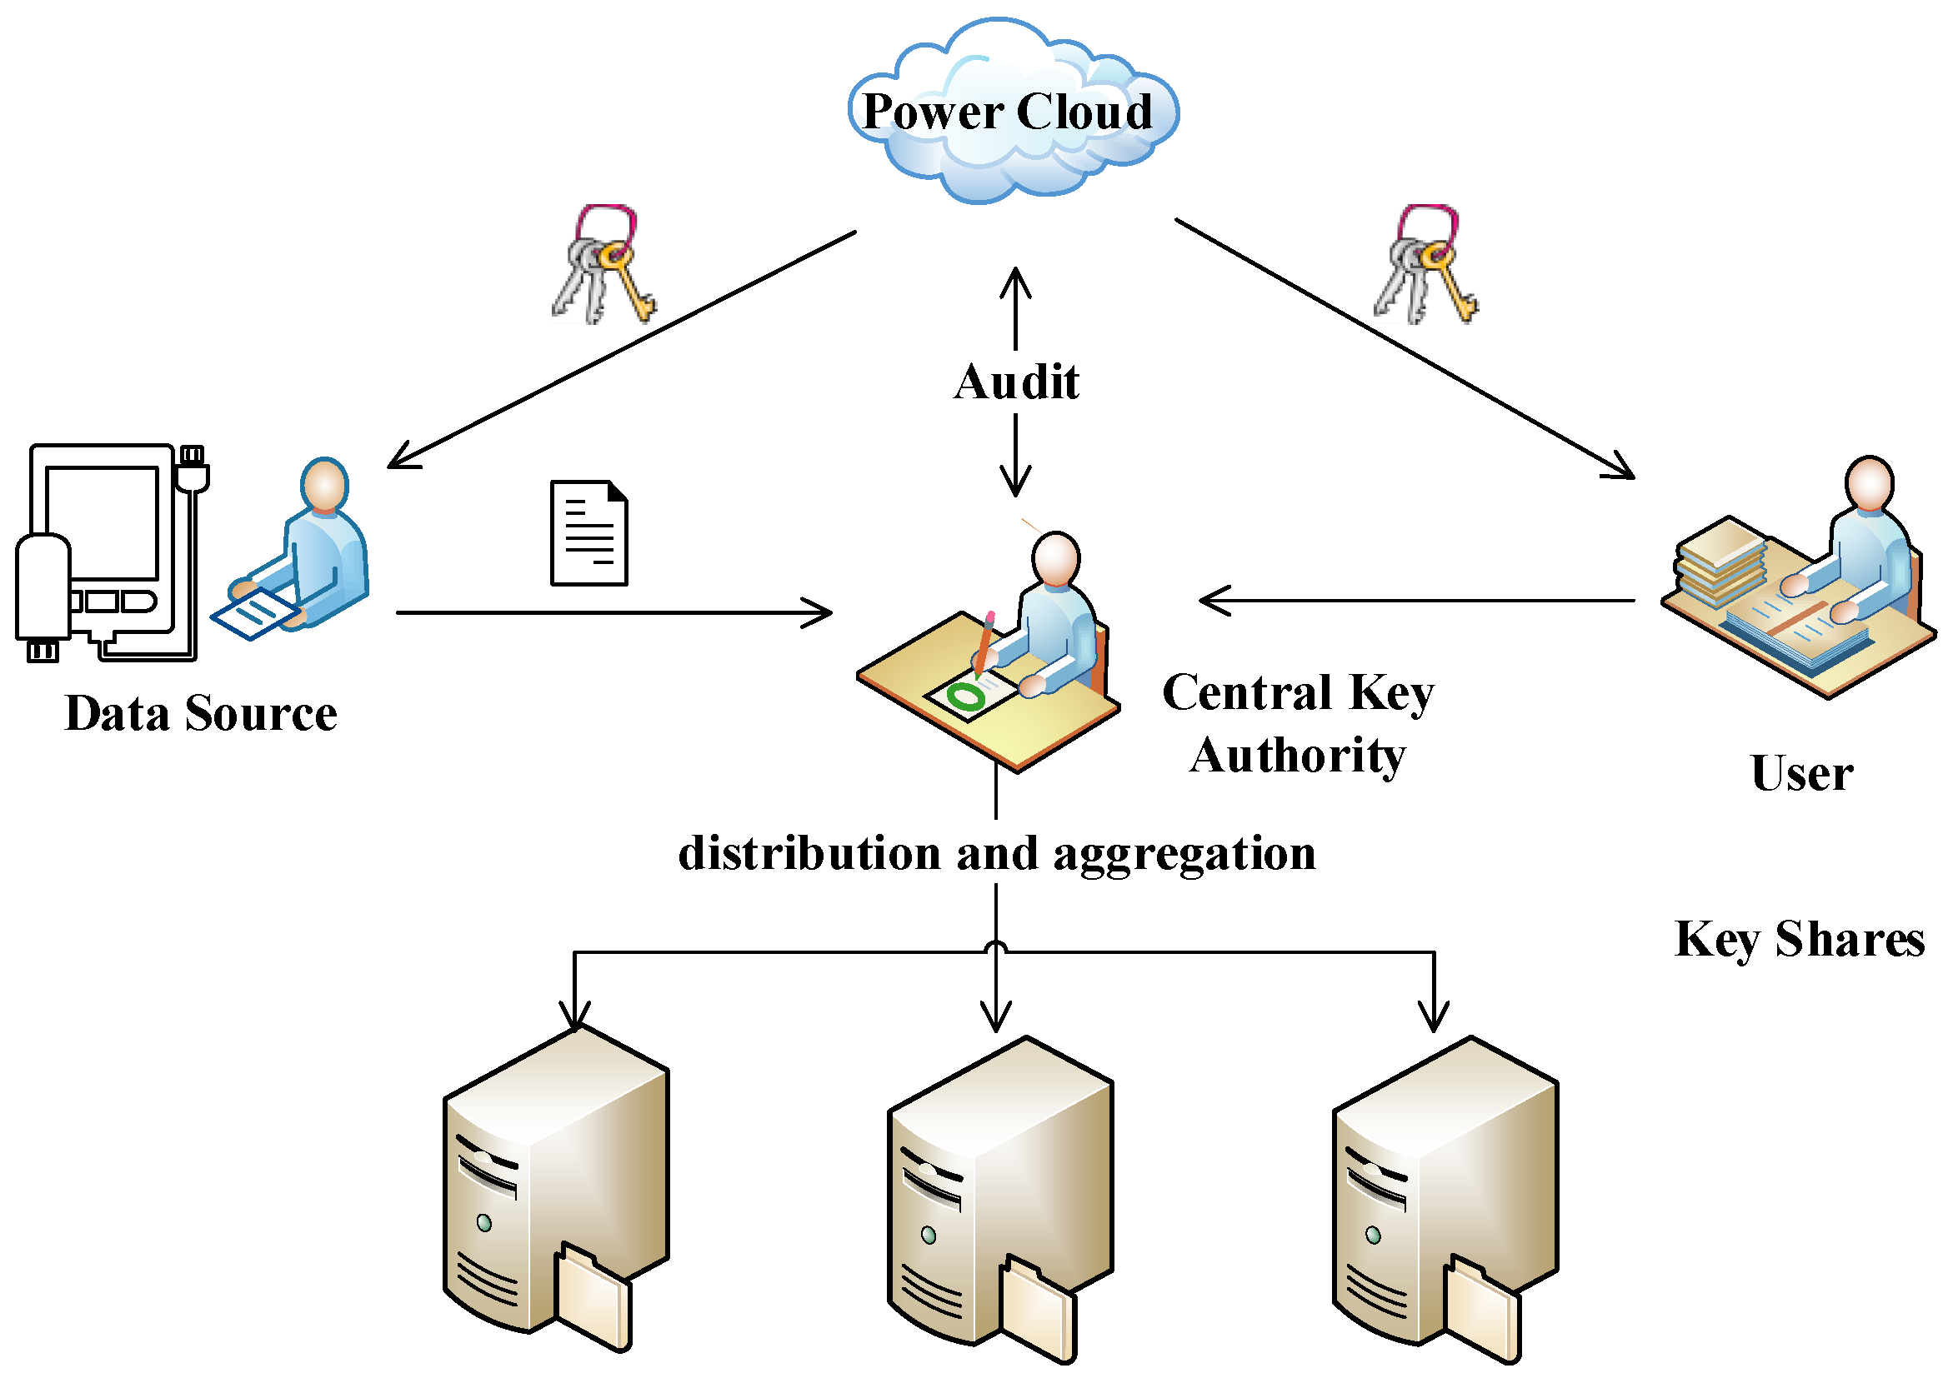

CHAPTER 4
TESTING AND IMPLEMENTATION

  - TESTING
Implementation is the stage of the project when the theoretical design is turned into a working system. This is the final and important phase in the system life cycle It is actually the process of converting the new system into a operational one.

4.1.1Unit Testing
Unit testing comprises the set of tests performed by an individual programmer prior to integration of the unit into a larger system. The module interface is tested to ensure that information properly flows into and out of the program unit. The local data structure is examined to ensure that data stored temporarily maintains its integrity during all steps in an algorithm’s execution. Boundary conditions are tested to ensure that the module operates properly at boundaries established to limit or restrict processing. All independent paths through the control structure are tested. All error-handling paths are tested.

4.1.2 Block Box Testing
Black-box testing is a method of software testing that examines the functionality of an application without peering into its internal structures or workings. This method of test can be applied virtually to every level of software testing: unit, integration, system and acceptance. It is sometimes referred to as specification-based testing.

4.2 SYSTEM IMPLEMENTATION
Implementation is the stage of the project when the theoretical design is turned into a working system. This is the final and important phase in the system life cycle It is actually the process of converting the new system into a operational one.

CHAPTER 5
CONCLUSION:
In this paper, we redesigned an attribute-based data sharing scheme in cloud computing. The improved key issuing protocol was presented to resolve the key escrow problem. It enhances data confidentiality and privacy in cloud system against the managers of KA and CSP as well as malicious system outsiders, where KA and CSP are semi-trusted. In addition, the weighted attribute was proposed to improve the expression of attribute, which can not only describe arbitrarystate attributes, but also reduce the complexity of access policy, so that the storage cost of ciphertext and time cost in encryption can be saved. Finally, we presented the performance and security analyses for the proposed scheme, in which the results demonstrate high efficiency and security of our scheme.

CHAPTER-6
REFERENCE
- [1] J. Baek, Q. H. Vu, J. K. Liu, X. Huang, and Y. Xiang, “A secure cloud computing based framework for big data information management of smart grid,” IEEE Trans. Cloud Comput., vol. 3, no. 2, pp. 233–244, Apr./Jun. 2015.
- [2] A. Balu and K. Kuppusamy, “An expressive and provably secure ciphertext-policy attribute-based encryption,” Inf. Sci., vol. 276, no. 4, pp. 354–362, Aug. 2014.
- [3] M. Belenkiy, J. Camenisch, M. Chase, M. Kohlweiss, A. Lysyanskaya, and H. Shacham, “Randomizable proofs and delegatable anonymous credentials,” in Proc. 29th Annu. Int. Cryptol. Conf., 2009, pp. 108–125.
- [4] J. Bethencourt, A. Sahai, and B. Waters, “Ciphertext-policy attributebased encryption,” in Proc. IEEE Symp. Secur. Privacy, May 2007, pp. 321–334.
- [5] D. Boneh, B. Lynn, and H. Shacham, “Short signatures from the Weil pairing,” J. Cryptol., vol. 17, no. 4, pp. 297–319, 2004.
- [6] M. Chase, “Multi-authority attribute based encryption,” in Proc. 4th Conf. Theory Cryptogr., 2007, pp. 515–534.
- [7] M. Chase and S. S. M. Chow, “Improving privacy and security in multiauthority attribute-based encryption,” in Proc. 16th ACM Conf. Comput. Commun. Secur., 2009, pp. 121–130.
- [8] L. Cheung and C. Newport, “Provably secure ciphertext policy ABE,” in Proc. 14th ACM Conf. Comput. Commun. Secur., 2007, pp. 456–465.
- [9] S. S. M. Chow, “Removing escrow from identity-based encryption,” in Proc. 12th Int. Conf. Pract. Theory Public Key Cryptogr., 2009, pp. 256–276.
- [10] C.-K. Chu, W.-T. Zhu, J. Han, J.-K. Liu, J. Xu, and J. Zhou, “Security concerns in popular cloud storage services,” IEEE Pervasive Comput., vol. 12, no. 4, pp. 50–57, Oct./Dec. 2013.

