Enabling (End-to-End) Encrypted Cloud Emails With Practical Forward Secrecy

ABSTRACT
With the widespread use of cloud emails and frequent reports on large-scale email leakage events, a security property so-called forward secrecy becomes desirable and indispensable for both individuals and cloud email service providers to strengthen the security of cloud email systems. However, due to the failure to meet the security and practicality requirements of email systems simultaneously, typical methods of achieving forward secrecy, such as Diffie-Hellman key exchange and forward-secure public-key encryption, have not been widely approved and adopted. In this paper, to capture forward secrecy of encrypted cloud email systems without sacrificing the practicability, we introduce a new cryptographic primitive named forward-secure puncturable identity-based encryption (fs-PIBE), which enables an email user to perform fine-grained revocation of decryption capacity. Based on this primitive, we build a framework of encrypted cloud email systems, and instantiate it with a concrete fs-PIBE construction that has constant size of ciphertext and provable security in the standard model. Furthermore, to improve the security and efficiency of the presented framework, we extend the proposed scheme to support end-to-end encryption and outsourced decryption, respectively. In addition, as a proof-of-concept of the proposed fs-PIBE scheme, we implement it and produce various experiments to demonstrate its practicability and correctness.

CHAPTER 2
2. SYSTEM ANALYSIS
  - EXISTING SYSTEM

- In an internet environment, consider the case that a sender B and a receiver A want to achieve secure communication via existing e-mail system and gain efficiency simultaneously.
- The purpose of encrypting bulk M using a conventional cryptographic system and encrypting k using a public key cryptographic system is to earn the efficiency.
- A protocol providing perfect forward secrecy means that even if one entity’s longterm secret key is compromised, it will never reveal any old short-term keys used before.
- The basic protection in an e-mail system is to encrypt the bulk mail using a conventional cryptosystem with a short-term key and to protect the short-term key using a public-key cryptosystem with the receiver’s public key.
2.1.1 DRAWBACKS OF EXISTING SYSTEM :
- In this work we systematically explore the problem of providing forward secrecy in asynchronous messaging systems.
- Our solution to this problem is to cryptographically bind the secret keys for the FS-PKE scheme with those for the punctured encryption scheme.
- To address these issues, we take a different approach. Rather than deleting elements from an existing decryption key, we desire a structure that allows us to add new restrictions on what the key can decrypt.
- In this setting, a trusted third party issues identities and then through some mechanism (typically either directly updating users keys or posting some public update information) updates only the keys of nonrevoked users.
2.2. PROPOSED SYSTEM
- In this letter, two secure e-mail protocols based on the Diffie-Hellman key agreement and CEMBS are proposed.
- Compared with the conventional method, the proposed scheme uses a short-term key to encrypt the message M, but doesn’t use the receiver’s public key to protect the short-term key.
- In order to provide perfect forward secrecy, two new email protocols are proposed.
- In the first protocol, the receiver requires a portable device to remember a used secret random integer. To remove the requirement, the second protocol is proposed.
- The second protocol is more flexible and suitable to the e-mail system in our real life.
2.2.1. ADVANTAGES OF PROPOSED SYSTEM
- In part this is because little work has been conducted to establish the concrete performance characteristics of such a system.
- We provide two types of experiments: microbenchmarks demonstrating performance of our hybrid (PFSE) scheme and simulated results illustrating the cost of the schemes in example usage scenarios.
- While the goal of this section is to investigate the performance of our hybrid scheme, our micro benchmarks illustrate the performance of operations related to the two underlying cryptographic components – forward-secure PKE and puncturable encryption.
- There are two performance metrics we are concerned with: the size of the secret keys and the amount of time we expect to spend perform cryptographic operations necessary to read messages.
Literature Survey:
TITLE | AUTHORS | DESCRIPTION
Using SMT solvers to automate design tasks for encryption and signature schemes | Joseph A Akinyele, Matthew Green, and Susan Hohenberger. | In this work, we investigate tools for programmatically altering existing cryptographic constructions to reflect particular design goals.
RELIC is an Efficient LIbrary for ˆ Cryptography | D. F. Aranha and C. P. L. Gouvea. | The paper aims to do a survey along with a comparative analysis of the various cryptography libraries that are applicable in the field of Internet of Things (IoT).
Forward Secrecy Extensions for OpenPGP | Adam Back and Ben Laurie. | In the era of big data, more and more users prefer messaging applications with endto-end encryption to protect their privacy.
Pairing-Friendly Elliptic Curves of Prime Order | Paulo S.L.M. Barreto and Michael Naehrig. | Previously known techniques to construct pairing-friendly curves of prime or near-prime order are restricted to embedding de- gree k 6 6.

2.3 FEASIBILITY STUDY
The feasibility Analysis is an analytical program through project manager determines the project success ratio and through feasibility study project manager able to see either project. The key considerations involved in the feasibility analysis are:
- Economic Feasibility
- Technical Feasibility
- Operational Feasibility
- Environmental Feasibility
2.3.1 ECONOMICAL FEASIBILITY
Hence this project is economically feasible there is no need to involve any cost for this project.

2.3.2 TECHNICAL FEASIBILITY
Software Technologies used are PHP and MySql. In the educational institutions, it is possible to update the system in future. No special hardware is required for the purpose of using this system. Hence it is declared that this project is technically feasible.
2.3.3 OPERATIONAL FEASIBILITY
As the admin work mainly to maintain the Patient and Doctor .Doctor will predict patient cancer disease. Hence it is easy to operate with training. Therefore it is operationally feasible for implementation.
2.3.4 ENVIRONMENTAL FEASIBILITY
This project environment is correct as a admin has developed this system and no expenditure is involved under any head and this process is part of admin document management, this project environment is accessible.
2.4 SYSTEM REQUIREMENTS
- System : Pentium IV 2.4 GHz.
- Hard Disk : 40 GB.
- Monitor : 15 inch VGA Color.
- Mouse : Logitech Mouse.
- Ram : 512 MB
- Keyboard : Standard Keyboard

2.4.1 HARDWARE REQUIREMENTS
The Hardware of the computer consists of physical component such as Input Devices, Storage Devices, Processing & Control units and Output Devices. Computer includes external storage unit to store data in programs.
The Hardware Configuration involved in this project
- System : Pentium IV 2.4 GHz.
- Hard Disk : 40 GB.
- Monitor : 15 inch VGA Color.
- Mouse : Logitech Mouse.
- Ram : 512 MB
- Keyboard : Standard Keyboard

2.4.2 SOFTWARE REQUIREMENTS
Software is a group of programs that computers need to do a particular task. It is an essential requirement of Computer System. The Software used to develop the project is
- Operating System : Windows XP.
- Platform : DOT NET TECHNOLOGY
- Front End : ASP.Net 3.5
- Back End : SQL SERVER 2005

CHAPTER 3
SYSTEM DESIGN AND DEVELOPEMENT
SYSTEM ARCHICTURE

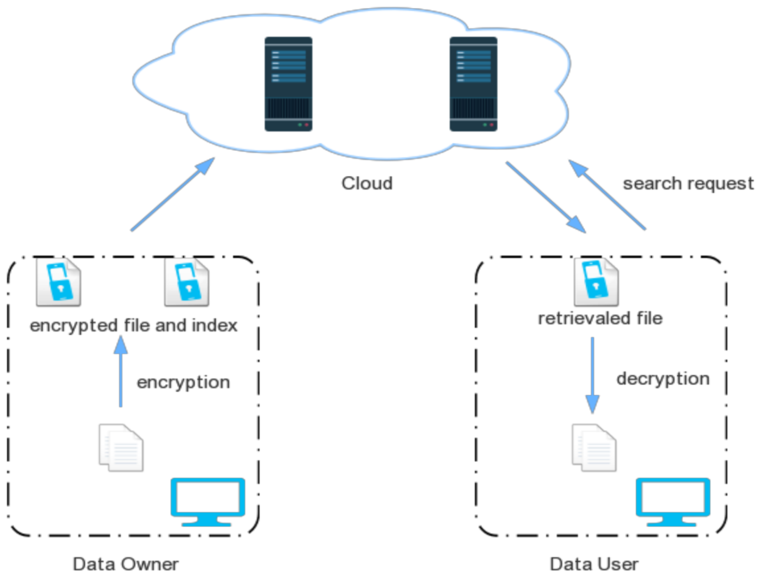

CHAPTER 4
TESTING AND IMPLEMENTATION

  - TESTING
Implementation is the stage of the project when the theoretical design is turned into a working system. This is the final and important phase in the system life cycle It is actually the process of converting the new system into a operational one.

4.1.1Unit Testing
Unit testing comprises the set of tests performed by an individual programmer prior to integration of the unit into a larger system. The module interface is tested to ensure that information properly flows into and out of the program unit. The local data structure is examined to ensure that data stored temporarily maintains its integrity during all steps in an algorithm’s execution. Boundary conditions are tested to ensure that the module operates properly at boundaries established to limit or restrict processing. All independent paths through the control structure are tested. All error-handling paths are tested.

4.1.2 Block Box Testing
Black-box testing is a method of software testing that examines the functionality of an application without peering into its internal structures or workings. This method of test can be applied virtually to every level of software testing: unit, integration, system and acceptance. It is sometimes referred to as specification-based testing.

4.2 SYSTEM IMPLEMENTATION
Implementation is the stage of the project when the theoretical design is turned into a working system. This is the final and important phase in the system life cycle It is actually the process of converting the new system into a operational one.

CHAPTER 5
CONCLUSION:
In this work we proposed puncturable encryption, a new primitive that allows users to control which ciphertexts their keys may decrypt. By combining this primitive with an efficient FS-PKE scheme, we showed that the two schemes can be used in practice in real messaging systems. This work leaves several open question. One major question is whether puncturable encryption can be realized from alternative building blocks besides Attribute-Based Encryption. In particular, it is interesting to consider whether puncturable encryption can be constructed from elliptic curve groups that do not support pairings. A second set of questions deals with ways to improve the efficiency of this scheme and make it more practical for deployment, including specific techniques for outsourcing the decryption of forward secure ciphertexts.

CHAPTER-6
REFERENCE
- [1] Forward secrecy for asynchronous messages. https://whispersystems. org/blog/asynchronous-security/. Accessed: 2014-11-13.
- [2] Google End-To-End. Available at https://code.google.com/p/ end-to-end/.
- [3] Pond. https://github.com/WhisperSystems/TextSecure/wiki/ProtocolV2. Accessed: 2014-11-13.
- [4] Textsecure. https://github.com/WhisperSystems/TextSecure/wiki/ ProtocolV2. Accessed: 2014-11-13.
- [5] The GNU Privacy Guard. https://www.gnupg.org/
- [6] Joseph A Akinyele, Matthew Green, and Susan Hohenberger. Using SMT solvers to automate design tasks for encryption and signature schemes. In Proceedings of the 2013 ACM SIGSAC conference on Computer & communications security, pages 399–410. ACM, 2013.
- [7] D. F. Aranha and C. P. L. Gouvea. RELIC is an Efficient LIbrary for ˆ Cryptography. http://code.google.com/p/relic-toolkit/.
- [8] Adam Back and Ben Laurie. Forward Secrecy Extensions for OpenPGP. Available at https://tools.ietf.org/html/draft-brown-pgp-pfs-01, August 2000.
- [9] Paulo S.L.M. Barreto and Michael Naehrig. Pairing-Friendly Elliptic Curves of Prime Order, volume 3897, pages 319–331. Springer Berlin Heidelberg, 2006.
- [10] Alexandra Boldyreva, Vipul Goyal, and Virendra Kumar. Identity-based encryption with efficient revocation. In Proceedings of the 15th ACM conference on Computer and communications security, pages 417–426. ACM, 2008.

