A Load-Balanced Re-embedding Scheme for Wireless Network Virtualization

ABSTRACT
In wireless network virtualization processes, load imbalance in substrate nodes and substrate links may significantly reduce the number of virtual network requests served by a substrate network. In addition, load imbalance also impairs resource utilization and increases embedding cost of the virtual networks. To tackle these issues, this work proposes a re-embedding scheme for virtual node (RSVN). Based on the load condition of a substrate network, RSVN first determines whether to start re-embedding procedure or not, and then selects proper re-embedded virtual nodes according to their re-embedding factors. Next, RSVN re-embeds the selected virtual nodes to balance the loads of a wireless substrate network. The extensive simulation results showed that RSVN improves the acceptance ratio of virtual network requests, increases the resource utilization of substrate networks, and reduces the average embedding cost of the entire virtual networks.

CHAPTER 2
2. SYSTEM ANALYSIS
  - EXISTING SYSTEM

- Network Virtualization allows the co-existence of multiple Virtual Networks (VNs) on the same physical infrastructure (often referred as substrate network, SN).
- Virtual Network Embedding (VNE) maps the virtual nodes and links requests from users onto the graph representing the physical infrastructure nodes and links and their connectivity.
- The algorithm focuses on virtual nodes requiring more resources by extending their allocations and maintaining their connectivity (even if the node is migrated) to other resources while tidying up (or consolidating) the infrastructure. The algorithm outperforms existing approaches.
- Unfortunately, they lead to network instability and service disruptions.
2.1.1 DRAWBACKS OF EXISTING SYSTEM :
- We identify a new flow scheduling problem in big data centers in clouds, i.e., dynamical load-balanced scheduling (DLBS), and formulate the DLBS problem.
- We propose a set of heuristic scheduling algorithms to address the DLBS problem.
- We firstly formulate the DLBS problem, and then develop a set of efficient heuristic scheduling algorithms for the two typical OpenFlow network models, which balance data flows time slot by time slot.
- Load-balanced flow scheduling for big data centers in clouds, in which a large amount of data needs to be transferred frequently among thousands of interconnected servers, is a key and challenging issue.
2.2. PROPOSED SYSTEM
- To circumvent this problem, some metrics for AP association that define a relation between RSSI and the amount of associated stations to an AP were proposed.
- Alternative approaches have been proposed, which perform a load balancing among APs by including load conditions in the frames in order to allow the STA to select the least loaded AP.
- In the proposed mechanism, the STAs manage associations with multiple APs using one virtual wireless interface for each AP.
- The performance of the proposed load balancing mechanism is closely tied to the active time duration of each virtual interface.
- Therefore, the proposed virtualization mechanism provides a dynamic load balancing across the APs while performing a fair resource sharing between STAs.
2.2.1. ADVANTAGES OF PROPOSED SYSTEM
- Load balancing means that all resources in a system are equally shared by all tasks in some measures. It can be mathematically described by means of a performance criterion.
- The performance of mid-way load-balanced scheduling can be measured by the network throughput under realistic conditions in the two network models.
- Thus, we can conclude that our DLBS can efficiently balance the global load so that it significantly improves throughput, transmission delay and bandwidth utilization rate especially under non-uniform network transmission patterns.
- This system can adaptively schedules a multi-stage switching fabric to efficiently utilize aggregated network resources.
Literature Survey:
TITLE | AUTHORS | DESCRIPTION
Joint Static and Dynamic Traffic Scheduling in Data Center Networks | Z.Z.Cao, M.Kodialam and T.V.Lakshman. | Various multilayer architectures employing thousands of switches have been proposed in the literature.
Bias Correction in Small Sample from Big Data | J.Lu, D.Li, | We point out that when small samples are used, there is a bias that is no longer negligible.
Grand Challenge: Applying Regulatory Science and Big Data to Improve Medical Device Innovation | A.G.Erdman, D.F.Keefe, R. Schiestl, | Today, designing and manufacturing medical devices requires extensive and expensive product cycles.
Efficient Skyline Computation on Big Data | X.Han, J.Li, D.Yang et al., | Skyline is an important operation in many applications to return a set of interesting points from a potentially huge data space.

2.3 FEASIBILITY STUDY
The feasibility Analysis is an analytical program through project manager determines the project success ratio and through feasibility study project manager able to see either project. The key considerations involved in the feasibility analysis are:
- Economic Feasibility
- Technical Feasibility
- Operational Feasibility
- Environmental Feasibility
2.3.1 ECONOMICAL FEASIBILITY
Hence this project is economically feasible there is no need to involve any cost for this project.
2.3.2 TECHNICAL FEASIBILITY
Software Technologies used are PHP and MySql. In the educational institutions, it is possible to update the system in future. No special hardware is required for the purpose of using this system. Hence it is declared that this project is technically feasible.
2.3.3 OPERATIONAL FEASIBILITY
As the admin work mainly to maintain the Patient and Doctor .Doctor will predict patient cancer disease. Hence it is easy to operate with training. Therefore it is operationally feasible for implementation.
2.3.4 ENVIRONMENTAL FEASIBILITY
This project environment is correct as a admin has developed this system and no expenditure is involved under any head and this process is part of admin document management, this project environment is accessible.
2.4 SYSTEM REQUIREMENTS
- System : Pentium IV 2.4 GHz.
- Hard Disk : 40 GB.
- Monitor : 15 inch VGA Color.
- Mouse : Logitech Mouse.
- Ram : 512 MB
- Keyboard : Standard Keyboard

2.4.1 HARDWARE REQUIREMENTS
The Hardware of the computer consists of physical component such as Input Devices, Storage Devices, Processing & Control units and Output Devices. Computer includes external storage unit to store data in programs.
The Hardware Configuration involved in this project
- System : Pentium IV 2.4 GHz.
- Hard Disk : 40 GB.
- Monitor : 15 inch VGA Color.
- Mouse : Logitech Mouse.
- Ram : 512 MB
- Keyboard : Standard Keyboard

2.4.2 SOFTWARE REQUIREMENTS
Software is a group of programs that computers need to do a particular task. It is an essential requirement of Computer System. The Software used to develop the project is
- Operating System : Windows XP.
- Platform : DOT NET TECHNOLOGY
- Front End : ASP.Net 3.5
- Back End : SQL SERVER 2005

CHAPTER 3
SYSTEM DESIGN AND DEVELOPEMENT
SYSTEM ARCHICTURE

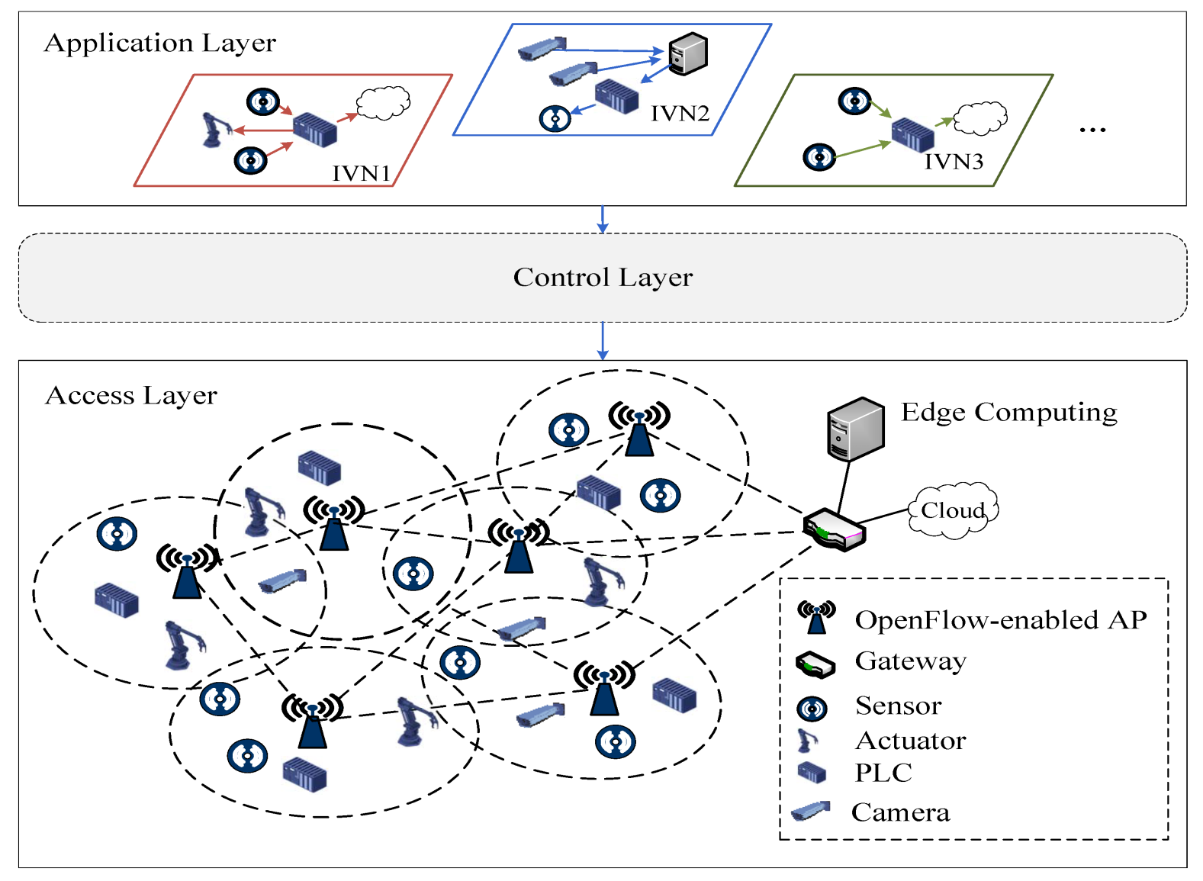

CHAPTER 4
TESTING AND IMPLEMENTATION

  - TESTING
Implementation is the stage of the project when the theoretical design is turned into a working system. This is the final and important phase in the system life cycle It is actually the process of converting the new system into a operational one.

4.1.1Unit Testing
Unit testing comprises the set of tests performed by an individual programmer prior to integration of the unit into a larger system. The module interface is tested to ensure that information properly flows into and out of the program unit. The local data structure is examined to ensure that data stored temporarily maintains its integrity during all steps in an algorithm’s execution. Boundary conditions are tested to ensure that the module operates properly at boundaries established to limit or restrict processing. All independent paths through the control structure are tested. All error-handling paths are tested.

4.1.2 Block Box Testing
Black-box testing is a method of software testing that examines the functionality of an application without peering into its internal structures or workings. This method of test can be applied virtually to every level of software testing: unit, integration, system and acceptance. It is sometimes referred to as specification-based testing.

4.2 SYSTEM IMPLEMENTATION
Implementation is the stage of the project when the theoretical design is turned into a working system. This is the final and important phase in the system life cycle It is actually the process of converting the new system into a operational one.

CHAPTER 5
CONCLUSION:
In this work, we address the load-balanced scheduling problem through balancing transmission traffic dynamically and globally in cloud data centers. Aiming at two typical OpenFlow architectures: FPN and FTN, we proposed and implemented a set of efficient scheduling algorithms DLBSFPN and DLBS-FTN respectively. Compared with existing scheduling schemes for load balancing and route selection, our algorithms have two main advantages. Firstly, our algorithms can adapt to dynamical network states and changing traffic requirements through updating load imbalance factor δ(t) and accordingly balancing the transmission load slot by slot during data transmissions. Next, our algorithms can globally balance transmission traffic in the whole network by means of evaluating link, path and network bandwidth utilization ratio proposed in this paper.

CHAPTER-6
REFERENCE
- [1] Z.Z.Cao, M.Kodialam and T.V.Lakshman. Joint Static and Dynamic Traffic Scheduling in Data Center Networks. in Proceedings of IEEE INFOCOM 2014, pp.2445-2553.
- [2] J.Lu, D.Li, Bias Correction in Small Sample from Big Data, IEEE Transactions on Knowledge and Data Engineering, Vol.25, No.11, 2013, pp.2658-2663.
- [3] A.G.Erdman, D.F.Keefe, R. Schiestl, Grand Challenge: Applying Regulatory Science and Big Data to Improve Medical Device Innovation, IEEE Transactions on Biomedical Engineering, 60(3) (2013) 700-706.
- [4] X.Han, J.Li, D.Yang et al., Efficient Skyline Computation on Big Data, IEEE Transactions on Knowledge and Data Engineering, Vol.25, No.11, 2013, pp.2521-2535.
- [5] A.G.Erdman, D.F.Keefe, R.Schiestl, Grand Challenge: Applying Regulatory Science and Big Data to Improve Medical Device Innovation, IEEE Transactions on Biomedical Engineering, Vol.60, No.3, 2013, pp.700-706.
- [6] K.Greene, TR10: Software-Defined Networking, MIT Technology Review, Retrieved Oct. 7, 2011.
- [7] R.M.Pathan and J.Jonsson. Load regulating algorithm for staticpriority task scheduling on multiprocessors. Proc. of 2010 IEEE International Symposium on Parallel and Distributed Processing (IPDPS), 2010, pp. 1-12.
- [8] N.Handigol, S.Seetharaman, M.Flajslik, N.McKeown, and R.Johari, Plug-n-Serve: Load-balancing web traffic using OpenFlow, Demo at ACM SIGCOMM, Aug. 2009.
- [9] M.Schlansker, Y.Turner, J.Tourrilhes, and A.Karp, Ensemble Routing for Datacenter Networks, In ACM ANCS, La Jolla, CA, 2010.
- [10] R.Wang, D.Butnariu, and J. Rexford, OpenFlow-Based Server Load Balancing Gone Wild, in: Proceedings of Workshop on HotICE, Mar. 2011.

