NISA Node Identification and Spoofing Attack Detection Based on Clock Features and Radio Information for Wireless Sensor Networks

ABSTRACT
Node identification based on unique hardware features like clock skews has been considered an efficient technique in wireless sensors networks (WSNs). Spoofing attacks imitating unique hardware features, however, could significantly impair or break down conventional clock-skew-based node identification due to exposed clock information through broadcasting. To defend against Spoofing attacks, we propose a new node identification scheme called node identification against Spoofing attack (NISA). It utilizes the reverse time synchronization framework, where sensor nodes’ clock skews are estimated at the head of a WSN, and the spatially-correlated radio link information to achieve simultaneous node identification and attack detection. We further provide centralized and distributed NISA for covering both single-hop and multi-hop scenarios, the former of which employs a single-input and multiple-output convolutional neural network. With a real WSN testbed consisting of TelosB sensor nodes running TinyOS, we investigate the identifiability of clock skews under temperature and voltage variations and evaluate the performance of both centralized and distributed NISA. Experimental results demonstrate that both centralized and distributed NISA could provide accurate node identification and Spoofing attack detection.

CHAPTER 2
2. SYSTEM ANALYSIS
  - EXISTING SYSTEM

- This paper studies the algorithm design and analysis in secure time synchronization for resource-constrained industrial wireless sensor networks under Sybil attacks, which cannot be well addressed by existing methods.
- Extensive simulations were conducted to demonstrate the efficiency of NiSTS and compare it with existing protocols.
- In existing time synchronization protocols against message manipulation attacks, a safe node disguised by the Sybil attackers would be regarded as a malicious node, and lose synchronization with other nodes.
- The first phase consists of message filtering rather than node isolation. The second phase involves updating the logical clock parameters based on an existing time synchronization algorithm.
2.1.1 DRAWBACKS OF EXISTING SYSTEM :
- The wireless network nodes can be attacked with the help of using the low cost sensor devices in which the spoofing attacks can be launched easily and make damage in the network and affect the performance of the network.
- DDoS Flooding attacks are the biggest problems in area of security. These flooding attacks make the explicit attempts to disturb the correct users to access the services.
- These attacks gain control over the nodes in the network by exploiting their vulnerabilities.
- Some mechanism is usually requires the comprehensive understanding of the problem and the techniques to prevent the attacks.
2.2. PROPOSED SYSTEM
- A node-identification-based secure time synchronization (NiSTS) protocol is proposed.
- Some countermeasures against Sybil attacks have been proposed based on key management and neighboring time information.
- However, they consume more computation, communication, storage, and hardware resources, which are not desirable for resource-constrained IWSNs.
- The proposed NiSTS consists of two parts: the detection process to filter malicious messages and the clock update process to realize time synchronization.
- Next, we detail the detection process, the design of NiSTS with the update rules, and the performance analysis.
2.2.1. ADVANTAGES OF PROPOSED SYSTEM
- The performance level of this prevention mechanism is better as that of the detection mechanism which is obtained theoretically.
- The shortest path from the source node to destination node was selected by using the AODV,. prevention mechanism will be very helpful for the quick identification of the attackers and also improve the network performance.
- The most efficient protocols in obtaining the shortest path and lower power consumption. It is mainly used in the Ad-hoc networks and wireless networks.
- There are various mechanisms are used to find out the route selection like the On-Demand Distance vector, DSR have been imposed in which the AODV is imposed through which the path can be selected efficiently to transfer the data.
Literature Survey:
TITLE | AUTHORS | DESCRIPTION
An Approach to Defend Against Warm hole Attack In Ad Hoc Network Using The Digital Signature | Sharma.p,Trivedi,A | The Wormhole attack is the most attention seeking attack in ad hoc networks; it consists of two malicious nodes and a tunnel between malicious nodes.
A Secure Method For Transferring Active Packet Using The Digital Signature Schemes | Youngsoo Kim, Daejeon, Jungchan Na, Seungwon Sohn | Flexibility is a powerful merit of active networks, but it can raise considerable security problems.
On The Node Clone Detection In Wireless Sensor Networks | Zhijun Li and Guang Gong | Wireless sensor networks are vulnerable to the node clone, and several distributed protocols have been proposed to detect this attack.
A Survey of Defence Mechanisms Against Distributed Denial of Service(DDoS) Flooding Attacks | Saman Taghavi Zargar, James Joshi, David Tipper | We categorize the DDoS flooding attacks and classify existing countermeasures based on where and when they prevent, detect, and respond to the DDoS flooding attacks.

2.3 FEASIBILITY STUDY
The feasibility Analysis is an analytical program through project manager determines the project success ratio and through feasibility study project manager able to see either project. The key considerations involved in the feasibility analysis are:
- Economic Feasibility
- Technical Feasibility
- Operational Feasibility
- Environmental Feasibility
2.3.1 ECONOMICAL FEASIBILITY
Hence this project is economically feasible there is no need to involve any cost for this project.
2.3.2 TECHNICAL FEASIBILITY
Software Technologies used are PHP and MySql. In the educational institutions, it is possible to update the system in future. No special hardware is required for the purpose of using this system. Hence it is declared that this project is technically feasible.
2.3.3 OPERATIONAL FEASIBILITY
As the admin work mainly to maintain the Patient and Doctor .Doctor will predict patient cancer disease. Hence it is easy to operate with training. Therefore it is operationally feasible for implementation.
2.3.4 ENVIRONMENTAL FEASIBILITY
This project environment is correct as a admin has developed this system and no expenditure is involved under any head and this process is part of admin document management, this project environment is accessible.
2.4 SYSTEM REQUIREMENTS
- System : Pentium IV 2.4 GHz.
- Hard Disk : 40 GB.
- Monitor : 15 inch VGA Color.
- Mouse : Logitech Mouse.
- Ram : 512 MB
- Keyboard : Standard Keyboard

2.4.1 HARDWARE REQUIREMENTS
The Hardware of the computer consists of physical component such as Input Devices, Storage Devices, Processing & Control units and Output Devices. Computer includes external storage unit to store data in programs.
The Hardware Configuration involved in this project
- System : Pentium IV 2.4 GHz.
- Hard Disk : 40 GB.
- Monitor : 15 inch VGA Color.
- Mouse : Logitech Mouse.
- Ram : 512 MB
- Keyboard : Standard Keyboard

2.4.2 SOFTWARE REQUIREMENTS
Software is a group of programs that computers need to do a particular task. It is an essential requirement of Computer System. The Software used to develop the project is
- Operating System : Windows XP.
- Platform : DOT NET TECHNOLOGY
- Front End : ASP.Net 3.5
- Back End : SQL SERVER 2005

CHAPTER 3
SYSTEM DESIGN AND DEVELOPEMENT
SYSTEM ARCHICTURE

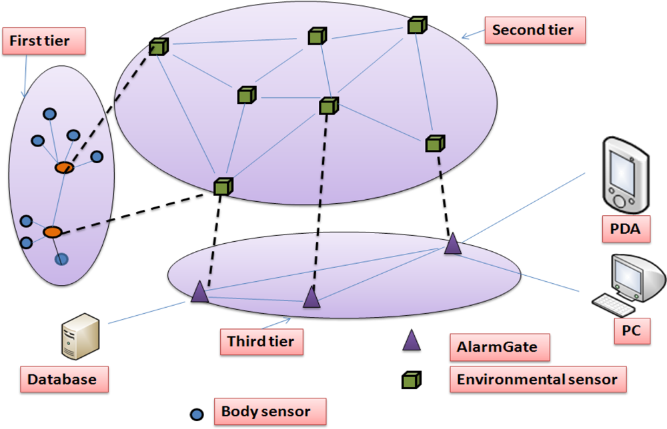

CHAPTER 4
TESTING AND IMPLEMENTATION

  - TESTING
Implementation is the stage of the project when the theoretical design is turned into a working system. This is the final and important phase in the system life cycle It is actually the process of converting the new system into a operational one.

4.1.1Unit Testing
Unit testing comprises the set of tests performed by an individual programmer prior to integration of the unit into a larger system. The module interface is tested to ensure that information properly flows into and out of the program unit. The local data structure is examined to ensure that data stored temporarily maintains its integrity during all steps in an algorithm’s execution. Boundary conditions are tested to ensure that the module operates properly at boundaries established to limit or restrict processing. All independent paths through the control structure are tested. All error-handling paths are tested.

4.1.2 Block Box Testing
Black-box testing is a method of software testing that examines the functionality of an application without peering into its internal structures or workings. This method of test can be applied virtually to every level of software testing: unit, integration, system and acceptance. It is sometimes referred to as specification-based testing.

4.2 SYSTEM IMPLEMENTATION
Implementation is the stage of the project when the theoretical design is turned into a working system. This is the final and important phase in the system life cycle It is actually the process of converting the new system into a operational one.

CHAPTER 5
CONCLUSION:
The attack prevention mechanism in the spoofing and the spoofing related attacks like the flooding and the man in the middle attack are effective compared to that of the detection mechanism where the attack is detected and then determining the number of attackers and then the location of the attacker is obtained. Using the neighbour node signature verification method the attackers are identified and prevented through which the data is transferred through the correct node. The performance level of this prevention mechanism is better as that of the detection mechanism which is obtained theoretically. It reduce the time, cost and energy consumption, and by only using this prevention method cannot guarantee that it can prevent all the attacks and there may be a chance of some exception that attacker exists, hence we can make this as the future enhancement using the advanced detection mechanism through which some attackers which exists in the prevention mechanism can be detected and prevent the other nodes in the network by giving alert information and prevent them by providing access to the network resources.

CHAPTER-6
REFERENCE
- [1] Sharma.p,Trivedi,A “An Approach to Defend Against Warm hole Attack In Ad Hoc Network Using The Digital Signature” Communication Software and Networks(ICCSN) 2011 IEEE 3rd International Conference on may 2011.
- [2] Youngsoo Kim, Daejeon, Jungchan Na, Seungwon Sohn “A Secure Method For Transferring Active Packet Using The Digital Signature Schemes” Telecommunications, 2003. ICT 2003. 10th International Conference Vol.01 on 23 Feb 2003 .
- [3] Zhijun Li and Guang Gong “On The Node Clone Detection In Wireless Sensor Networks” IEEE/ACM Transactions on networking, Vol.21,No.6,December 2013.
- [4] Saman Taghavi Zargar, James Joshi, David Tipper “A Survey of Defence Mechanisms Against Distributed Denial of Service(DDoS) Flooding Attacks” IEEE Communications Surveys & Tutorials Vol.15 Fourth Quarter 2013.
- [5] Joshi, Y, Das, D. ; Saha, S.”Mitigating Man in the Middle Attack Over Secure Socket Layer” on Internet Multimedia Services Architecture and Applications (IMSAA), 2009 IEEE International Conference on Dec.2009.
- [6] Guha, R.K. Furqan, Zeeshan ,Muhammad, Shahabuddin “Discovering Man in The Middle Attacks in Authentication protocols” Military Communications Conference, 2007. MILCOM 2007. IEEE on 31 oct 2007.
- [7] Chakeres, I.D. Belding-Royer, E.M. "AODV Routing Protocol Design Implementation” Distributed Computing Systems Workshops, 2004. Proceedings. 24th International Conference on march 2004
- [8] Royer, E.M. “An Implementation Study of the AODV Routing Protocol” Wireless Communications and Networking Confernce, 2000. WCNC. 2000 IEEE Vol.3 Sep 2003.
- [9] Jensen, M. Gruschka, N. ; Luttenberger, N “The Impact of Flooding Attacks on Network-Based Services” Availability, Reliability and Security, 2008. ARES 08. Third International Conference on March 2008.

