GCN2CDD A Commercial District Discovery Framework via Embedding Space Clustering on Graph Convolution Networks

ABSTRACT
Modern enterprises attach much attention to the selection of commercial locations. With the rapid development of urban data and machine learning, we can discover the patterns of human mobility with these data and technology to guide commercial district discovery. In this paper, we propose an unsupervised commercial district discovery framework via embedding space clustering on graph convolution networks (GCN2CDD) to solve the problem of commercial district discovery. Specifically, the proposed framework aggregates human mobility features according to geographic similarity by graph convolution networks. Based on the graph convolution networks embedding space, we apply hierarchical clustering to mine the latent functional regions hidden in different human patterns. Then with the kernel density estimation, we can obtain the semantic labels for the clustering results to discover commercial districts. Finally, we analyze the multi-sources data of the Xiaoshan District and Chengdu City and experiments verify the effectiveness of our framework.

CHAPTER 2
2. SYSTEM ANALYSIS
  - EXISTING SYSTEM

- We provide a detailed review over existing graph neural network models. We present a general design pipeline and discuss the variants of each module. We also introduce researches on theoretical and empirical analyses of GNN models.
- Edge-level tasks are edge classification and link prediction, which require the model to classify edge types or predict whether there is an edge existing between two given nodes.
- It uses the confidence-driven scheme to adaptively select the starting node and determine the node updating sequence.
- It follows the same idea of generalizing the existing LSTMs into the graph-structured data but has a specific updating sequence while methods mentioned above are agnostic to the order of nodes.
2.1.1 DRAWBACKS OF EXISTING SYSTEM :
- Many deep learning models have been proposed to solve the traffic flow prediction problem with the more expansive urban road sensing device arrangement and improved recognition accuracy.
- Therefore, the Cross-correlation method overcomes the phase sliding problem and compares the shape similarity of two-time series.
- In practice, the normalized value of Cross-correlation is usually used to limit the range to be within [−1, 1], where 1 means strong correlation and −1 means that they are completely opposite.
- Traffic congestion on urban roads is an important issue that needs to be addressed in smart cities’ development.
2.2. PROPOSED SYSTEM
- Based on CNNs and graph embedding, variants of graph neural networks (GNNs) are proposed to collectively aggregate information from graph structure.
- Apart from different variants of spatial approaches, several general frameworks are proposed aiming to integrate different models into one single framework.
- Neural network-based models require abundant labeled data and it is costly to obtain enormous human-labeled data.
- Selfsupervised methods are proposed to guide models to learn from unlabeled data which is easy to obtain from websites or knowledge bases.
2.2.1. ADVANTAGES OF PROPOSED SYSTEM
- We used the Simulation of Urban Mobility simulation platform to evaluate the performance of the proposed method under different traffic demand conditions, and the experimental results show that the proposed method can reduce the density of mainline bottlenecks and improve the efficiency of mainline traffic.
- We compared the performance of the proposed method and the traditional method under different traffic demands.
- The processed data is smoother and more continuous than the raw data, which is consistent with the real situation and helps the neural network’s training, and improves the neural network’s prediction performance.
- The distance-flow-based method and traffic-state-based method have a better performance on the congestion reduction.
Literature Survey:
TITLE | AUTHORS | DESCRIPTION
A comparative study for outlier detection techniques in data mining | Bakar ZA, Mohemad R, Ahmad A, Deris MM. 2006. | Existing studies in data mining mostly focus on finding patterns in large datasets and further using it for organizational decision making.
Using dynamic time warping to find patterns in time series | Berndt DJ, Clifford J. 1994. | In this paper, we present a simple technique for time series classification that exploits DTW’s strength on this task.
Optimization of mainline traffic via an adaptive co-ordinated ramp-metering control model with dynamic OD estimation | Chang TH, Li ZY. 2002. | Frequently implemented at freeway accesses to streamline traffic, ramp-metering control strategy is often implemented during rush hours in heavily congested areas.
Adaptive ramp metering control for Urban freeway using large-scale data | Chen J, Lin W, Yang Z, Li J, Cheng P. 2019a. | Urban freeway traffic control is of great importance for traffic management and intelligent transportation systems.

2.3 FEASIBILITY STUDY
The feasibility Analysis is an analytical program through project manager determines the project success ratio and through feasibility study project manager able to see either project. The key considerations involved in the feasibility analysis are:
- Economic Feasibility
- Technical Feasibility
- Operational Feasibility
- Environmental Feasibility
2.3.1 ECONOMICAL FEASIBILITY
Hence this project is economically feasible there is no need to involve any cost for this project.
2.3.2 TECHNICAL FEASIBILITY
Software Technologies used are PHP and MySql. In the educational institutions, it is possible to update the system in future. No special hardware is required for the purpose of using this system. Hence it is declared that this project is technically feasible.
2.3.3 OPERATIONAL FEASIBILITY
As the admin work mainly to maintain the Patient and Doctor .Doctor will predict patient cancer disease. Hence it is easy to operate with training. Therefore it is operationally feasible for implementation.
2.3.4 ENVIRONMENTAL FEASIBILITY
This project environment is correct as a admin has developed this system and no expenditure is involved under any head and this process is part of admin document management, this project environment is accessible.
2.4 SYSTEM REQUIREMENTS
- System : Pentium IV 2.4 GHz.
- Hard Disk : 40 GB.
- Monitor : 15 inch VGA Color.
- Mouse : Logitech Mouse.
- Ram : 512 MB
- Keyboard : Standard Keyboard

2.4.1 HARDWARE REQUIREMENTS
The Hardware of the computer consists of physical component such as Input Devices, Storage Devices, Processing & Control units and Output Devices. Computer includes external storage unit to store data in programs.
The Hardware Configuration involved in this project
- System : Pentium IV 2.4 GHz.
- Hard Disk : 40 GB.
- Monitor : 15 inch VGA Color.
- Mouse : Logitech Mouse.
- Ram : 512 MB
- Keyboard : Standard Keyboard

2.4.2 SOFTWARE REQUIREMENTS
Software is a group of programs that computers need to do a particular task. It is an essential requirement of Computer System. The Software used to develop the project is
- Operating System : Windows XP.
- Platform : DOT NET TECHNOLOGY
- Front End : ASP.Net 3.5
- Back End : SQL SERVER 2005

CHAPTER 3
SYSTEM DESIGN AND DEVELOPEMENT
SYSTEM ARCHICTURE

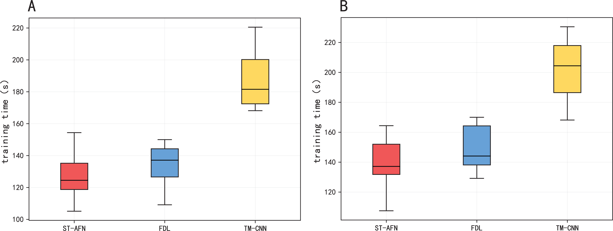

CHAPTER 4
TESTING AND IMPLEMENTATION

  - TESTING
Implementation is the stage of the project when the theoretical design is turned into a working system. This is the final and important phase in the system life cycle It is actually the process of converting the new system into a operational one.

4.1.1Unit Testing
Unit testing comprises the set of tests performed by an individual programmer prior to integration of the unit into a larger system. The module interface is tested to ensure that information properly flows into and out of the program unit. The local data structure is examined to ensure that data stored temporarily maintains its integrity during all steps in an algorithm’s execution. Boundary conditions are tested to ensure that the module operates properly at boundaries established to limit or restrict processing. All independent paths through the control structure are tested. All error-handling paths are tested.

4.1.2 Block Box Testing
Black-box testing is a method of software testing that examines the functionality of an application without peering into its internal structures or workings. This method of test can be applied virtually to every level of software testing: unit, integration, system and acceptance. It is sometimes referred to as specification-based testing.

4.2 SYSTEM IMPLEMENTATION
Implementation is the stage of the project when the theoretical design is turned into a working system. This is the final and important phase in the system life cycle It is actually the process of converting the new system into a operational one.

CHAPTER 5
CONCLUSION:
To address expressway congestion, we propose a coordinated signal optimization framework based on dynamic traffic states. In this article, the GRU neural network was used to predict the traffic flow. Cross-correlation obtains the dynamic correlation between the bottleneck and ramp traffic flow. Our framework considers both static road property and dynamic traffic state to achieve signal optimization compared with previous research. The performance of our algorithm was verified on the SUMO simulation platform. The results show that our approach can reduce the mainline bottleneck density by 7.1% and 13.0% under normal and heavy demand, separately. We also found that it is a more reasonable option in the lower traffic demand scenario without using a signal. Moreover, in congested scenarios, the use of signal optimization can reduce the density of the mainline.

CHAPTER-6
REFERENCE
- Bakar ZA, Mohemad R, Ahmad A, Deris MM. 2006. A comparative study for outlier detection techniques in data mining. In: IEEE Conference on Cybernetics and Intelligent Systems. Piscataway: IEEE, 1–6.
- Berkhin P. 2006. A survey of clustering data mining techniques. In: Kogan J, Nicholas C, Teboulle M, eds. Grouping Multidimensional Data. Heidelberg: Springer, 25–71.
- Berndt DJ, Clifford J. 1994. Using dynamic time warping to find patterns in time series. In: KDD Workshop. 359–370.
- Chang TH, Li ZY. 2002. Optimization of mainline traffic via an adaptive co-ordinated ramp-metering control model with dynamic OD estimation. Transportation Research Part C: Emerging Technologies 10(2):99–120 DOI 10.1016/S0968-090X(01)00006-7.
- Chen J, Lin L, Jiang R. 2017. Assigning on-ramp flows to maximize capacity of highway with two on-ramps and one off-ramp in between. Physica A: Statistical Mechanics and its Applications 465:347–357 DOI 10.1016/j.physa.2016.08.053.
- Chen J, Lin W, Yang Z, Li J, Cheng P. 2019a. Adaptive ramp metering control for Urban freeway using large-scale data. IEEE Transactions on Vehicular Technology 68(10):9507–9518 DOI 10.1109/TVT.2019.2937880.
- Chen Y, Liu F, Bai Q, Tao C, Qi X. 2019b. Coordinated ramp metering based on real-time OD information. IEEE Access 7:79233–79243 DOI 10.1109/ACCESS.2019.2923438.
- Cho K, Van Merriënboer B, Gulcehre C, Bahdanau D, Bougares F, Schwenk H, Bengio Y. 2014. Learning phrase representations using RNN encoder-decoder for statistical machine translation. In: Proceedings of the 2014 Conference on Empirical Methods in Natural Language Processing (EMNLP). 1724–1734.
- Dabiri A, Kulcsar B. 2017. Distributed ramp metering—a constrained discharge flow maximization approach. IEEE Transactions on Intelligent Transportation Systems 18(9):2525–2538 DOI 10.1109/TITS.2017.2673782.
- Erdmann J. 2015. SUMO’s lane-changing model. In: Behrisch M, Weber M, eds. Modeling Mobility with Open Data—Lecture Notes in Mobility. Cham: Springer, 105–123.

