Supplementary Power Control of an HVDC System and its Impact on Electromechanical Dynamics

ABSTRACT
This paper presents a comprehensive analysis of the impact that supplementary power control of an HVDC link has on the electromechanical dynamics of power systems. The presented work addresses an interesting phenomenon that may occur when an HVDC power controller is installed to support frequency stability. In specific cases, a high gain HVDC frequency controller could deteriorate system damping. The given analytical study is the first of its kind that addresses this issue by including both: (i) the important higher-order generator dynamics that affect small signal stability simultaneously with an HVDC control as well as (ii) the available local angle/frequency input signals of the controller. The methodological approach here analytically formulates the impact an HVDC control has on the single generator dynamics. Furthermore, the relationship between the damping/synchronizing coefficients and the HVDC gain is explicitly derived when a frequency proportional HVDC controller is installed. The derived expressions confirm that, indeed, there is an optimal HVDC gain with respect to the damping coefficient and a typically positive impact of the HVDC controller on the synchronizing component. Finally, the developed theoretical foundation is demonstrated by the tools of linear and nonlinear analysis in a one-machine system case study.

CHAPTER 2
2. SYSTEM ANALYSIS
  - EXISTING SYSTEM

- Power systems are becoming more stressed by the presence of low frequency electromechanical oscillations because the number of interconnections with other power systems increases every day.
- Furthermore, long distance power trading puts more stress on the existing transmission system.
- As a result, low frequency oscillations involving weakly damped interarea modes become more pronounced risking system security and lowering transmission capacity.
- This solution enables power grid owners to increase the existing transmission network capacity while improving the operating margins necessary for grid stability.
2.1.1 DRAWBACKS OF EXISTING SYSTEM :
- The dynamic stability problem is more serious in cases of heavy flow. The most unfavorable flow condition in which VSC-HVDC and generators nearby are in full power operation is used to compare the different dynamic responses of AC/DC system under two control modes.
- Reactive power control modes of the converter cannot be determined before we get a comprehensive knowledge about the influence of VSC-HVDC reactive power control modes on AC power system stability.
- To solve this problem, two reactive power control strategies commonly used in practice are considered, and two types of stability which are most concerned in safety and stability analysis are investigated in this paper.
2.2. PROPOSED SYSTEM
- The proposed coordination basically considered the wind power production and the gain of the control strategy for active power.
- A larger scale coordination of the controllers can be pursued. Coordination wind power production, POD control of wind power, POD control and voltage control of the VSC-HVDC transmission can be included in a more general approach.
- The SIME method relies on information from all generators in power systems, meanwhile with the approach proposed in this thesis, only some generators are considered.
- A coordination between wind park and a distant VSC-HVDC transmission for POD is suggested.
2.2.1. ADVANTAGES OF PROPOSED SYSTEM
- The work in shows that the AC voltage regulation in the VSC-HVDC link may adversely affect the dynamic performance of the host weak AC system under the multi-infeed VSC-HVDC scenario.
- However, the study of implies that the AC voltage regulation in the VSC-HVDC link may adversely affect the dynamic performance of the AC system.
- The simulation results of two independent VSC-HVDC converters in a generic system show that AC voltage control in the converter with a lower short-circuit ratio aggravated the stability of the least damped mode compared to reactive power control.
- When the medium-scale hydropower station is cut off, VSC-HVDC is the only dynamic reactive power source near the converter station.
Literature Survey:
TITLE | AUTHORS | DESCRIPTION
Challenges on the Road to an Offshore HVDC Grid | E. Koldby, M. Hyttinen, | There is already offshore experience with VSC HVDC and the experiences from those projects are good.
Continental Overlay HVDC-Grid | G. Asplund, B. Jacobson, B. Berggren, K. Lindén, | This paper focuses on analyzing the readiness of the current technologies and the challenges associated with overlay HVDC grids
The role of facts and HVDC in the future paneuropean transmission system development | A. L’Abbate, G. Migliavacca, U. Häger, C. Rehtanz, S. Rüberg, H. Ferreira, G. Fulli, A.Purvins, | The present paper focuses on FACTS (Flexible Alternating Current Transmission System) and HVDC (High Voltage Direct Current) transmission technologies.
Operation of HVDC Grids in Parallel withAC Grids | GUSTAVO PINARES CCORIMANYA | The DC voltage of the HVDC system has been identified to be an important parameter analogous to the frequency in AC systems.

2.3 FEASIBILITY STUDY
The feasibility Analysis is an analytical program through project manager determines the project success ratio and through feasibility study project manager able to see either project. The key considerations involved in the feasibility analysis are:
- Economic Feasibility
- Technical Feasibility
- Operational Feasibility
- Environmental Feasibility
2.3.1 ECONOMICAL FEASIBILITY
Hence this project is economically feasible there is no need to involve any cost for this project.
2.3.2 TECHNICAL FEASIBILITY
Software Technologies used are PHP and MySql. In the educational institutions, it is possible to update the system in future. No special hardware is required for the purpose of using this system. Hence it is declared that this project is technically feasible.
2.3.3 OPERATIONAL FEASIBILITY
As the admin work mainly to maintain the Patient and Doctor .Doctor will predict patient cancer disease. Hence it is easy to operate with training. Therefore it is operationally feasible for implementation.
2.3.4 ENVIRONMENTAL FEASIBILITY
This project environment is correct as a admin has developed this system and no expenditure is involved under any head and this process is part of admin document management, this project environment is accessible.
2.4 SYSTEM REQUIREMENTS
- System : Pentium IV 2.4 GHz.
- Hard Disk : 40 GB.
- Monitor : 15 inch VGA Color.
- Mouse : Logitech Mouse.
- Ram : 512 MB
- Keyboard : Standard Keyboard

2.4.1 HARDWARE REQUIREMENTS
The Hardware of the computer consists of physical component such as Input Devices, Storage Devices, Processing & Control units and Output Devices. Computer includes external storage unit to store data in programs.
The Hardware Configuration involved in this project
- System : Pentium IV 2.4 GHz.
- Hard Disk : 40 GB.
- Monitor : 15 inch VGA Color.
- Mouse : Logitech Mouse.
- Ram : 512 MB
- Keyboard : Standard Keyboard

2.4.2 SOFTWARE REQUIREMENTS
Software is a group of programs that computers need to do a particular task. It is an essential requirement of Computer System. The Software used to develop the project is
- Operating System : Windows XP.
- Platform : DOT NET TECHNOLOGY
- Front End : ASP.Net 3.5
- Back End : SQL SERVER 2005

CHAPTER 3
SYSTEM DESIGN AND DEVELOPEMENT
SYSTEM ARCHICTURE

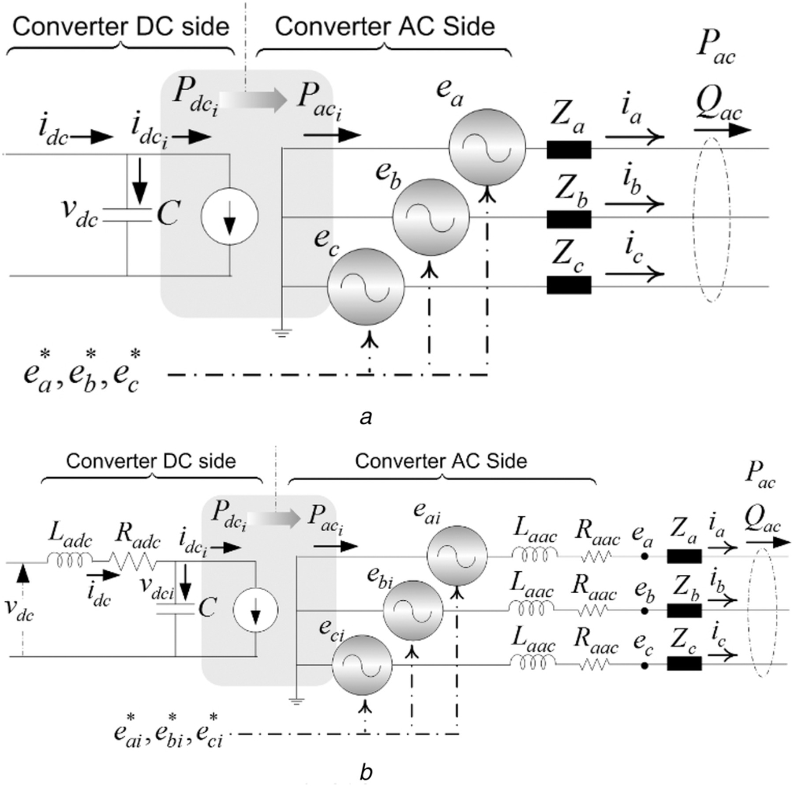

CHAPTER 4
TESTING AND IMPLEMENTATION

  - TESTING
Implementation is the stage of the project when the theoretical design is turned into a working system. This is the final and important phase in the system life cycle It is actually the process of converting the new system into a operational one.

4.1.1Unit Testing
Unit testing comprises the set of tests performed by an individual programmer prior to integration of the unit into a larger system. The module interface is tested to ensure that information properly flows into and out of the program unit. The local data structure is examined to ensure that data stored temporarily maintains its integrity during all steps in an algorithm’s execution. Boundary conditions are tested to ensure that the module operates properly at boundaries established to limit or restrict processing. All independent paths through the control structure are tested. All error-handling paths are tested.

4.1.2 Block Box Testing
Black-box testing is a method of software testing that examines the functionality of an application without peering into its internal structures or workings. This method of test can be applied virtually to every level of software testing: unit, integration, system and acceptance. It is sometimes referred to as specification-based testing.

4.2 SYSTEM IMPLEMENTATION
Implementation is the stage of the project when the theoretical design is turned into a working system. This is the final and important phase in the system life cycle It is actually the process of converting the new system into a operational one.

CHAPTER 5
CONCLUSION:
In this paper, the VSC-HVDC controller is studied for the analysis of power flows and electromechanical transients in power system. The typical VSC-HVDC system is modeled with constant active power and reactive power controller at rectifier and constant AC voltage and DC voltage controller at inverter. Steady state analysis of the system is carried out with the help of voltage magnitudeand angle. Transient stability Analysis with load through off at rectifier is studied and observed that constant active power controller is able to maintain constant power at rectifier.

CHAPTER-6
REFERENCE
- [1] HERTZ, Energinet.dk, Svenska Kraftnät, “Kriegers Flak Combined Grid Solution Feasibility Study,” Joint Report, 24,February,2010.http://www.50hertz.com/en/file/2010-02- 24_Final_Feasibility_Study_Public.pdf.
- [2] E. Koldby, M. Hyttinen, “Challenges on the Road to an Offshore HVDC Grid,” 5thNordic Wind Power Conference, 10-11, September 2009
- [3] G. Asplund, B. Jacobson, B. Berggren, K. Lindén, “Continental Overlay HVDC-Grid,”Cigré Session, Paris, France, 22-27, August, 2010
- [4] A. L’Abbate, G. Migliavacca, U. Häger, C. Rehtanz, S. Rüberg, H. Ferreira, G. Fulli, A.Purvins, “The role of facts and HVDC in the future paneuropean transmission system development,” 9th IET International Conference on AC and DC Power Transmission,London, UK, 19-21 Oct. 2010
- [5] J. Arrillaga, Y.H. Liu, N.R.Watson, Flexible Power Transmission: the HVDC Options,pp. 98, John Wiley and Sons Ltd, 2007.
- [6] GUSTAVO PINARES CCORIMANYA“Operation of HVDC Grids in Parallel withAC Grids”thesis Sweden, 2010.
- [7] J. Arrillaga, C. P. Arnold, “Computer Analysis of Power Systems,” Universityof Canterbury, John Wiley & Sons, 1990.
- [8] STRI AB, “SIMPOW User Manual 11.0,” Release 11, Sweden, 2010.
- [9] Stijn Cole, Jef Beerten, Ronnie Belmans, “Generalized Dynamic VSC MTDC Model for Power System Stability Studies,” IEEE Transactions on Power Systems, Vol 24, No. 4, November, 2009
- [10] Temesgen M. Hailesalassie, Marta Molinas, Tore Undeland, “Multi-terminal VSC-HVDC System for Integration of Offshore Wind Farms and Green Electrification of Platforms in the North Sea,” NORPIE 2008, Espoo, Finland, 9 - 11 June, 2008.

