On the Impact of Auto-Correlation of Stochastic Processes on the Transient Behavior of Power Systems

ABSTRACT
This letter studies the impact of auto-correlation of stochastic processes on the dynamic response of power systems. The frequency spectrum of the trajectories of the state variables of the system is utilized as a metric to evaluate this impact. The case study considers the well- known two-area system as well as with a 1479-bus dynamic model of the all-island Irish transmission system. Simulation results indicate that the auto-correlation have a direct impact on the amplitude of the dominant electro-mechanical modes of the system. Results also show that, for a wide range of the values of the auto-correlation, the impact of stochastic processes on system dynamics is local, affects differently each area of the system and, in some cases, can lead to instability and voltage collapse.

CHAPTER 2
2. SYSTEM ANALYSIS
  - EXISTING SYSTEM

- Using this relationship, we compute the expected waiting time of a newly-arrived customer to begin service; this requires that the existing average number of customers be served.
- Thus, the waiting time for service is computed as the product of the average number of customers in the system times the average departure time per customer.
- While in some cases such processes are local and independent, there exist processes that are intrinsically correlated. For example, in most locations, cloudy days tend to be more windy than clear-sky ones.
- Then the variations of the active and reactive power consumption of loads are coupled if the loads have a constant power factor.
2.1.1 DRAWBACKS OF EXISTING SYSTEM :
- Potential dangerous impacts which are intuitive to utilities are line congestion, transformer overloads and other not foreseen problems at the different grid levels, but mainly in distribution grids.
- Faced with the growing complexity of the future power grid and the stochastic disturbances caused by renewable energy sources such as PHEVS, wind and solar power, this dissertation deals with the issue of the stability of the power system and has presented contributions in the tools developed and analysis carried out to examine the stability of the power system when stochastic loads and generations are present.
- Depending on when and where the vehicles are plugged in, they could cause local or regional constraints on the grid
2.2. PROPOSED SYSTEM
- It is important to note that the proposed model can be applied to systems of any order and complexity without the need of any simplifications or assumptions in the original model.
- The proposed approach to model correlated SDEs using correlated Wiener processes is presented in describes how to include correlated stochastic processes in power systems.
- After that, the model proposed in this paper is capable or generating synthetic noise with the same statistical properties and same correlation.
- The proposed approach, thus, does not need to be continuously fed with measurement data. This is, in turn, one of the practical advantages of the proposed method.
2.2.1. ADVANTAGES OF PROPOSED SYSTEM
- The traditional approach to power system stability studies is based on a deterministic transient energy function.
- However, such a deterministic analysis does not provide a realistic evaluation of system transient performance where the intermittency and variability of energy production associated with any renewable technology needs to be reflected and accurately modeled in system stability and performance assessments.
- Electric motors are inherently more efficient than internal combustion engines; they do not consume energy while vehicles are stationary and they provide the opportunity to recover energy from braking.
- Out of this ambience the promise for more efficient individual transportation is partly represented by PHEVs, mitigating vehicle technology to an increased electrification.
Literature Survey:
TITLE | AUTHORS | DESCRIPTION
Probabilistic constrained load flow considering integration of wind power generation and electric vehicles | J. G. Vlachogiannis, | The developed stochastic model of EV demand/supply and the wind power generation model are incorporated into load flow studies
Probabilistic load modeling for power system expansion planning | M. B. Do Coutto Filho, A. M. Leite Da Silva, V. L. Arienti, S. M. P. Ribeiro, | The proposed TEP model can find the optimal trade-off between transmission investment and demand response expenses.
A Stochastic approach to small disturbance stability analysis | C. O. Nwankpa, S. M. Shahidehpour, Z. Schuss, | A systematic approach to the construction of stochastic models of electric power systems for small disturbance stability analysis is presented.
Probabilistic assessment of transient stability in a practical multimachine system | R. Billinton and P. R. S. Kuruganty, | The application of probabilistic techniques in the quantitative evaluation of power system reliability is steadily increasing.

2.3 FEASIBILITY STUDY
The feasibility Analysis is an analytical program through project manager determines the project success ratio and through feasibility study project manager able to see either project. The key considerations involved in the feasibility analysis are:
- Economic Feasibility
- Technical Feasibility
- Operational Feasibility
- Environmental Feasibility
2.3.1 ECONOMICAL FEASIBILITY
Hence this project is economically feasible there is no need to involve any cost for this project.
2.3.2 TECHNICAL FEASIBILITY
Software Technologies used are PHP and MySql. In the educational institutions, it is possible to update the system in future. No special hardware is required for the purpose of using this system. Hence it is declared that this project is technically feasible.
2.3.3 OPERATIONAL FEASIBILITY
As the admin work mainly to maintain the Patient and Doctor .Doctor will predict patient cancer disease. Hence it is easy to operate with training. Therefore it is operationally feasible for implementation.
2.3.4 ENVIRONMENTAL FEASIBILITY
This project environment is correct as a admin has developed this system and no expenditure is involved under any head and this process is part of admin document management, this project environment is accessible.
2.4 SYSTEM REQUIREMENTS
- System : Pentium IV 2.4 GHz.
- Hard Disk : 40 GB.
- Monitor : 15 inch VGA Color.
- Mouse : Logitech Mouse.
- Ram : 512 MB
- Keyboard : Standard Keyboard

2.4.1 HARDWARE REQUIREMENTS
The Hardware of the computer consists of physical component such as Input Devices, Storage Devices, Processing & Control units and Output Devices. Computer includes external storage unit to store data in programs.
The Hardware Configuration involved in this project
- System : Pentium IV 2.4 GHz.
- Hard Disk : 40 GB.
- Monitor : 15 inch VGA Color.
- Mouse : Logitech Mouse.
- Ram : 512 MB
- Keyboard : Standard Keyboard

2.4.2 SOFTWARE REQUIREMENTS
Software is a group of programs that computers need to do a particular task. It is an essential requirement of Computer System. The Software used to develop the project is
- Operating System : Windows XP.
- Platform : DOT NET TECHNOLOGY
- Front End : ASP.Net 3.5
- Back End : SQL SERVER 2005

CHAPTER 3
SYSTEM DESIGN AND DEVELOPEMENT
SYSTEM ARCHICTURE
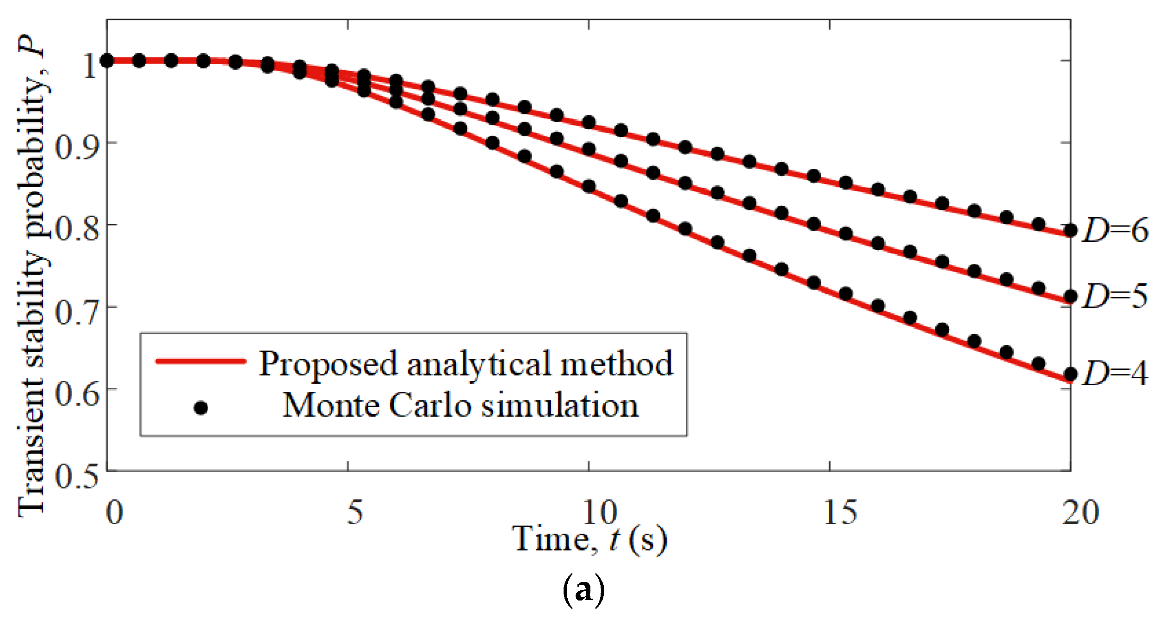

CHAPTER 4
TESTING AND IMPLEMENTATION

  - TESTING
Implementation is the stage of the project when the theoretical design is turned into a working system. This is the final and important phase in the system life cycle It is actually the process of converting the new system into a operational one.

4.1.1Unit Testing
Unit testing comprises the set of tests performed by an individual programmer prior to integration of the unit into a larger system. The module interface is tested to ensure that information properly flows into and out of the program unit. The local data structure is examined to ensure that data stored temporarily maintains its integrity during all steps in an algorithm’s execution. Boundary conditions are tested to ensure that the module operates properly at boundaries established to limit or restrict processing. All independent paths through the control structure are tested. All error-handling paths are tested.

4.1.2 Block Box Testing
Black-box testing is a method of software testing that examines the functionality of an application without peering into its internal structures or workings. This method of test can be applied virtually to every level of software testing: unit, integration, system and acceptance. It is sometimes referred to as specification-based testing.

4.2 SYSTEM IMPLEMENTATION
Implementation is the stage of the project when the theoretical design is turned into a working system. This is the final and important phase in the system life cycle It is actually the process of converting the new system into a operational one.

CHAPTER 5
CONCLUSION:
This paper develops an approach to analyze the impact of random load and generation variations on the transient stability of a power system. The well-known energy function method for power system transient stability is used as a basis to explore the stochastic power system stability through a stochastic Lyapunov stability analysis. Further, the method was extended numerically using the Euler-Maruyama method. It was shown that increasing either (or both) the variance and the magnitude of the applied variation can have a destabilizing effect on the power system. This could potentially cause difficulties as more randomness is introduced into the power system through renewable energy sources and plug-in-hybrid vehicles.

CHAPTER-6
REFERENCE
- [1] J. G. Vlachogiannis, “Probabilistic constrained load flow considering integration of wind power generation and electric vehicles,” IEEE Trans. on Power Systems, vol. 24, no. 4, Nov. 2009.
- [2] M. Meldorf, T. That, J. Kilter, Stochasticity of the Electrical Network Load, Estonian Academy Publishers, 2007.
- [3] M. B. Do Coutto Filho, A. M. Leite Da Silva, V. L. Arienti, S. M. P. Ribeiro, “Probabilistic load modeling for power system expansion planning,” IEE Third International Conference of Probabilistic Methods Applied to Electric Power Systems, 1991.
- [4] C. O. Nwankpa, S. M. Shahidehpour, Z. Schuss, “A Stochastic approach to small disturbance stability analysis,” IEEE Transactions on Power Systems, vol. 7, no. 4, November 1992.
- [5] R. Billinton and P. R. S. Kuruganty, “Probabilistic assessment of transient stability in a practical multimachine system,” IEEE Trans. on Power Apparatus and Systems, vol. 100, no. 7, July 1981.
- [6] F. F. Wu and Y-K Tsai, “Probabilistic dynamic security assessment of power systems: Part I - basic model,” IEEE Trans. on Circuits and Systems, vol. 30, no. 3, March 1983.
- [7] K. J. Timko, A. Bose, P. M. Anderson, “Monte Carlo simulation of power system stability,” IEEE Trans. on Power Apparatus and Systems, vol. 102, no. 10, Oct. 1983.
- [8] H. Mohammed and C. O. Nwankpa, “Stochastic analysis and simulation of gridconnected wind energy conversion system,” IEEE Trans. on Energy Conversion, vol 15, no. 1, March 2000.
- [9] J. R. Hockenberry and B. C. Lesieutre, “Evaluation of uncertainty in dynamic simulations of power system models: The Probabilistic collocation method,” IEEE Trans. on Power Systems, vol. 19, no. 3, August 2004.
- [10] S. O. Faried, R. Billinton, and S. Aboreschaid, “Probabilistic evaluation of transient stability of a wind farm,” IEEE Trans. on Energy Conversion, vol. 24, no. 3, Sept. 2009.

