Collaborative Cloud and Edge Mobile Computing in C-RAN Systems with Minimal End-to-End Latency

ABSTRACT
Mobile cloud and edge computing protocols make it possible to offer computationally heavy applications to mobile devices via computational offloading from devices to nearby edge servers or more powerful, but remote, cloud servers. Previous work assumed that computational tasks can be fractionally offloaded at both cloud processor (CP) and at a local edge node (EN) within a conventional Distributed Radio Access Networ k (D-RAN) that relies on non-cooperative ENs equipped with oneway uplink fronthaul connection to the cloud. In this paper, we propose to integrate collaborative fractional computing across CP and ENs within a Cloud RAN (C-RAN) architecture with finitecapacity two-way fronthaul links.Accordingly, tasks offloaded by a mobile device can be partially carried out at an EN and the CP, with multiple ENs communicating with a common CP to exchange data and computational outcomes while allowing for centralized precoding and decoding. Unlike prior work, we investigate joint optimization of computing and communication resources, including wireless and fronthaul segments, to minimize the end-to-end latency by accounting for a two-way uplink and downlink transmission. The problem is tackled by using fractional programming (FP) and matrix FP. Extensive numerical results validate the performance gain of the proposed architecture as compared to the previously studied D-RAN solution.

CHAPTER 2
2. SYSTEM ANALYSIS
  - EXISTING SYSTEM

- To achieve this, the MNOs would be required to incur exceptionally high operational expenditures (OPEX) and capital expenditures (CAPEX) for deploying more base stations or maintaining and operating the existing stations.
- In, a comprehensive assessment was carried out to compare the existing radio resource management schemes proposed for LTE/LTE-A femtocell and relay networks, in terms of interference mitigation, radio resource utilization, fairness, complexity, and QoS.
- The complexity analysis of the algorithms and performance comparison with other existing schemes in terms of the QoS (number of expensive inter-cluster handover) and resource (RRH, hosts, and energy) consumption was demonstrated.
2.1.1 DRAWBACKS OF EXISTING SYSTEM :
- In, the authors tackled the optimization of functional split for collaborative computing systems equipped with a packet-based fronthaul network. In, the authors addressed the task allocation and traffic path planning problem for a C-RAN system under the assumption that the service latency consists of task processing delay and path delay only on fronthaul links.
- To tackle the formulated problems, which turn out to be non-convex, we adopt fractional programming (FP) and matrix FP . We present extensive numerical results that confirm the convergence of the proposed optimization algorithms, the advantages of C-RAN architecture as compared to D-RAN, and the impact of collaborative cloud and edge computing on latency with C-RAN.
2.2. PROPOSED SYSTEM
- Several research works have proposed different methodologies for effective resource management in C-RAN.
- This study performs a comprehensive survey on the state-of-the-art resource management techniques that have been proposed recently for this architecture.
- The objective of resource management is to utilize the limited radio frequency spectrum resources and radio network infrastructure with maximum efficiency. Different resource allocation mechanisms have been proposed for efficient resource management in C-RAN.
- They proposed a combined bin packing method (BPM) and modified the best fit decreasing (MFBD) algorithm to solve this problem.
2.2.1. ADVANTAGES OF PROPOSED SYSTEM
- In a D-RAN, ENs perform local signal processing for channel encoding and decoding. Thus, the overall performance 2 can be degraded by interference in dense networks.
- In this paper, we propose integrating collaborative fractional cloudedge offloading within a cloud radio access network (CRAN) architecture, while accounting for the contributions of both uplink and downlink. In a C-RAN, joint signal processing, in the form of cooperative precoding and detection, at the CP enables effective interference management.
- We provide extensive numerical results in Sec. V to validate the performance gain of the proposed architecture as compared to the D-RAN solution.
Literature Survey:
TITLE | AUTHORS | DESCRIPTION
A survey of mobile cloud computing: Architecture, applications, and approaches | H. T. Dinh, C. Lee, D. Niyato and P. Wang, | Together with an explosive growth of the mobile applications and emerging of cloud computing concept, mobile cloud computing (MCC) has been introduced to be a potential technology for mobile services.
The case for VM-based cloudlets in mobile computing | M. Satyanarayanan, P. Bahl, R. Caceres and N. Davies, | This article discusses the technical obstacles to these transformations and proposes a new architecture for overcoming them.
Joint optimization of radio and computational resources for multicell mobile-edge computing | S. Sardellitti, G. Scutari and S. Barbarossa, | In this paper, we consider an MIMO multicell system where multiple mobile users (MUs) ask for computation offloading to a common cloud server.
Joint uplink/downlink optimization for backhaul-limited mobile cloud computing with user scheduling | A. Al-Shuwaili, O. Simeone, A. Bagheri and G. Scutari, | In this paper, the design of a mobile cloud computing system is investigated by proposing the joint optimization of computing and communication resources with the aim of minimizing the energy required for offloading across all MUs under latency constraints at the application layer.

2.3 FEASIBILITY STUDY
The feasibility Analysis is an analytical program through project manager determines the project success ratio and through feasibility study project manager able to see either project. The key considerations involved in the feasibility analysis are:
- Economic Feasibility
- Technical Feasibility
- Operational Feasibility
- Environmental Feasibility
2.3.1 ECONOMICAL FEASIBILITY
Hence this project is economically feasible there is no need to involve any cost for this project.
2.3.2 TECHNICAL FEASIBILITY
Software Technologies used are PHP and MySql. In the educational institutions, it is possible to update the system in future. No special hardware is required for the purpose of using this system. Hence it is declared that this project is technically feasible.
2.3.3 OPERATIONAL FEASIBILITY
As the admin work mainly to maintain the Patient and Doctor .Doctor will predict patient cancer disease. Hence it is easy to operate with training. Therefore it is operationally feasible for implementation.

2.3.4 ENVIRONMENTAL FEASIBILITY
This project environment is correct as a admin has developed this system and no expenditure is involved under any head and this process is part of admin document management, this project environment is accessible.
2.4 SYSTEM REQUIREMENTS
- System : Pentium IV 2.4 GHz.
- Hard Disk : 40 GB.
- Monitor : 15 inch VGA Color.
- Mouse : Logitech Mouse.
- Ram : 512 MB
- Keyboard : Standard Keyboard

2.4.1 HARDWARE REQUIREMENTS
The Hardware of the computer consists of physical component such as Input Devices, Storage Devices, Processing & Control units and Output Devices. Computer includes external storage unit to store data in programs.
The Hardware Configuration involved in this project
- System : Pentium IV 2.4 GHz.
- Hard Disk : 40 GB.
- Monitor : 15 inch VGA Color.
- Mouse : Logitech Mouse.
- Ram : 512 MB
- Keyboard : Standard Keyboard

2.4.2 SOFTWARE REQUIREMENTS
Software is a group of programs that computers need to do a particular task. It is an essential requirement of Computer System. The Software used to develop the project is
- Operating System : Windows XP.
- Platform : DOT NET TECHNOLOGY
- Front End : ASP.Net 3.5
- Back End : SQL SERVER 2005

CHAPTER 3
SYSTEM DESIGN AND DEVELOPEMENT
SYSTEM ARCHICTURE

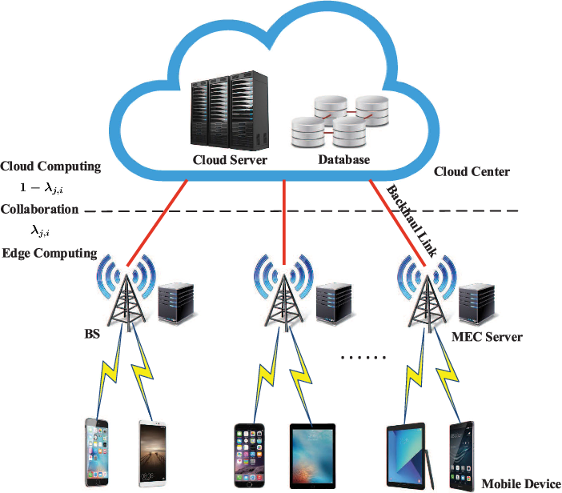

CHAPTER 4
TESTING AND IMPLEMENTATION

  - TESTING
Implementation is the stage of the project when the theoretical design is turned into a working system. This is the final and important phase in the system life cycle It is actually the process of converting the new system into a operational one.

4.1.1Unit Testing
Unit testing comprises the set of tests performed by an individual programmer prior to integration of the unit into a larger system. The module interface is tested to ensure that information properly flows into and out of the program unit. The local data structure is examined to ensure that data stored temporarily maintains its integrity during all steps in an algorithm’s execution. Boundary conditions are tested to ensure that the module operates properly at boundaries established to limit or restrict processing. All independent paths through the control structure are tested. All error-handling paths are tested.

4.1.2 Block Box Testing
Black-box testing is a method of software testing that examines the functionality of an application without peering into its internal structures or workings. This method of test can be applied virtually to every level of software testing: unit, integration, system and acceptance. It is sometimes referred to as specification-based testing.

4.2 SYSTEM IMPLEMENTATION
Implementation is the stage of the project when the theoretical design is turned into a working system. This is the final and important phase in the system life cycle It is actually the process of converting the new system into a operational one.

CHAPTER 5
CONCLUSION:
We have studied the design of collaborative cloud and edge mobile computing within a C-RAN architecture for minimal end-to-end latency. We have tackled the joint design of computational resource allocation and C-RAN signal processing strategies with the goal of minimizing end-to-end latency required for completing the computational tasks of all the participating UEs in the network. To tackle the non-convex optimization problem, we have applied FP and matrix FP. Via extensive numerical results, we have validated the convergence of the proposed optimization algorithms, the performance gain of C-RAN architecture as compared to D-RAN, and the impact of optimized computational resource allocation of collaborative cloud and edge computing. As future work, we mention the extension to collaborative AR , heterogeneous C-RAN and mobile computing integrated systems , the robust design with imperfect CSI, and the energyefficient design for energy-limited mobile UEs. Also, it would be relevant to verify the effectiveness of the proposed algorithms by deriving a tight lower bound on the optimal latency values

CHAPTER-6
REFERENCE
- [1] H. T. Dinh, C. Lee, D. Niyato and P. Wang, "A survey of mobile cloud computing: Architecture, applications, and approaches," Wireless Commun. Mobile Comput., vol. 13, no. 18, pp. 1587–1611, Dec. 2013.
- [2] M. Satyanarayanan, P. Bahl, R. Caceres and N. Davies, "The case for VM-based cloudlets in mobile computing," IEEE Pervasive Comput., vol. 8, no. 4, pp. 14–23, Oct. 2009.
- [3] S. Sardellitti, G. Scutari and S. Barbarossa, "Joint optimization of radio and computational resources for multicell mobile-edge computing," IEEE Trans. Signal Inf. Process. Netw., vol. 1, no. 2, pp. 89–103, Jun. 2015.
- [4] A. Al-Shuwaili, O. Simeone, A. Bagheri and G. Scutari, "Joint uplink/downlink optimization for backhaul-limited mobile cloud computing with user scheduling," IEEE Trans. Signal Inf. Process. Netw., vol. 3, no. 4, pp. 787–802, Dec. 2017.
- [5] T. X. Tran, A. Hajisami, P. Pandey and D. Pompili, "Collaborative mobile edge computing in 5G networks: New paradigms, scenarios, and challenges," IEEE Commun. Mag., vol. 55, no. 4, pp. 54–61, Apr. 2017.
- [6] P. Mach and Z. Becvar, "Mobile edge computing: A survey on architecture and computation offloading," IEEE Commun. Surveys Tuts., vol. 19, no. 3, pp. 1628–1656, 3rd.quart., 2017.
- [7] S. Xiao, C. Liu, K. Li and K. Li, "System delay optimization for mobile edge computing," Future Generation Computer Systems, vol. 109, pp. 17–28, Aug. 2020.
- [8] J. Ren, G. Yu, Y. He and G. Y. Li, "Collaborative cloud and edge computing for latency minimization," IEEE Trans. Veh. Technol., vol. 68, no. 5, pp. 5031–5044, May 2019.
- [9] D. Huang, P. Wang and D. Niyato, "A dynamic offloading algorithm for mobile computing," IEEE Trans. Wireless Commun., vol. 11, no. 6, pp. 1991–1995, Jun. 2012.
- [10] K. Kumar and Y. H. Lu, "Cloud computing for mobile users: Can offloading computation save energy?" Computers, vol. 43, no. 4, pp. 51–56, Apr. 2010.

