A Generative Machine Learning-Based Approach for Inverse Design of Multilayer Metasurfaces

ABSTRACT
The synthesis of a metasurface exhibiting a specific set of desired scattering properties is a time-consuming and resource-demanding process, which conventionally relies on many cycles of full-wave simulations.It requires an experienced designer to choose the number of the metallic layers, the scatterer shapes and dimensions, and the type and the thickness of the separating substrates.Here, we propose a generative machine learning (ML)-based approach to solve this one-tomany mapping and automate the inverse design of dual- and triple-layer metasurfaces.Using this approach, it is possible to solve multiobjective optimization problems by synthesizing thin structures composed of potentially brand-new scatterer designs, in cases where the inter-layer coupling between the layers is non-negligible and synthesis by traditional methods becomes cumbersome.Various examples to provide specific magnitude and phase responses of x- and y-polarized scattering coefficients across a frequency range as well as mask-based responses for different metasurface applications are presented to verify the practicality of the proposed method.

CHAPTER 2
2. SYSTEM ANALYSIS
  - EXISTING SYSTEM

- Existing methods to perform inverse freeform design, ranging from heuristic to gradient-based topology optimization, are not able to effectively solve for the global optimum because the design space for photonic devices is vast and non-convex.
- In all neural-network-based inverse-design methods discussed thus far, which rely on a training set, global optimization is only possible if devices near or at the global optimum are included in the training set.
- Discriminative and generative neural networks can be effective at fitting training data, but they cannot perform meaningful extrapolation tasks beyond the training set
2.1.1 DRAWBACKS OF EXISTING SYSTEM :
- Due to their increased degrees of freedom, multilayer EMMSs are both promising solutions and difficult to optimize for multiobjective electromagnetic problems.
- Placing the layers closely using thin substrates offers additional degrees of freedom in terms of the order of behavior, but at the same time, it complicates the design further.
- Conventionally, designing and optimizing structures with high interlayer coupling is difficult. It either requires sophisticated equivalent circuit models (ECMs) (and corresponding simulations to find the values of the ECMs), or brute-forcing the problem.
- In general, the solution space to design a multilayer EMMS includes different categories of scatterer shapes.
2.2. PROPOSED SYSTEM
The proposed framework performs inverse design and optimization mechanism for the generation of meta-atoms and meta-molecules as metasurface units based on DL models and genetic algorithm.
The framework includes consecutive DL models that emulate both numerical electromagnetic simulation and iterative processes of optimization, and generate optimized structural designs while simultaneously performing forward and inverse design tasks.
A selection and evaluation of generated structural designs is performed by the genetic algorithm to construct a desired optical response and design space that mimics real world responses. Importantly, our cyclical generation framework also explores the space of new metasurface topologies.
2.2.1. ADVANTAGES OF PROPOSED SYSTEM
- The VAE has been previously employed to represent single- and duallayer metasurfaces with negligible interlayer coupling using a continuous latent space .
- However, the optimum latent variable is found through ad hoc random selection instead of an optimization technique.
- Hence, this approach may miss an opportunity to exploit one of the important advantages of the VAE to accelerate optimization.
- we employ a generative model to produce new structures based on the target scattering coefficients in case exploring the gaps in the latent space becomes advantageous.
Literature Survey:
TITLE | AUTHORS | DESCRIPTION
Roadmap on metasurfaces | O. Quevedo-Teruel et al, | The main advantages of metasurfaces with respect to the existing conventional technology include their low cost, low level of absorption in comparison with bulky metamaterials, and easy integration due to their thin profile.
General metasurface synthesis based on susceptibility tensors | K. Achouri, M. A. Salem MA, C. Caloz, | A general method, based on susceptibility tensors, is proposed for the synthesis of metasurfaces transforming arbitrary incident waves into arbitrary reflected and transmitted waves.
Arbitrary power-conserving field transformations with passive lossless omega-type bianisotropic metasurfaces | A. Epstein and G. V. Eleftheriades, | We present a general theory for designing realistic omega-type bianisotropic metasurfaces (O-BMSs), unlocking their full potential for molding electromagnetic fields.
Fast and accurate modeling of dual-polarized reflectarray unit cells using support vector machines | D. R. Prado, J. A. Lopez-Fern ´ andez, G. Barquero, M. Arrebola , and ´ F. Las-Heras, | To efficiently obtain the surrogate model, a novel strategy to accelerate the training process is presented, remarkably reducing computing time.

2.3 FEASIBILITY STUDY
The feasibility Analysis is an analytical program through project manager determines the project success ratio and through feasibility study project manager able to see either project. The key considerations involved in the feasibility analysis are:
- Economic Feasibility
- Technical Feasibility
- Operational Feasibility
- Environmental Feasibility
2.3.1 ECONOMICAL FEASIBILITY
Hence this project is economically feasible there is no need to involve any cost for this project.
2.3.2 TECHNICAL FEASIBILITY
Software Technologies used are PHP and MySql. In the educational institutions, it is possible to update the system in future. No special hardware is required for the purpose of using this system. Hence it is declared that this project is technically feasible.
2.3.3 OPERATIONAL FEASIBILITY
As the admin work mainly to maintain the Patient and Doctor .Doctor will predict patient cancer disease. Hence it is easy to operate with training. Therefore it is operationally feasible for implementation.

2.3.4 ENVIRONMENTAL FEASIBILITY
This project environment is correct as a admin has developed this system and no expenditure is involved under any head and this process is part of admin document management, this project environment is accessible.
2.4 SYSTEM REQUIREMENTS
- System : Pentium IV 2.4 GHz.
- Hard Disk : 40 GB.
- Monitor : 15 inch VGA Color.
- Mouse : Logitech Mouse.
- Ram : 512 MB
- Keyboard : Standard Keyboard

2.4.1 HARDWARE REQUIREMENTS
The Hardware of the computer consists of physical component such as Input Devices, Storage Devices, Processing & Control units and Output Devices. Computer includes external storage unit to store data in programs.
The Hardware Configuration involved in this project
- System : Pentium IV 2.4 GHz.
- Hard Disk : 40 GB.
- Monitor : 15 inch VGA Color.
- Mouse : Logitech Mouse.
- Ram : 512 MB
- Keyboard : Standard Keyboard

2.4.2 SOFTWARE REQUIREMENTS
Software is a group of programs that computers need to do a particular task. It is an essential requirement of Computer System. The Software used to develop the project is
- Operating System : Windows XP.
- Platform : DOT NET TECHNOLOGY
- Front End : ASP.Net 3.5
- Back End : SQL SERVER 2005

CHAPTER 3
SYSTEM DESIGN AND DEVELOPEMENT
SYSTEM ARCHICTURE

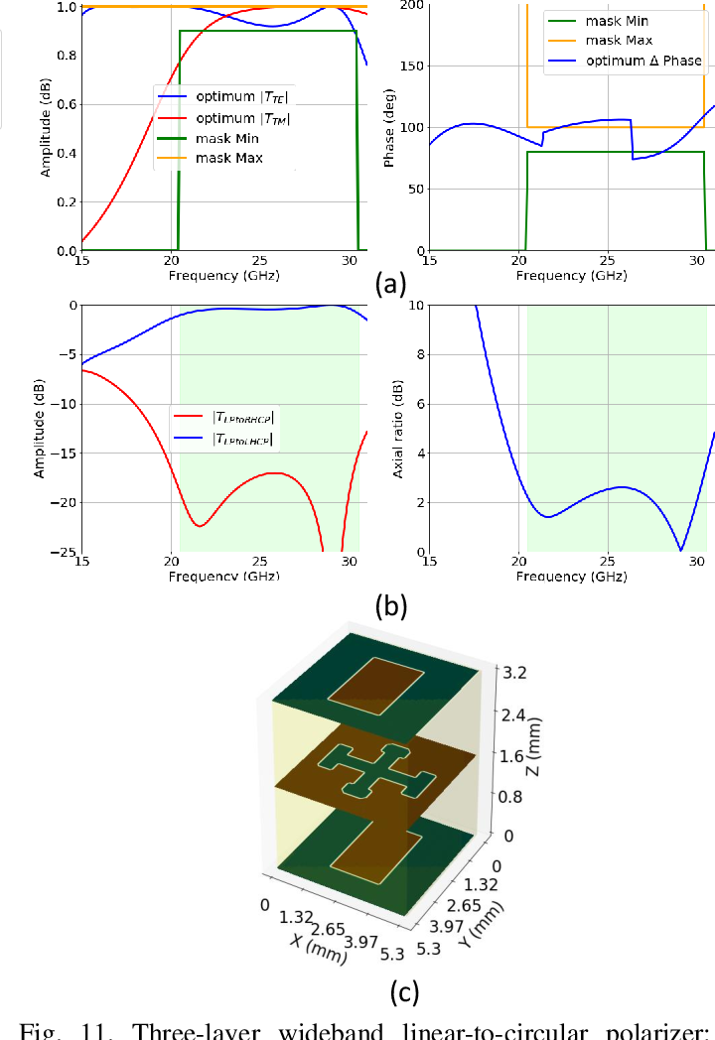

CHAPTER 4
TESTING AND IMPLEMENTATION

  - TESTING
Implementation is the stage of the project when the theoretical design is turned into a working system. This is the final and important phase in the system life cycle It is actually the process of converting the new system into a operational one.

4.1.1Unit Testing
Unit testing comprises the set of tests performed by an individual programmer prior to integration of the unit into a larger system. The module interface is tested to ensure that information properly flows into and out of the program unit. The local data structure is examined to ensure that data stored temporarily maintains its integrity during all steps in an algorithm’s execution. Boundary conditions are tested to ensure that the module operates properly at boundaries established to limit or restrict processing. All independent paths through the control structure are tested. All error-handling paths are tested.

4.1.2 Block Box Testing
Black-box testing is a method of software testing that examines the functionality of an application without peering into its internal structures or workings. This method of test can be applied virtually to every level of software testing: unit, integration, system and acceptance. It is sometimes referred to as specification-based testing.

4.2 SYSTEM IMPLEMENTATION
Implementation is the stage of the project when the theoretical design is turned into a working system. This is the final and important phase in the system life cycle It is actually the process of converting the new system into a operational one.

CHAPTER 5
CONCLUSION:
A machine learning-based approach has been proposed to solve the inverse problem of designing multilayer metasurfaces based on the desired scattering properties. Using a generative ML model based on a variational autoencoder, the structures and the scattering properties of the multilayer EMMSs in the training set are converted to a low-dimensional continuous latent space. In this latent space, the particle swarm optimizationhas been performed to find the optimum latent variable and consequently the physical design of the optimum EMMS. This approach exploits the information learned from the training set and explores the design space by interpolating the structures and the properties of the training structures in the latent space to propose new EMMSs that meet the desired requirements.

CHAPTER-6
REFERENCE
- [1] O. Quevedo-Teruel et al, “Roadmap on metasurfaces,” Journal of Optics, vol. 21, no. 7, pp. 073002 (44pp), Aug. 2019.
- [2] K. Achouri, M. A. Salem MA, C. Caloz, “General metasurface synthesis based on susceptibility tensors,” IEEE Trans Antennas Propag, vol. 63, no. 7, pp. 2977-2991, Jul. 2015.
- [3] A. Epstein and G. V. Eleftheriades, “Arbitrary power-conserving field transformations with passive lossless omega-type bianisotropic metasurfaces,” IEEE Trans. Antennas Propag., vol. 64, no. 9, pp. 3880–3895, 2016.
- [4] D. R. Prado, J. A. Lopez-Fern ´ andez, G. Barquero, M. Arrebola , and ´ F. Las-Heras, “Fast and accurate modeling of dual-polarized reflectarray unit cells using support vector machines,” IEEE Trans. Antennas Propag., vol. 66, no. 3, pp. 1258-1270, Mar. 2018.
- [5] T. Qiu et al, “Deep learning: a rapid and efficient route to automatic metasurface design,”Adv. Sci., no. 6, pp. 1900128 (1-12), 2019.
- [6] V. Richard, R. Loison, R. Gillard, H. Legay, and M. Romier, “Loss analysis of a reflectarray cell using ANNs with accurate magnitude prediction,” in Proc. 11th Eur. Conf. Antennas Propag. (EuCAP), Paris, France, Mar. 2017, pp. 2402–2405.
- [7] D. Kampouridou and A. Feresidis, “Machine learning-driven design optimization for a multi-layer metasurface antenna,” 14th Eur. Conf. Antennas Propag. (EuCAP), Copenhagen, Denmark, Mar. 2020.
- [8] D. Caputo, A. Pirisi, M. Mussetta, A. Freni, P. Pirinoli, and R. Zich, “Neural network characterization of microstrip patches for reflectarray optimization,” in Proc. 3rd Eur. Conf. Antennas Propag. (EuCAP), Berlin, Germany, Mar. 2009, pp. 2520-2522.
- [9] P. Robustillo, J. Zapata, J. A. Encinar, and J. Rubio, “ANN characterization of multi-layer reflectarray elements for contoured-beam space antennas in the Ku-band,” IEEE Trans. Antennas Propag., vol. 60, no. 7, pp. 3205-3214, Jul. 2012.
- [10] G. Gosal, “The use of inverse neural networks in the fast design of printed lens antennas,” M.A.Sc. Thesis, University of Ottawa, Ottawa, ON, Canada, 2015, http://www.ruor.uottawa.ca/handle/10393/32249.

