VeriML Enabling Integrity Assurances and Fair Payments for Machine Learning as a Service

ABSTRACT
Machine Learning as a Service (MLaaS) allows clients with limited resources to outsource their expensive ML tasks to powerful servers. Despite the huge benefits, current MLaaS solutions still lack strong assurances on: 1) service correctness (i.e., whether the MLaaS works as expected); 2) trustworthy accounting (i.e., whether the bill for the MLaaS resource consumption is correctly accounted); 3) fair payment (i.e., whether a client gets the entire MLaaS result before making the payment).Without these assurances, unfaithful service providers can return improperly-executed ML task results or partiallytrained ML models while asking for over-claimed rewards. Moreover, it is hard to argue for wide adoption of MLaaS to both the client and the service provider, especially in the open market without a trusted third party.In this paper, we present VeriML, a novel and efficient framework to bring integrity assurances and fair payments to MLaaS. With VeriML, clients can be assured that ML tasks are correctly executed on an untrusted server and the resource consumption claimed by the service provider equals to the actual workload.We strategically use succinct non-interactive arguments of knowledge (SNARK) on randomly-selected iterations during the ML training phase for efficiency with tunable probabilistic assurance. We also develop multiple ML-specific optimizations to the arithmetic circuit required by SNARK. Our system implements six common algorithms: linear regression, logistic regression, neural network, support vector machine, Kmeans and decision tree. The experimental results have validated the practical performance of VeriML.

CHAPTER 2
2. SYSTEM ANALYSIS
  - EXISTING SYSTEM
- We implement vCNN and compare it with the existing zkSNARKs in terms of size and computation.
- The proposed scheme improves the key generation/proving time 25 fold and the CRS size 30 fold compared with the state-of-art zk-SNARK scheme.
- This paper proposes a new efficient verifiable convolutional neural network (vCNN) framework which accelerates the proving performance tremendously.
- To increase the proving performance, we propose a new efficient relation representation for convolution equations.
2.1.1 DRAWBACKS OF EXISTING SYSTEM :
- In our system, a client C outsources a machine learning task to a server S with a training dataset D. S trains a prediction model M according to a certain ML algorithm and parameters.
- After the training phase, C submits challenges r to verify the execution of the learning algorithm, and in turn, S returns the corresponding proofs π without providing M.
- The main purpose of our work is to solve the problem in verifying the integrity of ML model training, i.e., proving that S has actually executed the specified computation task.
- Beyond that, we also aim to ensure the integrity of prediction services provided by S without revealing the ML model to C.
2.2. PROPOSED SYSTEM
The proposed scheme is a verifier-friendly zk-SNARK scheme with a constant proof size, and its verification time complexity linearly depends on the input and output only, regardless of convolution intricacy.
We propose an efficient construction of vCNN to verify the evaluation of the whole CNNs.
Our construction includes QPP-based zk-SNARKs optimized for convolutions and QAP-based zk-SNARKs effectively working for Pooling and ReLU, and interconnects them using CPSNARKs.
2.2.1. ADVANTAGES OF PROPOSED SYSTEM
- We develop a new commit-and-prove protocol that can verify the loop iterations when training machine learning models with high efficiency.
- The detailed theoretic analysis demonstrates that our scheme can detect incorrect computations with high probability.
- We implement the VeriML framework with six popular ML algorithms: linear regression, logistic regression, neural network, support vector machine, Kmeans and decision tree on four real-world datasets to demonstrate its performance.
- Our results show that VeriML has a practical overhead as well as a negligible accuracy loss in training.

Literature Survey:
TITLE | AUTHORS | DESCRIPTION
Safetynets: Verifiable execution of deep neural networks on an untrusted cloud | Z. Ghodsi, T. Gu, and S. Garg, | Inference using deep neural networks is often outsourced to the cloud since it is a computationally demanding task.
Oblivious neural network predictions via minionn transformations | J. Liu, M. Juuti, Y. Lu, and N. Asokan, | In this paper, we explore the problem of privacy-preserving predictions: after each prediction, the server learns nothing about clients' input and clients learn nothing about the model.
Secureml: A system for scalable privacypreserving machine learning | P. Mohassel and Y. Zhang, | Machine learning is widely used in practice to produce predictive models for applications such as image processing, speech and text recognition.
Zero knowledge contingent payment. 2011 | G. Maxwell, | We survey the state-of-the-art non-interactive zero-knowledge argument schemes and their applications in confidential transactions and private smart contracts on blockchain.

2.3 FEASIBILITY STUDY
The feasibility Analysis is an analytical program through project manager determines the project success ratio and through feasibility study project manager able to see either project. The key considerations involved in the feasibility analysis are:
- Economic Feasibility
- Technical Feasibility
- Operational Feasibility
- Environmental Feasibility
2.3.1 ECONOMICAL FEASIBILITY
Hence this project is economically feasible there is no need to involve any cost for this project.
2.3.2 TECHNICAL FEASIBILITY
Software Technologies used are PHP and MySql. In the educational institutions, it is possible to update the system in future. No special hardware is required for the purpose of using this system. Hence it is declared that this project is technically feasible.
2.3.3 OPERATIONAL FEASIBILITY
As the admin work mainly to maintain the Patient and Doctor .Doctor will predict patient cancer disease. Hence it is easy to operate with training. Therefore it is operationally feasible for implementation.

2.3.4 ENVIRONMENTAL FEASIBILITY
This project environment is correct as a admin has developed this system and no expenditure is involved under any head and this process is part of admin document management, this project environment is accessible.
2.4 SYSTEM REQUIREMENTS
- System : Pentium IV 2.4 GHz.
- Hard Disk : 40 GB.
- Monitor : 15 inch VGA Color.
- Mouse : Logitech Mouse.
- Ram : 512 MB
- Keyboard : Standard Keyboard

2.4.1 HARDWARE REQUIREMENTS
The Hardware of the computer consists of physical component such as Input Devices, Storage Devices, Processing & Control units and Output Devices. Computer includes external storage unit to store data in programs.
The Hardware Configuration involved in this project
- System : Pentium IV 2.4 GHz.
- Hard Disk : 40 GB.
- Monitor : 15 inch VGA Color.
- Mouse : Logitech Mouse.
- Ram : 512 MB
- Keyboard : Standard Keyboard

2.4.2 SOFTWARE REQUIREMENTS
Software is a group of programs that computers need to do a particular task. It is an essential requirement of Computer System. The Software used to develop the project is
- Operating System : Windows XP.
- Platform : DOT NET TECHNOLOGY
- Front End : ASP.Net 3.5
- Back End : SQL SERVER 2005

CHAPTER 3
SYSTEM DESIGN AND DEVELOPEMENT
SYSTEM ARCHICTURE

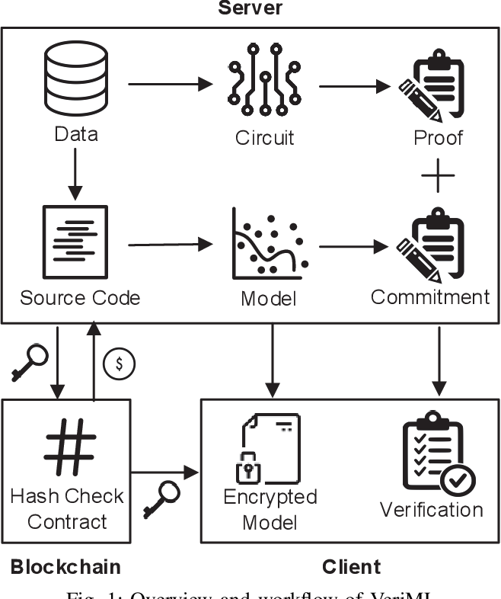

CHAPTER 4
TESTING AND IMPLEMENTATION

  - TESTING
Implementation is the stage of the project when the theoretical design is turned into a working system. This is the final and important phase in the system life cycle It is actually the process of converting the new system into a operational one.

4.1.1Unit Testing
Unit testing comprises the set of tests performed by an individual programmer prior to integration of the unit into a larger system. The module interface is tested to ensure that information properly flows into and out of the program unit. The local data structure is examined to ensure that data stored temporarily maintains its integrity during all steps in an algorithm’s execution. Boundary conditions are tested to ensure that the module operates properly at boundaries established to limit or restrict processing. All independent paths through the control structure are tested. All error-handling paths are tested.

4.1.2 Block Box Testing
Black-box testing is a method of software testing that examines the functionality of an application without peering into its internal structures or workings. This method of test can be applied virtually to every level of software testing: unit, integration, system and acceptance. It is sometimes referred to as specification-based testing.

4.2 SYSTEM IMPLEMENTATION
Implementation is the stage of the project when the theoretical design is turned into a working system. This is the final and important phase in the system life cycle It is actually the process of converting the new system into a operational one.

CHAPTER 5
CONCLUSION:
In this paper, we presented the design, implementation and evaluation of VeriML, a verifiable and fair outsourced machine learning service. We transformed machine learning algorithms to quadratic arithmetic circuits to generate proofs, then designed a new commit-and-prove protocol to detect misbehaviors during the training process with high probability. Blockchain is leveraged to serve as a decentralized trusted third party to achieve fair exchange by a hash-locked transaction. Our experiments on real-world datasets validate that the computation and communication costs of VeriML are practical, and it can be readily applied to the existing MLaaS platforms. There are some important future directions. First of all, the efficiency of existing SNARK implementations can be further improved. The underlying VC protocol can be replaced by other similar building blocks which have the zero-knowledge property. Moreover, we will seek for better approximations of non-linear functions, especially for the diversified non-linear functions used in many other machine learning algorithms.

CHAPTER-6
REFERENCE
- [1] Amazon Web Services (AWS), https://aws.amazon.com/.
- [2] Microsoft Azure, https://azure.microsoft.com/.
- [3] Z. Ghodsi, T. Gu, and S. Garg, “Safetynets: Verifiable execution of deep neural networks on an untrusted cloud,” in Proc. of NIPS’17, 2017, pp. 4672–4681.
- [4] J. Liu, M. Juuti, Y. Lu, and N. Asokan, “Oblivious neural network predictions via minionn transformations,” in Proc. of CCS’17. ACM, 2017, pp. 619–631.
- [5] P. Mohassel and Y. Zhang, “Secureml: A system for scalable privacypreserving machine learning,” in Proc. of S&P’17. IEEE, 2017, pp. 19–38.
- [6] G. Maxwell, “Zero knowledge contingent payment. 2011,” URl: https://en. bitcoin. it/wiki/Zero Knowledge Contingent Payment (visited on 05/01/2016), 2011.
- [7] M. Campanelli, R. Gennaro, S. Goldfeder, and L. Nizzardo, “Zeroknowledge contingent payments revisited: Attacks and payments for services,” in Proc. of CCS’17. ACM, 2017, pp. 229–243.
- [8] S. Dziembowski, L. Eckey, and S. Faust, “Fairswap: How to fairly exchange digital goods,” in Proc. of CCS’18. ACM, 2018, pp. 967– 984.
- [9] E. Ben-Sasson, A. Chiesa, D. Genkin, E. Tromer, and M. Virza, “Snarks for c: Verifying program executions succinctly and in zero knowledge,” in Proc. of CRYPTO’13. Springer, 2013, pp. 90–108.
- [10] B. Parno, J. Howell, C. Gentry, and M. Raykova, “Pinocchio: Nearly practical verifiable computation,” in Proc. of S&P’13. IEEE, 2013, pp. 238–252.
- [11] D. Papadopoulos, C. Papamanthou, R. Tamassia, and N. Triandopoulos, “Practical authenticated pattern matching with optimal proof size,” Proc. of VLDB’15, vol. 8, no. 7, pp. 750–761, 2015.

