A Multiple Gradient Descent Design for Multi-task Learning on Edge Computing Multi-objective Machine Learning Approach

ABSTRACT
Multi-task learning technique is widely utilized in machine learning modeling where commonalities and differences across multiple tasks are exploited. However, multiple conflicting objectives often occur in multi-task learning. Conventionally, a common compromise is to minimize the weighted sum of multiple objectives which may be invalid if the objectives are competing. In this paper, a novel multi-objective machine learning approach is proposed to solve this challenging issue, which formulates the multi-task learning as multi-objective optimization. To address the time-consuming problem contributed by the multi-objective evolution algorithms, a multi-gradient descent algorithm is introduced for a multi-objective machine learning problem by which an innovative gradient-based optimization is leveraged to converge to an optimal solution of the Pareto set. Moreover, the gradient surgery for the multi-gradient descent algorithm is proposed to obtain a stable Pareto optimal solution. As most of the edge computing devices are computational resource-constrained, the proposed method is implemented for optimizing the edge device's memory, computation and communication demands. The proposed method is applied to the multiple license plate recognition problem. The experimental results show that the proposed method outperforms state-of-the-art learning methods and can successfully find solutions that balance multiple objectives of the learning task over the different datasets.
CHAPTER
2. SYSTEM ANALYSIS
  - EXISTING SYSTEM

- We now propose an efficient method that optimizes an upper bound of the objective and requires only a single backward pass. We further show that optimizing this upper bound yields a Pareto optimal solution under realistic assumptions. The architectures we address conjoin a shared representation function with task-specific decision functions.
- We use a similar construction. For each image, a different one is chosen uniformly in random. Then one of these images is put at the top-left and the other one is at the bottom-right. The resulting tasks are: classifying the digit on the top-left (task-L) and classifying the digit on the bottom-right (task-R). We use 60K examples and directly apply existing single-task MNIST models.

2.1.1 DRAWBACKS OF EXISTING SYSTEM :
- In this paper, we assume that each edge server has the same limited resources to handle the request of the mobile vehicle, i.e., each edge server has the same processing power and these servers are arranged at certain BS locations for mobile vehicle access.
- We treat multiple vehicles as multiple computing tasks. Multi computing tasks scheduling problem is analogous to multi task learning (MTL) model.
- Due to the sharing process that produces data, even real-world tasks that appear to be unrelated have strong dependencies.
- This causes the application of multiple tasks to become the inductive bias in the learning model
2.2. PROPOSED SYSTEM
- Algorithms proposed in the computational geometry literature address the problem of finding minimum-norm points in the convex hull of a large number of points in a low-dimensional space (typically of dimensionality 2 or 3).
- In our setting, the number of points is the number of tasks and is typically low; in contrast, the dimensionality is the number of shared parameters and can be in the millions.
- On the accuracy side, we expect both methods to perform similarly as long as the full-rank assumption is satisfied.
- As expected, the accuracy of both methods is very similar.
2.2.1. ADVANTAGES OF PROPOSED SYSTEM
It takes advantage of the gradient of each task and solves the optimization problem while determining updates over global parameters. However, the large-scale application of MGDA is still impractical due to two technical issues.
(1) Potential optimization problems cannot be extended to high dimensional gradients better, but this naturally occurs in deep networks. (2) The algorithm needs to clarify the gradient of each task, which will increase the number of backward propagations linearly, and multiply the training time by the amount of tasks.

Literature Survey:
TITLE | AUTHORS | DESCRIPTION
Multi-task feature learning | Argyriou, T. Evgeniou, and M. Pontil. | We report experiments on a simulated and a real data set which demonstrate that the proposed method dramatically improves the per- formance relative to learning each task independently.
Content-based image retrieval through a multi-agent meta-learning framework | A. Bagherjeiran, R. Vilalta, and C. F. Eick. | The framework adapts a distance function defined over both image distance weights and image queries to identify clusters of algorithms that produce similar solutions to similar problems.
Task clustering and gating for Bayesian multitask learning | B. Bakker and T. Heskes. | In machine learning, this subject is approached through `multitask learning', where parallel tasks are modeled as multiple outputs of the same network.
A model of inductive bias learning | J. Baxter. | In this paper a model for automatically learning bias is investigated. The central assumption of the model is that the learner is embedded within an environment of related learning tasks.

2.3 FEASIBILITY STUDY
The feasibility Analysis is an analytical program through project manager determines the project success ratio and through feasibility study project manager able to see either project. The key considerations involved in the feasibility analysis are:
- Economic Feasibility
- Technical Feasibility
- Operational Feasibility
- Environmental Feasibility
2.3.1 ECONOMICAL FEASIBILITY
Hence this project is economically feasible there is no need to involve any cost for this project.
2.3.2 TECHNICAL FEASIBILITY
Software Technologies used are PHP and MySql. In the educational institutions, it is possible to update the system in future. No special hardware is required for the purpose of using this system. Hence it is declared that this project is technically feasible.
2.3.3 OPERATIONAL FEASIBILITY
As the admin work mainly to maintain the Patient and Doctor .Doctor will predict patient cancer disease. Hence it is easy to operate with training. Therefore it is operationally feasible for implementation.

2.3.4 ENVIRONMENTAL FEASIBILITY
This project environment is correct as a admin has developed this system and no expenditure is involved under any head and this process is part of admin document management, this project environment is accessible.
2.4 SYSTEM REQUIREMENTS
- System : Pentium IV 2.4 GHz.
- Hard Disk : 40 GB.
- Monitor : 15 inch VGA Color.
- Mouse : Logitech Mouse.
- Ram : 512 MB
- Keyboard : Standard Keyboard

2.4.1 HARDWARE REQUIREMENTS
The Hardware of the computer consists of physical component such as Input Devices, Storage Devices, Processing & Control units and Output Devices. Computer includes external storage unit to store data in programs.
The Hardware Configuration involved in this project
- System : Pentium IV 2.4 GHz.
- Hard Disk : 40 GB.
- Monitor : 15 inch VGA Color.
- Mouse : Logitech Mouse.
- Ram : 512 MB
- Keyboard : Standard Keyboard

2.4.2 SOFTWARE REQUIREMENTS
Software is a group of programs that computers need to do a particular task. It is an essential requirement of Computer System. The Software used to develop the project is
- Operating System : Windows XP.
- Platform : DOT NET TECHNOLOGY
- Front End : ASP.Net 3.5
- Back End : SQL SERVER 2005

CHAPTER
SYSTEM DESIGN AND DEVELOPEMENT
SYSTEM ARCHICTURE

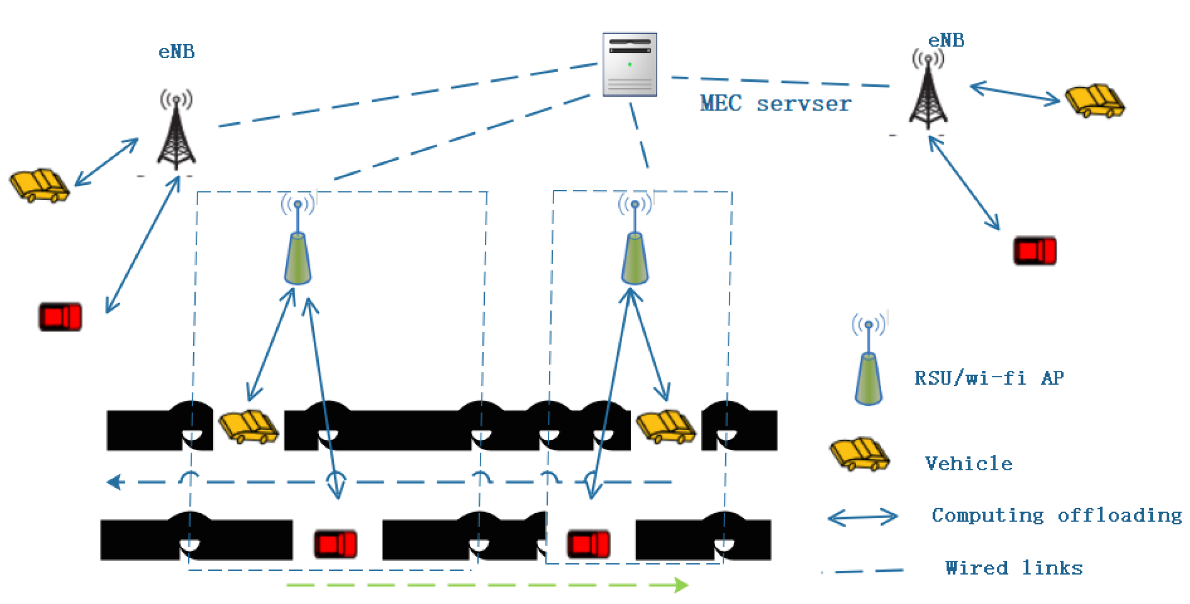

CHAPTER 4
TESTING AND IMPLEMENTATION

  - TESTING
Implementation is the stage of the project when the theoretical design is turned into a working system. This is the final and important phase in the system life cycle It is actually the process of converting the new system into a operational one.

4.1.1Unit Testing
Unit testing comprises the set of tests performed by an individual programmer prior to integration of the unit into a larger system. The module interface is tested to ensure that information properly flows into and out of the program unit. The local data structure is examined to ensure that data stored temporarily maintains its integrity during all steps in an algorithm’s execution. Boundary conditions are tested to ensure that the module operates properly at boundaries established to limit or restrict processing. All independent paths through the control structure are tested. All error-handling paths are tested.

4.1.2 Block Box Testing
Black-box testing is a method of software testing that examines the functionality of an application without peering into its internal structures or workings. This method of test can be applied virtually to every level of software testing: unit, integration, system and acceptance. It is sometimes referred to as specification-based testing.

4.2 SYSTEM IMPLEMENTATION
Implementation is the stage of the project when the theoretical design is turned into a working system. This is the final and important phase in the system life cycle It is actually the process of converting the new system into a operational one.

CHAPTER 5
CONCLUSION:
In this paper, we form a framework of optimal resource allocation strategy for computing in vehicular networks. We formulate the optimal computing task scheduling to minimize the VNET loss under the constraints of dynamically computational resource at RSU and the limited storage capacities as well as under the constraints of hardware deadline at end-to-end and the vehicular mobility. To avoid conflicts between tasks during vehicle mobility, we convert the multi-task scheduling problem into a multi-objective optimization problem, and then find the Pareto optimal solution. For the specific large-scale vehicular network in reality, we propose a Frank–Wolfe–based MGDA optimization algorithm and extend it to the high-dimensional space. Meanwhile, we give the upper bound of the MGDA algorithm and prove it can be solved by a backward propagation without a specific-task gradient. Finally, the experimental results show that our method is greatly improved in terms of accuracy compared with the existing methods.

CHAPTER-6
REFERENCE
- Argyriou, T. Evgeniou, and M. Pontil. Multi-task feature learning. In NIPS, 2007.
- A. Bagherjeiran, R. Vilalta, and C. F. Eick. Content-based image retrieval through a multi-agent meta-learning framework. In International Conference on Tools with Artificial Intelligence, 2005.
- B. Bakker and T. Heskes. Task clustering and gating for Bayesian multitask learning. JMLR, 4:83–99, 2003.
- J. Baxter. A model of inductive bias learning. Journal of Artificial Intelligence Research, 12:149–198, 2000.
- H. Bilen and A. Vedaldi. Integrated perception with recurrent multi-task neural networks. In NIPS, 2016.
- R. Caruana. Multitask learning. Machine Learning, 28(1):41–75, 1997.
- Z. Chen, V. Badrinarayanan, C. Lee, and A. Rabinovich. GradNorm: Gradient normalization for adaptive loss balancing in deep multitask networks. In ICML, 2018.
- R. Collobert and J. Weston. A unified architecture for natural language processing: Deep neural networks with multitask learning. In ICML, 2008.
- M. Cordts, M. Omran, S. Ramos, T. Rehfeld, M. Enzweiler, R. Benenson, U. Franke, S. Roth, and B. Schiele. The Cityscapes dataset for semantic urban scene understanding. In CVPR, 2016.
- P. B. C. de Miranda, R. B. C. Prudêncio, A. C. P. L. F. de Carvalho, and C. Soares. Combining a multi-objective optimization approach with meta-learning for SVM parameter selection. In International Conference on Systems, Man, and Cybernetics, 2012.

