Predicting Machine Learning Pipeline Runtimes in the Context of Automated Machine Learning

ABSTRACT
- Automated Machine Learning (AutoML) seeks to automatically find so-called machine learning pipelines that maximize the prediction performance when being used to train a model on a given dataset. One of the main and yet open challenges in AutoML is an effective use of computational resources: An AutoML process involves the evaluation of many candidate pipelines, which are costly but often ineffective because they are canceled due to a timeout. In this paper, we present an approach to predict the runtime of two-step machine learning pipelines with up to one pre-processor, which can be used to anticipate whether or not a pipeline will time out. Separate runtime models are trained offline for each algorithm that may be used in a pipeline, and an overall prediction is derived from these models. We empirically show that the approach increases successful evaluations made by an AutoML tool while preserving or even improving on the previously best solutions.

CHAPTER 2
2. SYSTEM ANALYSIS
  - EXISTING SYSTEM

- We introduce a mathematical formulation covering the complete procedure of automatic ML pipeline synthesis and compare it with existing problem formulations.
- We review open-source frameworks for building ML pipelines automatically.
- An evaluation of eight HPO algorithms on 137 real data sets is conducted. To the best of our knowledge, this is the first independent benchmark of HPO algorithms.
- An empirical evaluation of six AutoML frameworks on 73 real data sets is performed. To the best of our knowledge, this is the most extensive evaluation—in terms of tested frameworks as well as used data sets—of AutoML frameworks.

2.1.1 DRAWBACKS OF EXISTING SYSTEM :
- Task type and subtype categories with controlled vocabularies to categorize problems into a wide range of tasks, beyond just basic classification and regression.
- Which performance metrics the AutoML system should optimize for.
- Which columns in a dataset are target columns.
- A list of privileged data columns related to unavailable attributes during testing. These columns do not have data available in the test split of a dataset.
- Additional metadata like human-friendly name and description.
2.2. PROPOSED SYSTEM
- Many different algorithms have been proposed to solve specific problem instances efficiently, for example convex optimization.
- To use these methods, the features and shape of the underlying objective function—in this case the loss L—have to be known to select applicable solvers.
- In general, it is not possible to predict any properties of the loss function or even formulate it as closed-form expression as it depends on the generative model.
2.2.1. ADVANTAGES OF PROPOSED SYSTEM
- The framework should allow most of ML and data processing programs to be described as its pipelines, if not all, but be as simple as possible to facilitate both automatic generation and automatic consumption of pipelines.
- Pipelines should allow description of complete end-to-end ML programs, starting with raw files and finishing with predictions or any other ML output from models embedded in pipelines.
- The focus of the framework is machine generation and consumption as opposed to human generation and consumption. It should enable automation as much as possible.
- The framework should be extensible and framework’s components should be decoupled from each other, cf. in most programming languages a typing system and execution semantics are tightly coupled with the language itself.
- Control of side-effects and randomness in pipelines, and in general full reproducibility should be part of the framework and not an afterthought.

Literature Survey:
TITLE | AUTHORS | DESCRIPTION
On Learning Algorithm Selection for Classification | Shawkat Ali and Kate A. Smith. | This paper introduces a new method for learning algorithm evaluation and selection, with empirical results based on classification.
The species problem in Iris | Edgar Anderson. | Quantitative morphological characters are continuous among populations and also correlate with environmental conditions, preventing species delimitation according to Phenetic and Ecological SC.
Designing neural network architectures using reinforcement learning | Bowen Baker et al. | We propose a meta-modelling approach based on reinforcement learning to automatically generate high-performing CNN architectures for a given learning task.
Hyperopt: A python library for optimizing the hyperparameters of machine learning algorithms | James Bergstra, Dan Yamins, and David D Cox. | This paper presents an introductory tutorial on the usage of the Hyperopt library, including the description of search spaces, minimization (in serial and parallel), and the analysis of the results collected in the course of minimization.

2.3 FEASIBILITY STUDY
The feasibility Analysis is an analytical program through project manager determines the project success ratio and through feasibility study project manager able to see either project. The key considerations involved in the feasibility analysis are:
- Economic Feasibility
- Technical Feasibility
- Operational Feasibility
- Environmental Feasibility
2.3.1 ECONOMICAL FEASIBILITY
Hence this project is economically feasible there is no need to involve any cost for this project.
2.3.2 TECHNICAL FEASIBILITY
Software Technologies used are PHP and MySql. In the educational institutions, it is possible to update the system in future. No special hardware is required for the purpose of using this system. Hence it is declared that this project is technically feasible.
2.3.3 OPERATIONAL FEASIBILITY
As the admin work mainly to maintain the Patient and Doctor .Doctor will predict patient cancer disease. Hence it is easy to operate with training. Therefore it is operationally feasible for implementation.

2.3.4 ENVIRONMENTAL FEASIBILITY
This project environment is correct as a admin has developed this system and no expenditure is involved under any head and this process is part of admin document management, this project environment is accessible.
2.4 SYSTEM REQUIREMENTS
- System : Pentium IV 2.4 GHz.
- Hard Disk : 40 GB.
- Monitor : 15 inch VGA Color.
- Mouse : Logitech Mouse.
- Ram : 512 MB
- Keyboard : Standard Keyboard

2.4.1 HARDWARE REQUIREMENTS
The Hardware of the computer consists of physical component such as Input Devices, Storage Devices, Processing & Control units and Output Devices. Computer includes external storage unit to store data in programs.
The Hardware Configuration involved in this project
- System : Pentium IV 2.4 GHz.
- Hard Disk : 40 GB.
- Monitor : 15 inch VGA Color.
- Mouse : Logitech Mouse.
- Ram : 512 MB
- Keyboard : Standard Keyboard

2.4.2 SOFTWARE REQUIREMENTS
Software is a group of programs that computers need to do a particular task. It is an essential requirement of Computer System. The Software used to develop the project is
- Operating System : Windows XP.
- Platform : DOT NET TECHNOLOGY
- Front End : ASP.Net 3.5
- Back End : SQL SERVER 2005

CHAPTER 3
SYSTEM DESIGN AND DEVELOPMENT
SYSTEM ARCHICTURE

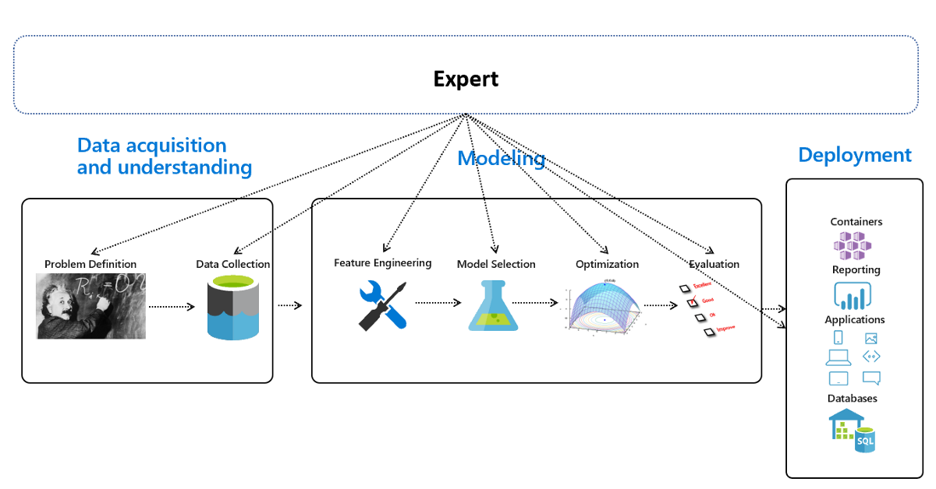

CHAPTER 4
TESTING AND IMPLEMENTATION

  - TESTING
Implementation is the stage of the project when the theoretical design is turned into a working system. This is the final and important phase in the system life cycle It is actually the process of converting the new system into a operational one.

4.1.1Unit Testing
Unit testing comprises the set of tests performed by an individual programmer prior to integration of the unit into a larger system. The module interface is tested to ensure that information properly flows into and out of the program unit. The local data structure is examined to ensure that data stored temporarily maintains its integrity during all steps in an algorithm’s execution. Boundary conditions are tested to ensure that the module operates properly at boundaries established to limit or restrict processing. All independent paths through the control structure are tested. All error-handling paths are tested.

4.1.2 Block Box Testing
Black-box testing is a method of software testing that examines the functionality of an application without peering into its internal structures or workings. This method of test can be applied virtually to every level of software testing: unit, integration, system and acceptance. It is sometimes referred to as specification-based testing.

4.2 SYSTEM IMPLEMENTATION
Implementation is the stage of the project when the theoretical design is turned into a working system. This is the final and important phase in the system life cycle It is actually the process of converting the new system into a operational one.

CHAPTER 5
CONCLUSION:
In this work, we addressed the challenge of representing ML programs for metalearning purposes with the end goal of improving AutoML systems that use metalearning. Moreover, this standard representation facilitates better comparison of different AutoML systems by allowing us to compare the approaches used by those systems, not just comparing their predictions. To this end we have designed and implemented this framework for ML pipelines.

CHAPTER-6
REFERENCE
- [1] Shawkat Ali and Kate A. Smith. “On Learning Algorithm Selection for Classification”. In: Appl. Soft Comput. 6.2 (Jan. 2006), pp. 119–138. issn: 1568-4946. doi: 10.1016/ j.asoc.2004.12.002. url: http://dx.doi.org/10.1016/j.asoc.2004.12.002.
- [2] Edgar Anderson. “The species problem in Iris”. In: Annals of the Missouri Botanical Garden 23.3 (1936), pp. 457–509.
- [3] Bowen Baker et al. “Designing neural network architectures using reinforcement learning”. In: arXiv preprint arXiv:1611.02167 (2016). url: https://arxiv.org/abs/ 1611.02167.
- [4] Oren Ben-Kiki, Clark Evans, and Ingy d¨ot Net. YAML Ain’t Markup Language. Oct. 2009. url: https://yaml.org/spec/ (visited on 05/14/2019).
- [5] James Bergstra, Dan Yamins, and David D Cox. “Hyperopt: A python library for optimizing the hyperparameters of machine learning algorithms”. In: Proceedings of the 12th Python in science conference. Citeseer. 2013, pp. 13–20.
- [6] Tim Bray. The JavaScript Object Notation (JSON) Data Interchange Format. RFC 8259. RFC Editor, Dec. 2017. url: http://www.rfc-editor.org/rfc/rfc8259.txt.
- [7] Fran¸cois Chollet et al. Keras. 2015. url: https://keras.io (visited on 05/14/2019).
- [8] Cornell University. arXiv. url: https://arxiv.org/ (visited on 05/14/2019).
- [9] Joe Davison et al. DEvol: Deep Neural Network Evolution. 2017. url: https : / / github.com/joeddav/devol (visited on 05/14/2019).
- [10] Iddo Drori et al. “AlphaD3M: Machine learning pipeline synthesis”. In: AutoML Workshop at ICML. 2018.

