On the Synergies between Machine Learning and Binocular Stereo for Depth Estimation from Images a Survey

ABSTRACT
Stereo matching is one of the longest-standing problems in computer vision with close to 40 years of studies and research. Throughout the years the paradigm has shifted from local, pixel-level decision to various forms of discrete and continuous optimization to data-driven, learning-based methods. Recently, the rise of machine learning and the rapid proliferation of deep learning enhanced stereo matching with new exciting trends and applications unthinkable until a few years ago. Interestingly, the relationship between these two worlds is two-way. While machine, and especially deep, learning advanced the state-of-the-art in stereo matching, stereo itself enabled new ground-breaking methodologies such as self-supervised monocular depth estimation based on deep networks. In this paper, we review recent research in the field of learning-based depth estimation from single and binocular images highlighting the synergies, the successes achieved so far and the open challenges the community is going to face in the immediate future.

CHAPTER
2. SYSTEM ANALYSIS
  - EXISTING SYSTEM

- we analyze the problem domain and its characteristics that make it difficult to work with images from this domain.
- We also look at existing datasets, their advantages, and their problems.
- Then we explain the hypothesis and the reason for attempting simulation. The simulation characteristics and parameters are also explained in this section.
- Afterwards, we explain our methodology in solving the Stereo Correspondence problem using deep learning and report the result of experiments on both synthesized data and real data.

2.1.1 DRAWBACKS OF EXISTING SYSTEM :
- we move our focus to a new and exciting research trend: depth estimation from a single image, for which the synergy between stereo and deep learning recently allowed for results unimaginable just a few years ago.
- In monocular depth estimation, the goal is to learn a non-linear mapping between a single RGB image and its corresponding depth map.
- Even though this task comes natural to humans, it is an ill-posed problem, since a single 2D image might originate from an infinite number of different 3D scenes.

2.2. PROPOSED SYSTEM
- In addition to optimizing the cost function for each scan-line, some constraints between the neighboring scan-lines can be used to reduce the ambiguity.
- Ohta and Kanade try optimizing a two-dimensional area around the scan-line.
- They have integrated the between scan-line optimization into the original optimization process.
- Belhumeur approached this issue in two stages. First, optimizing the cost function for each scan-line then smoothing disparities between the scan-lines. Cox et al.
- proposed to reduce the inconsistencies between scan-lines by penalizing the discontinuities.
2.2.1. ADVANTAGES OF PROPOSED SYSTEM
- We observe that faster models (DispNet-C, MADNet and StereoNet) aiming for real-time performance achieve the worse D1-all score among all methods including the MCCNN-acrt pipeline.
- We also point out that unsupervised models like OASM-Net already outperform conventional non-data-driven algorithms like SGM.
- Efficiency, by maximizing accuracy improvement out of each adaptation step, is desirable when adapting online to new environments.
- To achieve a starting parameter configuration that is suitable for adaptation, Tonioni et al. propose the Learning to Adapt (L2A) training protocol.

Literature Survey:
TITLE | AUTHORS | DESCRIPTION
A taxonomy and evaluation of dense two-frame stereo correspondence algorithms | D. Scharstein and R. Szeliski, | In this paper, we present a taxonomy of dense, two-frame stereo methods designed to assess the different components and design decisions made in individual stereo algorithms.
Deep learning | Y. LeCun, Y. Bengio, and G. Hinton, | A computer can reason about statements in these formal languages automatically using logical inference rules. This is known as the knowledge base approach to artificial intelligence
Unsupervised CNN for single view depth estimation: Geometry to the rescue | R. Garg, V. K. BG, G. Carneiro, and I. Reid, | We achieve this by training the network in a manner analogous to an autoencoder. At training time we consider a pair of images, source and target, with small, known camera motion between the two such as a stereo pair.
Advances in computational stereo | M. Brown, D. Burschka, and G. Hager, | Computational stereo refers to the problem of determining three‐dimensional structure of a scene from two or more images taken from distinct viewpoints.

2.3 FEASIBILITY STUDY
The feasibility Analysis is an analytical program through project manager determines the project success ratio and through feasibility study project manager able to see either project. The key considerations involved in the feasibility analysis are:
- Economic Feasibility
- Technical Feasibility
- Operational Feasibility
- Environmental Feasibility
2.3.1 ECONOMICAL FEASIBILITY
Hence this project is economically feasible there is no need to involve any cost for this project.
2.3.2 TECHNICAL FEASIBILITY
Software Technologies used are PHP and MySql. In the educational institutions, it is possible to update the system in future. No special hardware is required for the purpose of using this system. Hence it is declared that this project is technically feasible.
2.3.3 OPERATIONAL FEASIBILITY
As the admin work mainly to maintain the Patient and Doctor .Doctor will predict patient cancer disease. Hence it is easy to operate with training. Therefore it is operationally feasible for implementation.

2.3.4 ENVIRONMENTAL FEASIBILITY
This project environment is correct as a admin has developed this system and no expenditure is involved under any head and this process is part of admin document management, this project environment is accessible.
2.4 SYSTEM REQUIREMENTS
- System : Pentium IV 2.4 GHz.
- Hard Disk : 40 GB.
- Monitor : 15 inch VGA Color.
- Mouse : Logitech Mouse.
- Ram : 512 MB
- Keyboard : Standard Keyboard

2.4.1 HARDWARE REQUIREMENTS
The Hardware of the computer consists of physical component such as Input Devices, Storage Devices, Processing & Control units and Output Devices. Computer includes external storage unit to store data in programs.
The Hardware Configuration involved in this project
- System : Pentium IV 2.4 GHz.
- Hard Disk : 40 GB.
- Monitor : 15 inch VGA Color.
- Mouse : Logitech Mouse.
- Ram : 512 MB
- Keyboard : Standard Keyboard

2.4.2 SOFTWARE REQUIREMENTS
Software is a group of programs that computers need to do a particular task. It is an essential requirement of Computer System. The Software used to develop the project is
- Operating System : Windows XP.
- Platform : DOT NET TECHNOLOGY
- Front End : ASP.Net 3.5
- Back End : SQL SERVER 2005

CHAPTER 3
SYSTEM DESIGN AND DEVELOPEMENT
SYSTEM ARCHICTURE
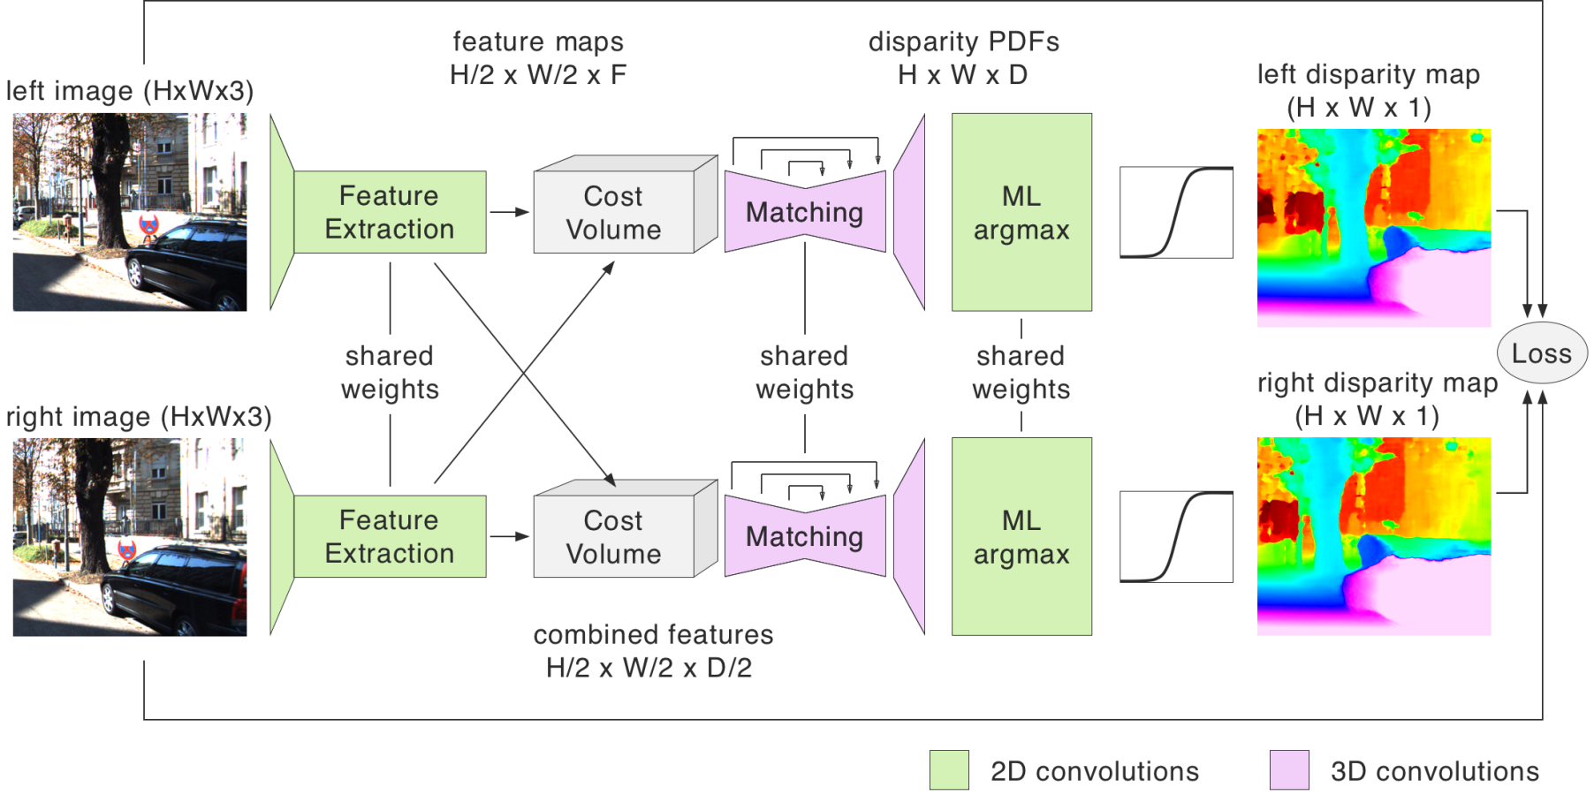

CHAPTER 4
TESTING AND IMPLEMENTATION

  - TESTING
Implementation is the stage of the project when the theoretical design is turned into a working system. This is the final and important phase in the system life cycle It is actually the process of converting the new system into a operational one.

4.1.1Unit Testing
Unit testing comprises the set of tests performed by an individual programmer prior to integration of the unit into a larger system. The module interface is tested to ensure that information properly flows into and out of the program unit. The local data structure is examined to ensure that data stored temporarily maintains its integrity during all steps in an algorithm’s execution. Boundary conditions are tested to ensure that the module operates properly at boundaries established to limit or restrict processing. All independent paths through the control structure are tested. All error-handling paths are tested.

4.1.2 Block Box Testing
Black-box testing is a method of software testing that examines the functionality of an application without peering into its internal structures or workings. This method of test can be applied virtually to every level of software testing: unit, integration, system and acceptance. It is sometimes referred to as specification-based testing.

4.2 SYSTEM IMPLEMENTATION
Implementation is the stage of the project when the theoretical design is turned into a working system. This is the final and important phase in the system life cycle It is actually the process of converting the new system into a operational one.

CHAPTER 5
CONCLUSION:

- We have presented a comprehensive survey of recent advances in depth estimation from images leveraging the synergies between binocular stereo and data-driven, learningbased methods.
- Reviewing the literature reveals that the relationship is bidirectional and new machine learning approaches had to be developed to address depth estimation.
- While research is ongoing and voluminous, we believe that this survey will be valuable for researchers entering this field, as well as for experts.

CHAPTER-6
REFERENCE
- [1] D. Scharstein and R. Szeliski, “A taxonomy and evaluation of dense two-frame stereo correspondence algorithms,” IJCV, vol. 47, no. 1-3, pp. 7–42, 2002.
- [2] Y. LeCun, Y. Bengio, and G. Hinton, “Deep learning,” Nature, vol. 521, no. 7553, p. 436, 2015.
- [3] R. Garg, V. K. BG, G. Carneiro, and I. Reid, “Unsupervised CNN for single view depth estimation: Geometry to the rescue,” in ECCV. Springer, 2016, pp. 740–756.
- [4] M. Brown, D. Burschka, and G. Hager, “Advances in computational stereo,” PAMI, vol. 25, no. 8, pp. 993–1008, 2003.
- [5] D. Scharstein and R. Szeliski, “High-accuracy stereo depth maps using structured light,” in CVPR, 2003.
- [6] H. Hirschmuller and D. Scharstein, “Evaluation of cost functions ¨ for stereo matching,” in CVPR, 2007.
- [7] A. Geiger, P. Lenz, and R. Urtasun, “Are we ready for autonomous driving? The KITTI vision benchmark suite,” in CVPR, 2012.
- [8] D. Scharstein, H. Hirschmuller, Y. Kitajima, G. Krathwohl, ¨ N. Nesiˇ c, X. Wang, and P. Westling, “High-resolution stereo ´ datasets with subpixel-accurate ground truth,” in German Conference on Pattern Recognition, 2014, pp. 31–42.
- [9] M. Menze and A. Geiger, “Object scene flow for autonomous vehicles,” in CVPR, 2015, pp. 3061–3070.
- [10] T. Schops, J. L. Sch ¨ onberger, S. Galliani, T. Sattler, K. Schindler, ¨ M. Pollefeys, and A. Geiger, “A multi-view stereo benchmark with high-resolution images and multi-camera videos,” in CVPR, 2017, pp. 3260–3269.

