Hash Based Conditional Privacy phishing In WSN

Abstract
In WSN network there is Cyber Attack occurs are one of the most common and most dangerous attacks among cybercrimes. The aim of these attacks is to steal the information used by individuals and organizations to conduct transactions. Phishing websites contain various hints among their contents and web browser-based information. The purpose of this study is to perform Extreme Learning Machine (ELM) based classification for 30 features including Phishing Websites Data in UC Irvine Machine Learning Repository database. For results assessment, ELM was compared with other machine learning methods such as Support Vector Machine (SVM).

Existing System

Phishing is a type of cyber threats that is targeting to get private information such as credit cards information and social security numbers. De-synchronization Attack is the pseudonym stored at the gateway node GW and the sensor node SN memory would not be the same, because of an adversary blocks the communication between the parties. There is not a specific solution that can detect whole phishing.

Disadvantage of Existing System
- Internet is an essential part of our life. Internet users can be affected from different types of cyber threats.
- Thus cyber threats may attack ﬁnancial data, private information, online banking and e-commerce.
- Sql Injection
- Dos Attack
- Password Attack

PROPOSED SYSTEM

In this study, features in the database created for phishing websites are classified by determining the input and output parameters for the Support Vector machine classifier. Results obtained by SVM show that has higher achievement compared to other classifier methods.

ADVANTAGE
- The proposed methodology imports data-set of phishing and legitimate URLs from the database and then the imported data is pre-processed.
- The Attackers url will be blocked based on request from hackers server.

Introduction
Phishing is an Internet scam used by the phisher to fool Internet users for malicious activities. Phishing can be done in many ways. Among that, email phishing is the traditional and most common way of performing phishing. Usually, the phisher sends an email by stating some emergency which evokes the user to clickon the hyperlink or the attachment provided in the email. The phisher comes with a new technique every time to fool Internet users. According to the Anti-Phishing Working Group [27] survey report, there are 1,220,523 unique phishing attacks occurred in January-March for the year 2018. Pharming is the advanced way of phishing scams, where the phisher redirects the user to a spoofed site that looks and feels exactly like the original site. This can be done either by modifying the host files on the user system or by hijacking(replacing the IP address) the DNS servers. If the IP address on the DNS server is changed, the entire traffic ofthe website is redirected to the site specified by the phisher. Pharming is more dangerous and very difficult to detect.To prevent internet users from phishing scams, Anti-phishing solutions had been developed. Anti-Phishing helps in detecting the phishing scams. In this study, we classified the existing anti-phishing solutions into two main categories; namely Content-based and Non-content based. The content-based approaches analyze the content from webpage, URL, email to decide whether it is phishing or not. The Non-content based approaches don’t analyze the content instead it will verify with the existing Blacklist (stores the Phishing data), a white list (list of trusted sites). In this work, we focus on the following aspects that are different from the existing taxonomies:–A complete classification of Anti-Phishing solutions.–Presenting a literature survey on existing anti-phishing algorithms used by different approaches, the dataset used, and the limitations are discussed in detail.–Presenting a comparison of existing Anti-Phishing toolbars in literature. In this paper, a complete Classification of Anti-Phishing solutions is pro-vided. The classification assists to understand various approaches utilized for developing anti-phishing solutions and the current trends. Section-2 is about research methodology to illustrate how this literature is performed. Section-3 explains a complete classification of Anti-Phishing solutions and the existinganti-phishing approaches. Section-4 elucidates existing anti-phishing browser ex-tensions/toolbars with pros and cons. Section-5 is about discussion and Section-6 is a concluding statement.
Wireless sensor networks (WSNs) play a pivotal role in the origin and propagation of the IoT, the notion that each object (virtual or physical) can be sensed, identified, accessed and interconnected via the Internet within a dynamic ubiquitous network. Wireless sensor networks (WSNs) are networks composed of a large number of randomly distributed sensor nodes. These sensor nodes jointly perceive environmental information and transmit the perceived information to the gateway node through a self-organizing multi-hop network. WSNs are widely used in battlefield situational awareness, environmental monitoring, medical care and water quality monitoring due to their characteristics of self-organization and reliability. Sensor nodes are usually deployed in unmanned or hostile areas,
and their perceived information is of high value, so users must pass identity authentication before obtaining the information perceived by the sensor nodes [1,2]. Usually, the gateway node stores the information transmitted by the sensor node, and the user sends the request for data to the gateway node and obtains the data stored by it. However, in many scenarios with high demand for real-time data application, such as battlefield situational awareness and enemy detection, users need to obtain real-time data directly from sensor nodes. Various authentication
protocols have been proposed for wireless sensor networks scenario, such as in [2–20]. In order to describe the security authentication requirements in this scenario, Das designed a two-factor authentication protocol using smart cards and passwords [3]. Two-factor protocol combines two di_erent authentication methods. An attacker can only destroy the security of the protocol by corrupting all authentication factors and corrupting only one authentication factor will not a_ect the security of the protocol. Das claims that their protocol can resist known attacks such as replay attacks, password guessing attacks, and impersonation attacks. However, Nyang et al. found that the Das’s protocol could not resist o_ine dictionary attack, node capture attack, and the protocol could not protect the response information of the query [4]. Nyang et al. proposed an improved protocol to overcome the shortage of Das’s protocol. Chen et al. pointed out that the Das protocol failed to realize two-way authentication and made corresponding improvements [5]. In addition, He et al. found that Das’s protocol could
not resist insider attacks and internal malicious user impersonation attacks [6]. Later, Khan et al. pointed out that in Das’s protocol, attackers can bypass the authentication of gateway node and can directly obtain information from sensor node. Khan et al. also identified that this protocol cannot resist privileged insider attack, does not provide any password update mechanism, and fails to realize the
two-way authentication between gateway node and sensor node [7]. Khan et al. proposed an improved protocol to overcome the security flaws in the Das protocol. However, Sun et al. pointed out that Khan et al.’s improved protocol was still subject to gateway node impersonation attack and privileged insider attack, and attackers could still bypass the authentication of gateway node and directly obtain
information from sensor node [8]. Aiming at the security vulnerability of Khan et al.’s protocol, Sun et al. proposed a two-factor authentication protocol and proved the security of their protocol under BR model [9]. Yuan et al. also found that Khan et al.’s protocol could not provide non-repudiation, could not resist smart card theft attacks, and could not achieve two-way authentication between users and
sensor nodes [10]. Yuan et al. then designed a multi-factor authentication protocol using biological authentication and proved the security of the protocol by using GNY logic [11]. Wu et al. [12] designed a provably secure three-factor user authentication protocol for wireless sensor networks. Their scheme attains a number of desirable features but the computational and communication overheads are high. Recently, Das proposed a multi-factor authentication protocol combining password, smart card and biological information [18]. Their protocol only adopts lightweight cryptographic components, such as hash function and symmetric encryption algorithm, so it confirms to the characteristics of limited resource of sensor nodes in wireless sensor network. In addition, Das uses formalized proof method and an automatic protocol verification tool to prove the security of its protocol. However, we found that Das’s protocol has the following security vulnerabilities: (1) the attacker can impersonate the user to the gateway node by using the captured sensor node, and can decrypt all the encrypted data of
the user; (2) anonymity requires a lot of computing by the gateway node, which will lead to denial of service attack on the gateway node. Therefore, the protocol does not have user anonymity. In viewof the above security vulnerabilities, we further improve the Das’s protocol and give the formalized security proof of the improved protocol under the random prediction model. It can be seen from the
e_ciency analysis that compared with similar protocols, our improved protocol has higher security while having considerable computing and communication costs, so it is more compatible with the application requirements of WSN.

Literature Review
TITLE | AUTHOR | CONCEPT
“Security enhanced user authentication protocol for wireless sensor networks using elliptic curves cryptography,” Sensors, vol. | Y. Choi, D. Lee, J. Kim, J. Jung, J. Nam, and D. Won, | Wireless sensor networks (WSNs) consist of sensors, gateways and users. Sensors are widely distributed to monitor various conditions, such as temperature, sound, speed and pressure but they have limited computational ability and energy. To reduce the resource use of sensors and enhance the security of WSNs, various user authentication protocols have been proposed.
J. Nam, M. Kim, J. Paik, Y. Lee, and D. Won, “A provably-secure ecc-based authentication scheme for wireless sensor networks,” Sensors, vol. | J. Nam, M. Kim, J. Paik, Y. Lee, and D. Won, | A smart-card-based user authentication scheme for wireless sensor networks (in short, a SUA-WSN scheme) is designed to restrict access to the sensor data only to users who are in possession of both a smart card and the corresponding password.

“A realistic lightweight anonymous authentication protocol for securing real-time application data access in wireless sensor networks. | P. Gope and T. Hwang, | User authentication in wireless sensor networks (WSN) is a critical security issue due to their unattended and hostile deployment in the field. Since the sensor nodes are equipped with limited computing power, storage, and communication modules, authenticating remote users in such resource-constrained environment is a paramount security concern.
, “A dynamic user authentication scheme for wireless sensor networks,” in Proceedings of the IEEE International Conference on Sensor Networks, Ubiquitous, and Trustworthy Computing, pp. | K. H. M. Wong, Z. Yuan, C. Jiannong, and W. Sheng Wei | Authenticating remote users in wireless sensor networks (WSN) is an important security issue due to their un-attended and hostile deployments. Usually, sensor nodes are equipped with limited computing power, storage, and communication module, thus authenticating remote users in such resource-constrained environment is a critical security concern.

System Architecture

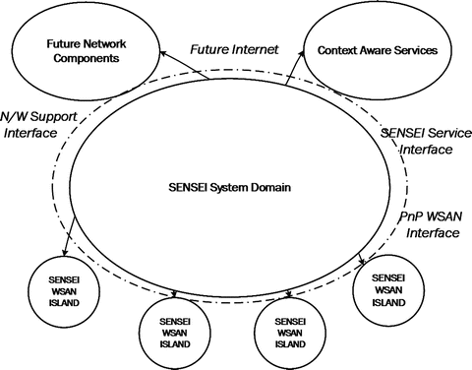

UML DIAGRAM

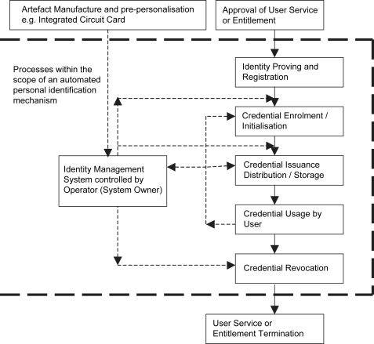

DATA FLOW DIAGRAM

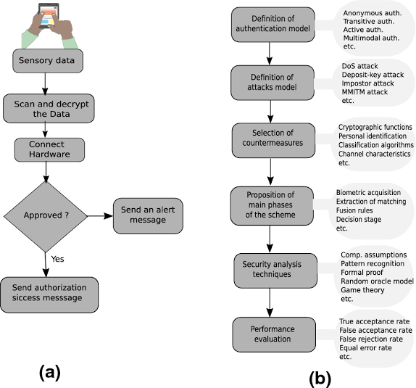

TECHNIQUES
- Support Vector machine

MODULES
- Register and Login
- Cipher Text Encryption
- Cipher Text Decryption
- Image Authentication.

